OALCF Task Cover Sheet
Task Title: Analyzing Farm Records
Learner Name:

Date Started: Date Completed:

Successful Completion: Yes___ No___
Goal Path: Employment  Apprenticeship___ Secondary School Post Secondary Independence___
Task Description:
The learner needs to count and calculate costs based on a farmer’s field notes.
Competency:  A: Find and Use Information  B: Communicate Ideas and Information  C: Understand and Use Numbers | Task Group(s):  A1: Read Continuous Text  A2: Interpret documents  B3: Complete and create documents  C1: Manage money  C4: Manage data
Level Indicators:
A1.2: Read texts to locate and connect ideas and information
A2.1: Interpret very simple documents to locate specific details
A2.2: Interpret simple documents to locate and connect information.
B3.2b: Create simple documents to sort, display and organize information.
C1.2: Make low-level inferences to calculate costs and expenses that may include rates such as taxes and discounts
C4.1: Make simple comparisons and calculations
C4.2: Make low-level inferences to organize, make summary calculations and represent data
Performance Descriptors: see chart on last page
Materials Required:
- Paper and pen
- Calculator
- Question sheet (attached)
- Answer sheet (attached)
- Sunnyside Farm Field Notes
Skill Building Activities: The learner will need to be able to draw a simple bar graph and understand ratios and percents.
Task Title: Analyzing Farm Records
A farmer owns and operates Sunnyside Farm. Their bull, Samson, has sired a number of calves which were born during March and April of 2014.
In order to plan for the next calving season, and to monitor the health of the beef operation, the farmer has recorded the attached field notes on each calf and needs to complete the following calculations. Look at the Sunnyside Farm Field Notes.
Learner Information and Tasks:
Task 1: Calculate the number of calves that were born.

Task 2: Calculate the number of calves that were born between 11:00 p.m. and up to and including 7:00 a.m.

Task 3: Calculate the percentage of calves that were born with normal weight.

Task 4: Calculate the ratio of bulls [B] to heifers [H] that were born.

Task 5: The farmer requires a veterinarian to be in attendance for difficult births at the rate of $200.00 per visit. They also require the veterinarian to examine all calves born normally. The vet charges a fee of $150 for a regular visit and $5 per calf examination. If the farmer arranges for the veterinarian to visit once per week, usually on Monday morning, calculate the total veterinarian costs. Use the attached calendars for March & April.

Task 6: Draw a bar graph to compare the number of heifers [H] and bulls [B] born for each month. Your graph should include a title.

SUNNYSIDE FARM FIELD NOTES
Cow # | Calf # | Birth Date | Time of birth | Sex | Ease of birth | Size at birth
160 | 13 | Tuesday, March 9 | 3 a.m. | B | Normal | Normal
59 | 14 | Thursday,  March 13 | 7 a.m. | H | Normal | Normal
81 | 15 | Friday, March 14 | 4 p.m. | B | Normal | Normal
137 | 16 | Sunday, March 16 | 1 p.m. | H | Difficult. Calf not born live. | Normal
159 | 17 | Monday, March 17 | 7 a.m. | B | Normal | Normal
44 | 1 | Monday, March 17 | 2:30 p.m. | B | Normal | Normal
80 | 2 | Tuesday, March 18 | 2:00 p.m. | B | Normal | Normal
59 | 3 | Wednesday, March 19 | 2:00 a.m. | B | Normal | Normal
82 | 4 | Thursday, March 20 | 11:00 a.m. | H | Normal | Normal
80 | 5 | Saturday, March 22 | 5 a.m. | H | Normal | Normal
157 | 6 | Monday, March 24 | 11:00 a.m. | H | Normal | Normal
37 | 7 | Wednesday, March 26 | 12:00 p.m. | B | Normal | Normal
61 | 8 | Tuesday, April 1 | 7:00 a.m. | H | Normal | Extra small
57 | 9 | Tuesday, April 1 | 12:00 p.m. | H | Normal | Normal
126 | 10 | Tuesday, April 1 | 2:00 a.m. | H | Normal | Normal
113 | 11 | Thursday, April 3 | 5:00 a.m. | B | Normal | Normal
138 | 12 | Saturday, April 12 | 3:00 a.m. | H | Normal | Normal
75 | 18 | Wednesday, April 23 | 4:00 p.m. | H | Normal | Normal
79 | 19 | Wednesday, April 30 | 2:00 a.m. | B | Normal | Normal
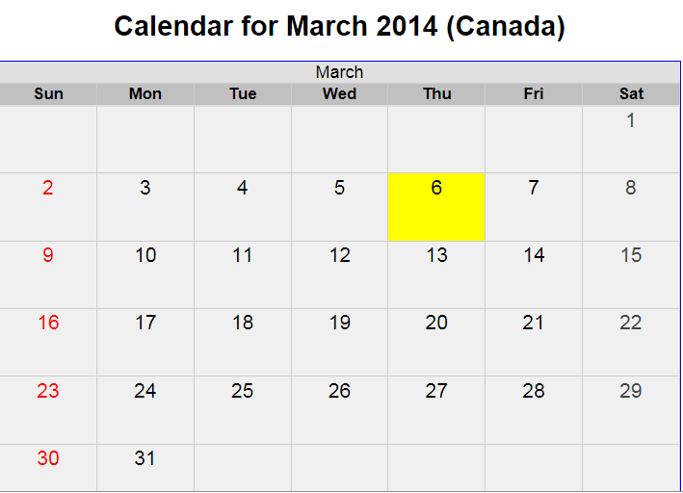

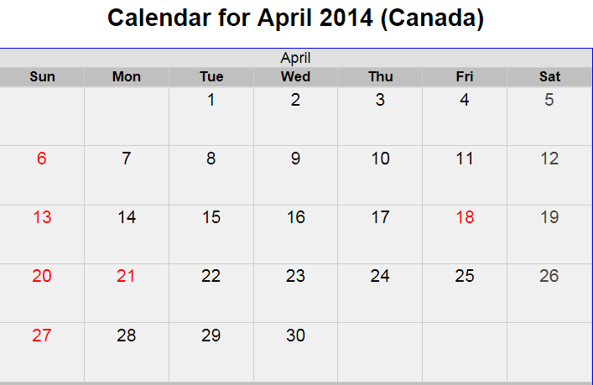

Task Title: Analyzing Farm Records
Answer Key
Task 1: Calculate the number of calves that were born.
19 calves
Task 2: Calculate the number of calves that were born between 11:00 p.m. and 7:00 a.m.
10 calves
Task 3: Calculate the percentage of calves that were born with normal weight.
18 normal calves/19 total calves X 100% = 94.74%
Task 4: Calculate the ratio of bulls [B] to heifers [H] that were born.
9 bulls to 10 heifers OR 9:10
Task 5: The farmer requires a veterinarian to be in attendance for difficult births at the rate of $200.00 per visit. They also require the veterinarian to examine all calves born normally. The vet charges a fee of $150 for a regular visit and $5 per calf examination. If the farmer arranges for the veterinarian to visit once per week, usually on Monday morning, calculate the total veterinarian costs. Use the attached calendars for March & April.
1 difficult birth @ $200 per visit = $200.00
18 calves born normally @ $5 per calf = $90.00
Calving period from March 9 to April 30 = 9 visits @ $150 per visit = $1350.00
Total Veterinarian costs = $1640.00
Task 6: Draw a bar graph to compare the number of heifers [H] and bulls [B] born for each month.
Number of Heifers and Bulls born in March and April 2014.
Task Title: Analyzing farm records
Performance Descriptors |  | Needs Work | Completes task with support from practitioner | Completes task independently
A1.2 | - scans text to locate information
 | - locates multiple pieces of information in simple texts
 | - makes low-level inferences
A2.1 | - scans to locate specific details
 | - interprets brief text and common symbols
 | - locates specific details in simple documents, such as labels and signs
 | - identifies how lists are organized (e.g. sequential, chronological, alphabetical)
 | - requires support to identify sources and to evaluate and integrate information
A2.2 | - performs limited searches using one or two search criteria
 | - extracts information from tables and forms
 | - locates information in simple graphs and maps
 | - uses layout to locate information
 | - makes connections between parts of documents
 | - makes low-level inferences
 | - begins to identify sources and evaluate information
B3.2b | - follows conventions to display information in simple documents (e.g. use of font, colour, shading, bulleted lists)
 | - sorts entries into categories
 | - displays one or two categories of information organized according to content to be presented
 | - identifies parts of documents using titles, row and column headings and labels
C1.2 | - calculates using numbers expressed as whole numbers, fractions, decimals, percentages and integers
 | - interprets and applies rates (e.g. $/kg, $/1)
 | - chooses and performs required operation(s); may make inferences to identify required operation(s)
 | - selects appropriate steps to reach solutions
 | - represents costs and rates using monetary symbols, decimals and percentages
C4.1 | - adds, subtracts, multiplies and divides whole numbers and decimals
 | - identifies and compares quantities of items
 | - identifies and performs required operation
C4.2 | - calculates using numbers expressed as whole numbers, fractions, decimals, percentages and integers
 | - understands and uses ratio and proportion
 | - finds ranges for data sets
 | - calculates averages (mean) and percentages
 | - collects, organizes and represents data using simple tables and graphs

This task: was successfully completed___ needs to be tried again___

Learner Comments

____________________________ _________________________

Instructor (print) Learner Signature

