  - Transition Task: Prepared for the Project, Teaching to Fish (Build Tasks) Integrating OALCF Task Development within Ontario’s Literacy Programs (2014)

Task Title: Applying for a Job Online

OALCF Cover Sheet – Practitioner Copy

Learner Name:
Date Started (m/d/yyyy):
Date Completed (m/d/yyyy):
Successful Completion: Yes No
Goal Path: | Employment | Apprenticeship
Secondary School | Post Secondary | Independence
Task Description: Understand how to find job opportunities online, type of information required, and format of information
Competency: A: Find and Use Information, B: Communicate Ideas and Information, D: Use Digital Technology
Task Groups: A1: Read continuous text, A2: Interpret documents, B3: Complete and create documents, D2: Use digital technology
Level Indicators:
- A1.1: Read brief texts to locate specific details
- A1.2: Read texts to locate and connect ideas and information
- A2.2: Interpret simple documents to locate and connect information
- B3.2a: Use layout to determine where to make entries in simple documents
- D.2: Perform well-defined, multi-step digital tasks
Performance Descriptors: See chart on last page
Materials Required:
- Pen and paper (optional)
- Computer with Internet access
Learner Information:

When applying for a job online, companies have different terminology and requirements. One requirement may include creating a user account, another may be that a company will not accept attachments and you will have to type in your resume. Read the document Applying Online.

Applying Online
Many companies now post open positions online. You can search out the position you want as well as the location. Once you determine the position and location you will select the job and it will give a description of the duties and skills you will require. If you are satisfied this is what you want to do there will be a button that usually says Apply Now for you to continue.
To begin your search of companies online you may do a couple of things.
Search out the company using only the name of the company, if you select only the company name you will have to search the company website for career or employment opportunities:
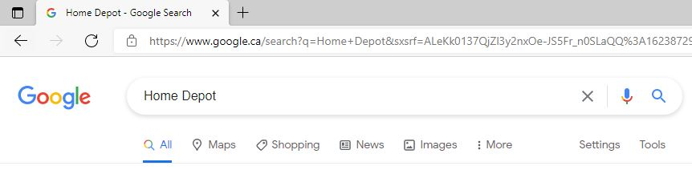
Or you can add the word jobs or careers to limit your search; this will take you directly to the career or employment opportunities page:
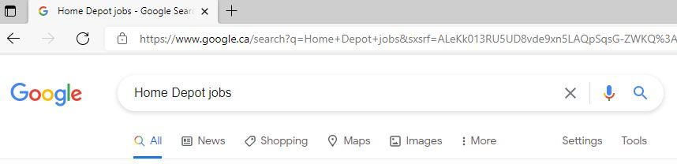
Select the link for jobs or careers for that company. Since you narrowed your search to only websites related to jobs for Home Depot they have come to the top of the search. As you can see there are several choices for Home Depot jobs. Select the one you think is appropriate:
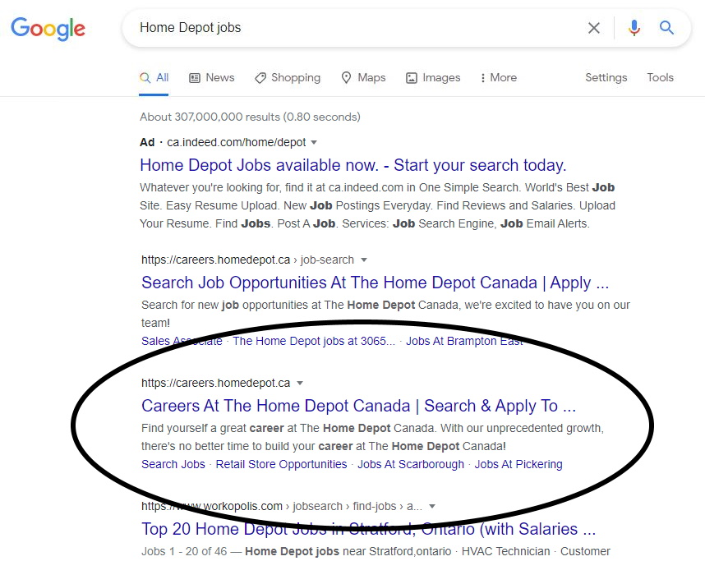
Once you select search jobs, many positions may pop up. In many cases when you choose a position, a job description will open. The next window to open will ask you to create a user account. Most employers ask you to create a user so that you can customize your job searching tools for the site. In some cases, employers may email you job opportunities that are suited to you in the future based on the information in your user account.
Let's walk through the process of applying online.

Create a User Account
User Name: | Job Seeker
Password: | Unique numbers and letters
Re-enter password: | Unique numbers and letters
Select a security question: | What was the first school you attended
Answer to your security question: | Grade school - use the name
User Profile
This profile will present information to a company in a set format. This format has the information organized in such a way that it is easy to review for appropriate candidates for the job.
Edit Your Profile
- Contact Name
- Address
- Phone Number
- Email
- Name your CV/Resume
Work Experience
- Position/Job Title
- Organization Name
- Responsibilities
- Skills
- Start Year
- End Year
- Most Recent
Education
- University or Educational Institution
- Subject or area of study
- Qualification
- Grad Year
- Most Recent

Attaching a Resume or Cover Letter
You can attach a file, but it must have an acceptable extension. An extension is the identification letters at the end of the document name. For example: jobsearch.docx, the .docx is the extension. Each company will indicate which type of file it will accept, usually by indicating the acceptable extensions.

Enter your information
In some cases, employers will not accept attachments and will require you to enter the information into a set format. This will require you typing in everything from your cover letter to your resume.

Work Sheet:
Complete the following tasks.
Task 1: How would you limit your search to job opportunities only?
Answer:

Task 2: Why do companies ask you to create a user account?
Answer:

Task 3: If a company will not accept attachments, what might they expect you to do?
Answer:

Task 4: List the main categories of information that a company will ask for when creating your User Profile.
Answer:

Task 5: Enter this information into a chart like the below, starting with the most recent job:
- GE Canada, machine operator, met deadlines, operated various production equipment, June 1999, January 2010
- Quaker Oats, custodian, responsible for maintaining Good Housekeeping practices, March 1995, November 1998
- Sears, sales, responsible for cash transactions, customer service, part time, June 1994, March 1995
Answer:
Job Title | Company | Skills | Start Date | End Date

Task 6: Use the internet to locate the job opportunities for Walmart and Home Depot. List two jobs you would be interested in.
Answer:

Answers
Task 1 Answer:
- Use the key words jobs, employment, or careers along with the company name.
Task 2 Answer:
- So that you can customize your job searching tools, or the company can email you with jobs that are suited to you.
Task 3 Answer:
- You will have to type it in.
Task 4 Answer:
- Edit your profile, Work experience, Education
Task 5 Answer:
Job Title | Company | Skills | Start Date | End Date
Machine Operator | GE Canada | Met deadlines, operated various production equipment | June 1999 | January 2010
Custodian | Quaker Oats | Responsible for maintaining Good Housekeeping practices | March 1995 | November 1998
Sales | Sears | Responsible for cash transactions, Customer Service | June 1994 | March 1995

Task 6 Answer:
- These answers will vary, but may include Sales Associate, Manager, and Night crews.

Performance Descriptors
Levels | Performance Descriptors | Needs Work | Completes task with support from practitioner | Completes task independently
A1.1 | Reads short texts to locate a single piece of information
A1.1 | Decodes words and makes meaning of sentences in a single text
A1.1 | Follows the sequence of events in straight forward chronological texts
A1.1 | Follows simple, straightforward instructional texts
A1.2 | Scans text to locate information
A1.2 | Locates multiple pieces of information in simple texts
A1.2 | Makes low-level inferences
A2.2 | Performs limited searches using one or two search criteria
A2.2 | Extracts information from tables and forms

Levels | Performance Descriptors | Needs Work | Completes task with support from practitioner | Completes task independently
A2.2 | Locates information in simple graphs and maps
A2.2 | Uses layout to locate information
A2.2 | Makes connections between parts of documents
A2.2 | Makes low-level inferences
A2.2 | Begins to identify sources and evaluate information
B3.2a | Uses layout to determine where to make entries
B3.2a | Begins to make some inferences to decide what information is needed, where and how to enter the information
B3.2a | Makes entries using a limited range of vocabulary
B3.2a | Follows instructions on documents
D.2 | Selects and follows appropriate steps to complete tasks

Levels | Performance Descriptors | Needs Work | Completes task with support from practitioner | Completes task independently
D.2 | Locates and recognizes functions and commands
D.2 | Makes low-level inferences to interpret icons and text
D.2 | Begins to identify sources and evaluate information
D.2 | Performs simple searches using keywords (e.g., internet, software help menu)
This task: Was successfully completed Needs to be tried again
Learner Comments:

Instructor (print): Learner Name:

