OALCF Tasks for the Apprenticeship Goal Path: Prepared for the Project, Developing Best Practices for Increasing, Supporting and Retaining Apprentices in Northern Ontario (2014) - Updated 2023 as part of CLO’s Skills for Success Initiative

Task Title: Automotive Vehicle Inspection

OALCF Cover Sheet – Practitioner Copy

Learner Name:
Date Started (m/d/yyyy):
Date Completed (m/d/yyyy):
Successful Completion: Yes No

Goal Path: | Employment | Apprenticeship
Secondary School | Post Secondary | Independence
Task Description: Use an automotive vehicle inspection document to record a vehicle’s current condition.
Competency: A: Find and Use Information, B: Communicate Ideas and Information
Task Groups: A2: Interpret documents, B3: Complete and create documents
Level Indicators:
- A2.2: Interpret simple documents to locate and connect information
- B3.1a: Make straightforward entries to complete very simple documents
- B3.2a: Use layout to determine where to make entries in simple documents

Embedded Skills for Success: | Digital
Adaptability | Numeracy
Collaboration | Problem Solving
Communication | Reading
Creativity and Innovation | Writing

Performance Descriptors: See chart on last page
Instructor note: if printing in black and white, let your learner know that the three dots beside each item in the vehicle report card are green, yellow, and red (from left to right).

Learner Information and Work Sheet
When customers bring their car into a garage, Automotive Service Technicians do a routine inspection. They will look at many parts of the car, including the windshield, lights, engine, underside of the car, fluid levels, brakes and tires.
While they do this inspection, Automotive Service Technicians and apprentices fill out inspection reports to document what they see. These inspection reports may indicate recommended maintenance or repairs to the vehicle.
Complete the tasks below and enter the required information on the Vehicle Report Card on the following page.
Task 1: An automotive service technician is inspecting a white 2019 Ford Taurus with an odometer reading of 238,126 km. Enter the odometer reading into the appropriate boxes on the vehicle report card.

Task 2: When doing a visual parameter inspection, the automotive service technician notices that the right front (RF) headlight is burnt out. It needs to be replaced immediately. Record this information on the vehicle report card.

Task 3: The tread on the right front (RF), left front (LF), right rear (RR) and left rear (LR) tire measures 2/32, which is the minimum legal tread depth. At this level, tires are considered bald and unsafe. Record the tire tread depth on the vehicle report card, and indicate that these four tires need immediate attention.

Task 4: The car’s owner mentions that the check oil light is on. When the automotive service technician looks under the vehicle, they see that oil is leaking. They check the fluid levels and find the oil is very low and needs to be replaced immediately. Check the appropriate boxes on the vehicle report card.

Your Vehicle Report Card
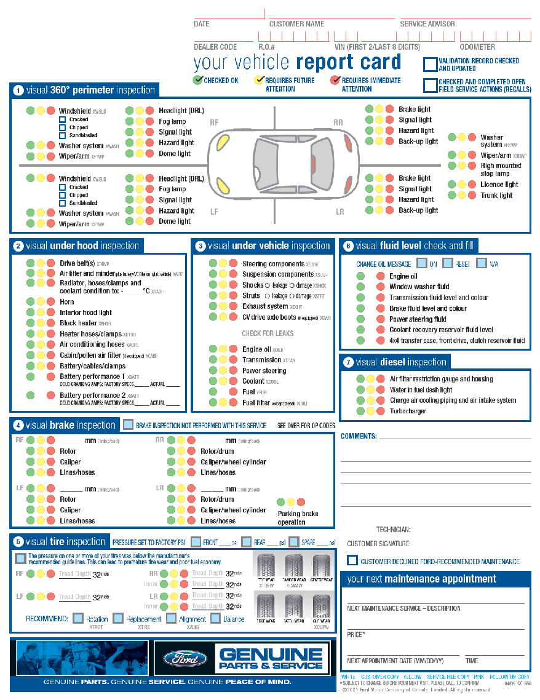

Answers
Task 1: The information is entered at the top of the document on the right side. It should be filled in as seen below.
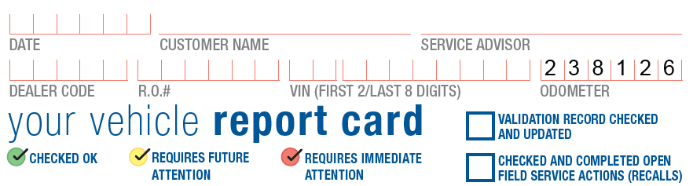

Task 2: Locate box number 1, “visual 360o perimeter inspection” at the top of the document. It should be filled in as seen below.
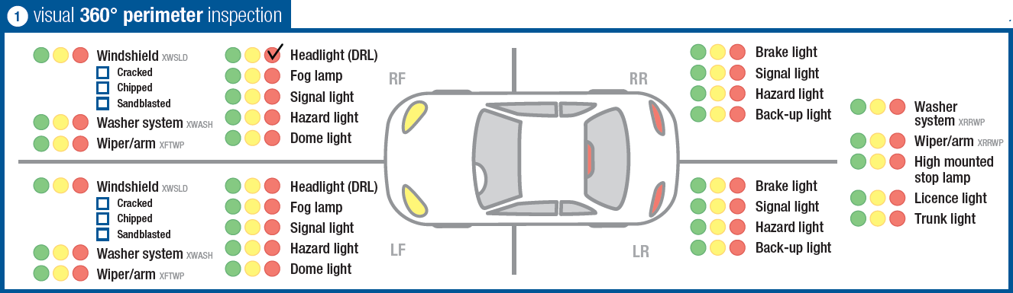

Task 3: Locate box number 5, “visual tire inspection” on the bottom left side of the document. It should be filled in as seen below.
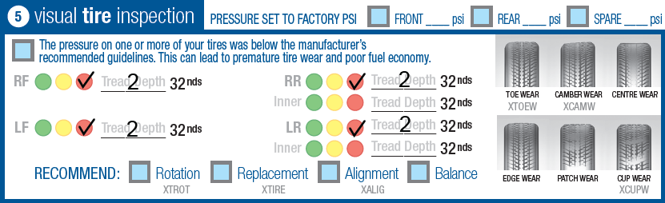
Task 4: Locate box number 3, “visual under vehicle inspection” and box number 6 “visual fluid level check and fill” on the right side of the document. They should be filled in as seen below.
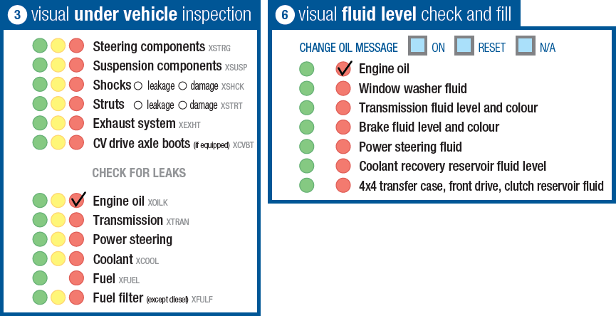

Performance Descriptors
Levels | Performance Descriptors | Needs Work | Completes task with support from practitioner | Completes task independently
A2.2 | Performs limited searches using one or two search criteria
A2.2 | Extracts information from tables and forms
A2.2 | Uses layout to locate information
A2.2 | Makes connections between parts of documents
A2.2 | Makes low-level inferences
B3.1a | Makes a direct match between what is requested and what is entered
B3.1a | Makes entries using familiar vocabulary
B3.2a | Uses layout to determine where to make entries
B3.2a | Begins to make some inferences to decide what information is needed, where and how to enter the information
B3.2a | Makes entries using a limited range of vocabulary

This task: Was successfully completed Needs to be tried again

Learner Comments:

Instructor (print): Learner (print):

