OALCF Task Cover Sheet
Task Title: Read a business message
Learner Name:

Date Started: Date Completed:

Successful Completion: Yes___ No___
Goal Path: Employment ✔ Apprenticeship___ Secondary School___ Post Secondary___ Independence ✔
Task Description:
Read aloud a message from a business and then answer written questions about the message.

Competency:  - Find and Use information  - Communicate ideas and information  - Understand and use numbers  E. Manage learning | Task Group(s):  A1: Read continuous text  A2: Interpret documents  C2: Manage time  E: Manage learning
Level Indicators:
A1.2: Read texts to locate and connect ideas and information
A2.1: Interpret very simple documents to locate specific details
C2.1: Measure time and make simple calculations
E.1: Set short-term goals, begin to use limited strategies and begin to monitor own learning

Performance Descriptors: see chart on last page
Materials Required:
- Message form
- Paper (questions) and pen

Task Title: Read a business message
Practitioner Instructions:
- Review the student’s instructions with the student.
- Go over the checklist with your student so that your student is aware of the skills to be demonstrated.
- Ask the student to read the message aloud.
- When the student has completed the task, complete the evaluation together with the student, enter the date completed, and note whether it was successful or needs to be tried again.
Help allowed: Dictionary
Adaptation: any other message from a retail or wholesale outlet

Task Title: Read a business message– Answer Key
*there may be some variation, depending on the questions that the learner was asked
Answer Sheet:
- Janet
- by phone
- George Roberts
- Mrs. Adamson
- 11:15 am
- to tell George of special deals and see if he is interested
- retail carpet cleaning
- before 5pm
- We don’t know what the special deals are. Who is Pat?...answers will vary dependent on the learner
Task Title: Read a business message

Learner Information and Instructions:

Task 1: Look at all parts of the message your instructor gives you.

Task 2: Read the message aloud to your instructor.

Task 3: Answer these questions. Try to write your answers on your own.

- Who took the message? _______________________________________

- How did she get this message? __________________________________

- Who is the message for? _______________________________________

- Who was the message from? ________________________________________

- When was the message left? ___________________________________

- What is the main purpose of this message? ___________________________________
______________________________________________________________________

- What do you think the special deal is about ? _____________________________________
_________________________________________________________________________

- When does George have to return the call? ____________________

- Do you think this message is clear? Why or why not?___________________________
_______________________________________________________________________

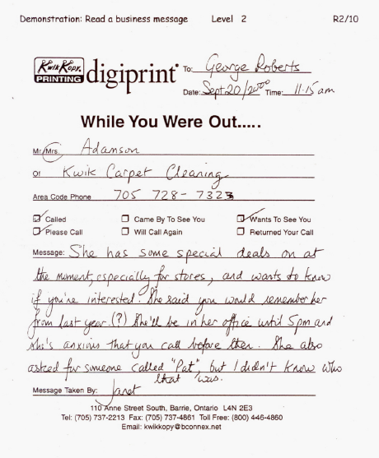
Task Title: Read a business message
Task Title: Read a business message

Learner’s self reflection:

I recognized that this was a telephone message. Yes ❑ No ❑

I knew who took this message and who this message was for. Yes ❑ No ❑

I knew what had to be done. Yes ❑ No ❑

I could read all the names on this message. Yes ❑ No ❑

I found it easy to read this message. Yes ❑ No ❑

I answered __ out of 9 questions correctly. Yes ❑ No ❑

Learner Comments:

Task Title: Read a business message
Performance Descriptors |  | Needs Work | Completes task with support from practitioner | Completes task independently
A1.2 | - follows the main events of informational texts
 | - scans text to locate information
 | - locates multiple pieces of information in simple texts
 | - makes low level inferences
A2.1 | - interprets brief text
 | - locates specific details in simple documents
 | - scans to locate specific details
C2.1 | - understands and uses common date formats
 | - represents dates and times using standard conventions (a.m. and p.m.)
E.1 | - begins to monitor own learning
 | - uses feedback to improve performance
This task: was successfully completed___ needs to be tried again___

______________________________________ _____________________________________

Instructor (print) Learner Signature

