OALCF Task Cover Sheet
Task Title: Changing Power Settings on a Computer
Learner Name:

Date Started: Date Completed:

Successful Completion: Yes___ No___
Goal Path: Employment___ Apprenticeship___ Secondary School___ Post Secondary___ Independence✓
Task Description: People who and use computers need to be familiar with the different power saving settings to be able to get optimum performance from the computer. This can also save energy and reduce utility bills. This task has the learner practice changing power saving settings on a computer with a Microsoft Windows Operating System.
Competency:  - Find and Use Information  D. Use Digital Technology | Task Group(s):  A2: Interpret Documents  A3: Extract info from films, broadcasts and presentations (if viewing the optional video)  n/a
Level Indicators:
A2.2 Interpret simple documents to locate and connect information
A3 Tasks in this task group are not rated for complexity
D.2 Perform well-defined, multi-step digital tasks
Performance Descriptors: see chart on last page
Materials Required:
- Access to a computer with a Microsoft Windows Operating System ( Windows XP, Vista, 7 or higher)
- Internet access if watching the optional video http://www.ehow.com/video_4982585_change-power-settings-computer.html
- Task set with graphics
Instructor Preparation: Set learner up a computer that has a Windows Operating System (XP or higher). If you are having the learner view the optional online video then the computer will need to have a high speed internet connection. Have the learner turn on the computer and be at the desktop screen, with no programs open. If you are having the learner view the optional how-to video then have them turn on the internet connection, open the browser of choice in your program and in the browser window enter http://www.ehow.com/video_4982585_change-power-settings-computer.html. Let the learner just watch and listen to this 3 minute video. When the video is over, have the learner exit the site and close the browser. Provide the learner with the task set. If skipping the video, give the learner the task set once the computer is on. (Source: http://www.ehow.com/how_2319598_change-power-options-computer.html)
Task Title: Changing Power Settings on a Computer
Computer users need to know how to change different settings on the computer. Complete the tasks below to learn how to change the power setting on your computer.
Task 1: Click on the Windows Start menu and go to Control Panel.
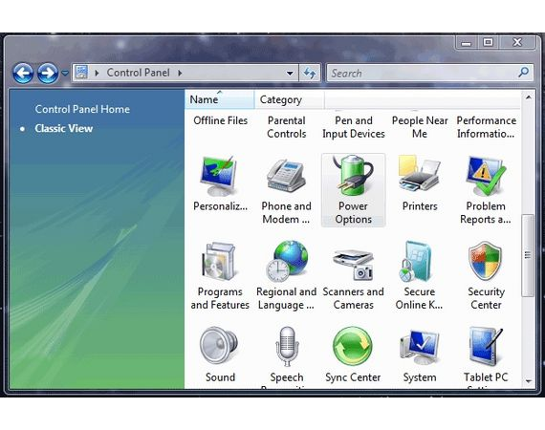
Task 2: Click the "Power Options" choice located inside Windows Control Panel. The choices are listed in alphabetical order. Look at the picture on the right to see what you are looking for.

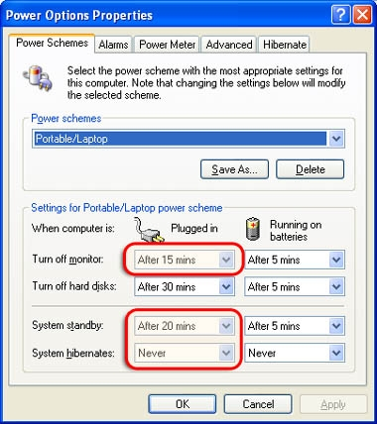
Task 3: In the section title Power schemes click on the arrow in the drop down box, and select the one that best suits your computer (usually a desktop or a portable/laptop).

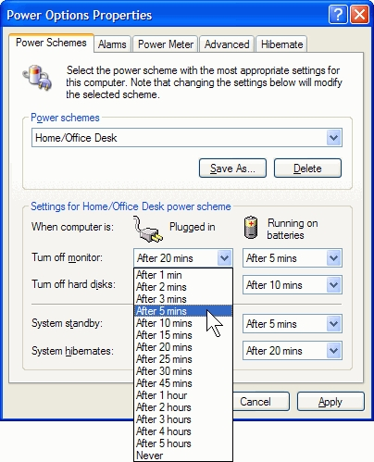
Task 4: Click on the "Turn off monitor" options and select your desired time limit from the drop down box. You can select "never" for this choice or any of the other options. Do this for both columns Plugged In and Running on Batteries. You don’t have to pick the same time for each column.

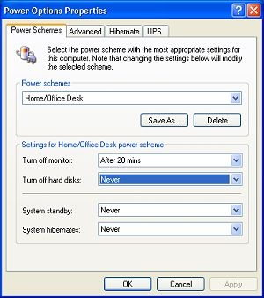
Task 5: Click the "Turn off Hard Disks" choice if you would like to change the timing of that.

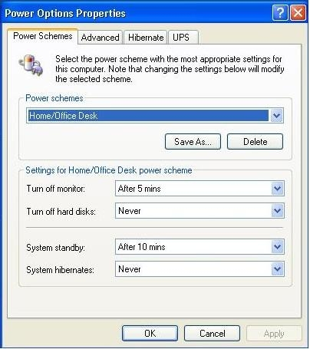
Task 6: Click on "System Standby" and make any changes to the time limits as needed. This is optional. It may be best to select "never" or at least a few hours for this choice.

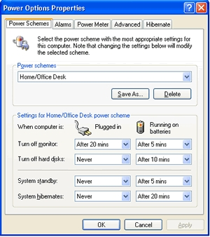
Task 7: Click "System Hibernates" if you want to have your computer hibernate (or "sleep") after a certain length of time.

Task 8: Click "OK" to save all of your choices.

Task Title: Changing Power Settings on a Computer
Performance Descriptors |  | Needs Work | Completes task with support from practitioner | Completes task independently
A2.2 | - extracts information from tables and forms
 | - makes connections between parts of documents
D.2 | - selects and follows appropriate steps to complete tasks
 | - locates and recognizes functions and commands
 | - makes low-level inferences to interpret icons and text

This task: was successfully completed___ needs to be tried again___

Learner Comments

____________________________ _________________________

Instructor (print) Learner Signature

