Task Title: Understand a Cleaning Product MSDS

OALCF Cover Sheet – Practitioner Copy

Learner Name:
Date Started (m/d/yyyy):
Date Completed (m/d/yyyy):
Successful Completion: Yes No

Goal Path: | Employment | Apprenticeship
Secondary School | Post Secondary | Independence
Task Description: The learner becomes familiar with a cleaning product MSDS as used in jobs where cleaning is important.
Competency: A Find and Use Information
B Communicate Ideas and Information
Task Groups: A2: Interpret documents
B2 Write continuous text
Level Indicators:
- A2.1: Interpret very simple documents to locate specific details
- A2.2: Interpret simple documents to locate and connect information
- B2.1: Write brief texts to convey simple ideas and factual information

Performance Descriptors: See chart on last page
Preparation for this task
Bridging the Employment Gap Janitorial Safety Module, especially 5. Learn how to protect yourself and 6. Personal Protective Equipment (PPE)
Check https://2ky701279qlou23p6256zftv-wpengine.netdna-ssl.com/wp-content/uploads/2020/08/Janitorial.pdf

Materials Required:
- Pen and paper and/or digital device
- cleaning product MSDS: formula409glasssurfacecleaner082012.pdf taken from http://www.thecloroxcompany.com/products/msds/
- Question Sheet

Learner Information

Cleaners and workers in jobs where cleaning is important (like Early Childhood Educators) need to use products that have a Material Safety Data Sheet (MSDS). Look at the Material Safety Data Sheet provided.

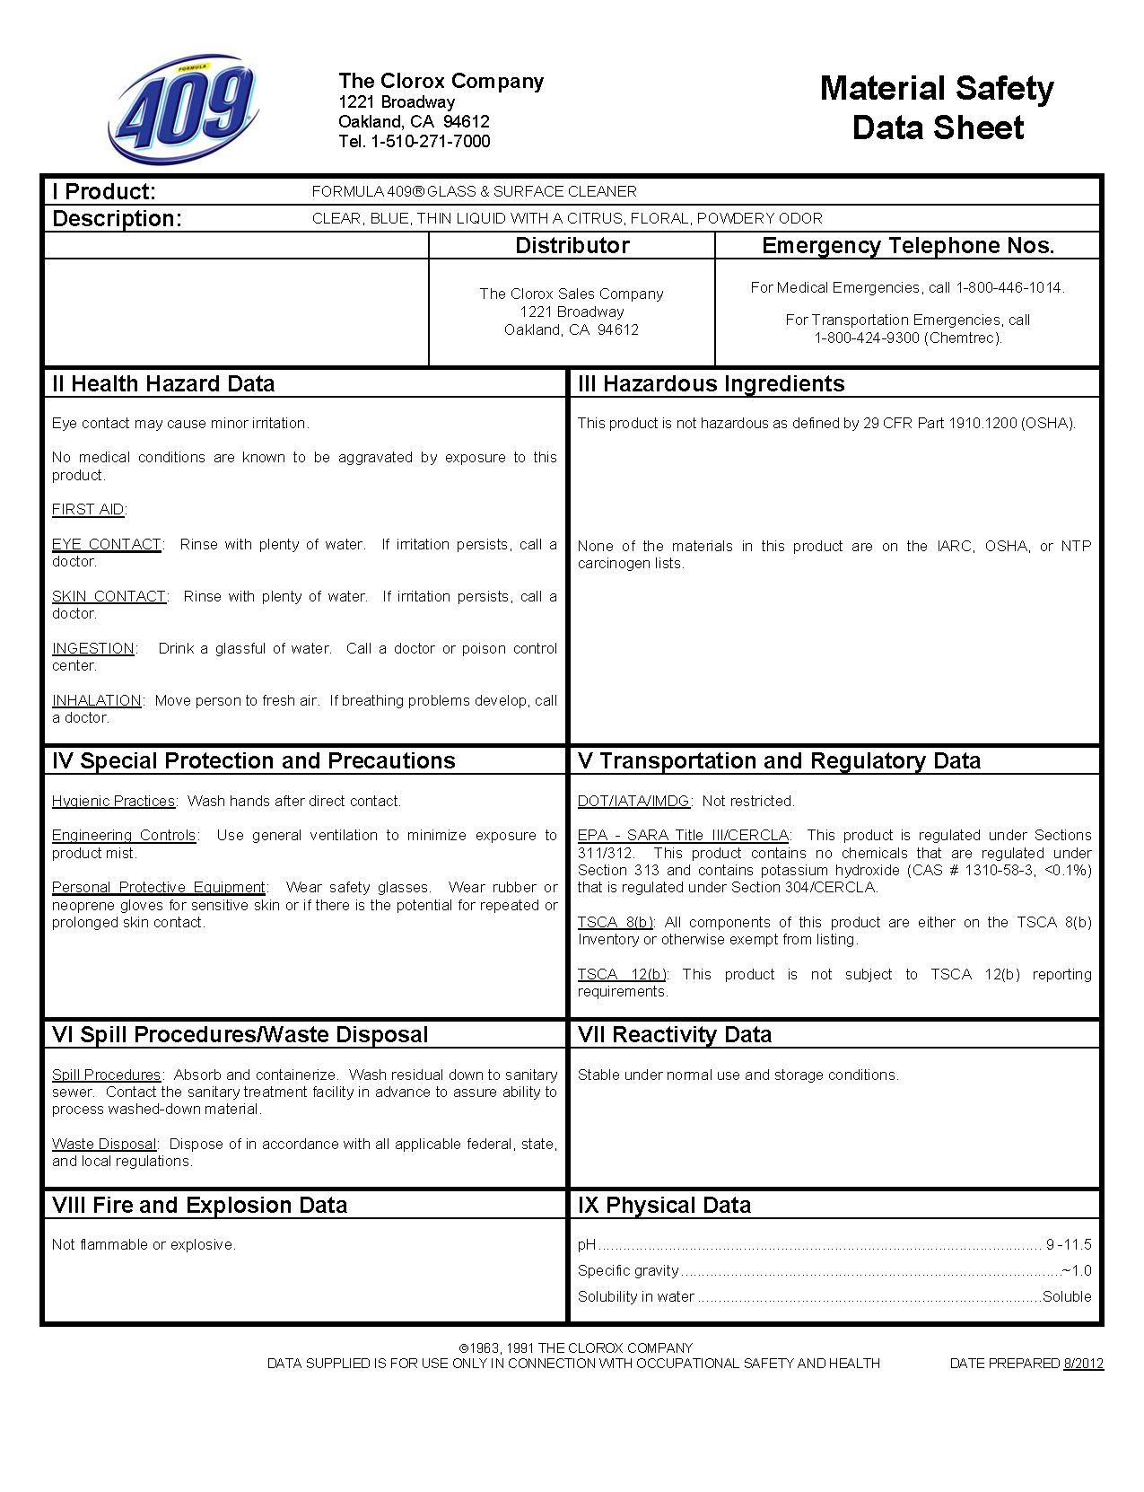

Work Sheet
Task 1: What is the product Name.
Answer:

Task 2: Who is the distributor for this product?
Answer:

Task 3: What is the purpose of the Health Hazard Data section?
Answer:

Task 4: What should the cleaner do if Formula 409 is accidentally swallowed?
Answer:

Task 5: What should the cleaner do if they are splashed by Formula 409?
Answer:

Task 6: List the recommended PPE (Personal Protective Equipment) items.
Answer:

Task 7: What should the cleaner do to minimize exposure to product mist?
Answer:

Task 8: Why would the cleaner use this product?
Answer:

Answer Key
Task 1: What is the product name.
Formula 409® glass & surface cleaner
Task 2: Who is the distributor for this product?
The Clorox Sales Company
Task 3: What is the purpose of the Health Hazard Data section?
It gives directions in case of injury or discomfort from exposure when using the product.
Task 4: What should the cleaner do if Formula 409 is accidentally swallowed?
Drink a glassful of water. Call a doctor or poison control centre.
Task 5: What should the cleaner do if they are splashed by Formula 409? Rinse with plenty of water. If irritation persists, call a doctor.
Task 6: What are the recommended PPE (Personal Protective Equipment) items?
Safety glasses; use gloves if you have sensitive skin.
Task 7: What should the cleaner do to minimize exposure to product mist? Use general ventilation to minimize exposure to product mist.
Task 8: Why would the cleaner use this product?
To clean glass and other surfaces.

Performance Descriptors 1
Levels | Performance Descriptors | Needs Work | Completes task with support from practitioner | Completes task independently
A2.1 | Scans to locate specific details
 | Requires support to identify sources and to evaluate and integrate information
A2.2 | Performs limited searches using one or two search criteria
 | Extracts information from tables and forms
 | Uses layout to locate information
 | Makes connections between parts of documents
 | Makes low-level inferences
 | Begins to identify sources and evaluate information
B2.1 | Writes simple texts to request, remind or inform
 | Conveys simple ideas and factual information
 | Demonstrates a limited understanding of sequence
 | Uses sentence structure, upper and lower case and basic punctuation
 | Uses highly familiar vocabulary

Performance Descriptors 2
This task: Was successfully completed Needs to be tried again

Learner Comments:

Instructor (print):

