Task Title: College Calendar

OALCF Cover Sheet – Practitioner Copy

Learner Name:
Date Started (m/d/yyyy):
Date Completed (m/d/yyyy):
Successful Completion: Yes No

Goal Path: | Employment | Apprenticeship
Secondary School | Post Secondary | Independence
Task Description: Use a college calendar to find information regarding various programs.
Competency: A: Find and Use Information
B: Communicate Ideas and Information

Task Groups: A1: Read Continuous Text
A2: Interpret Documents
B2: Write Continuous Text
B3: Complete Documents

Level Indicators:
- A1.1: Read brief texts to locate specific details
- A2.2: Interpret simple documents to locate and connect information
- B2.1: Write brief texts to convey simple ideas and factual information

Performance Descriptors: See chart on last page
Materials Required:
- Chart of Programs Offered 2011-2012
- Highlighter
- Pen or pencil or digital device

Learner Information
Persons considering post-secondary programs look over charts provided in college calendars to get a quick overview of programs offered by a particular college. Look at the Algonquin College 2011-12 Calendar.
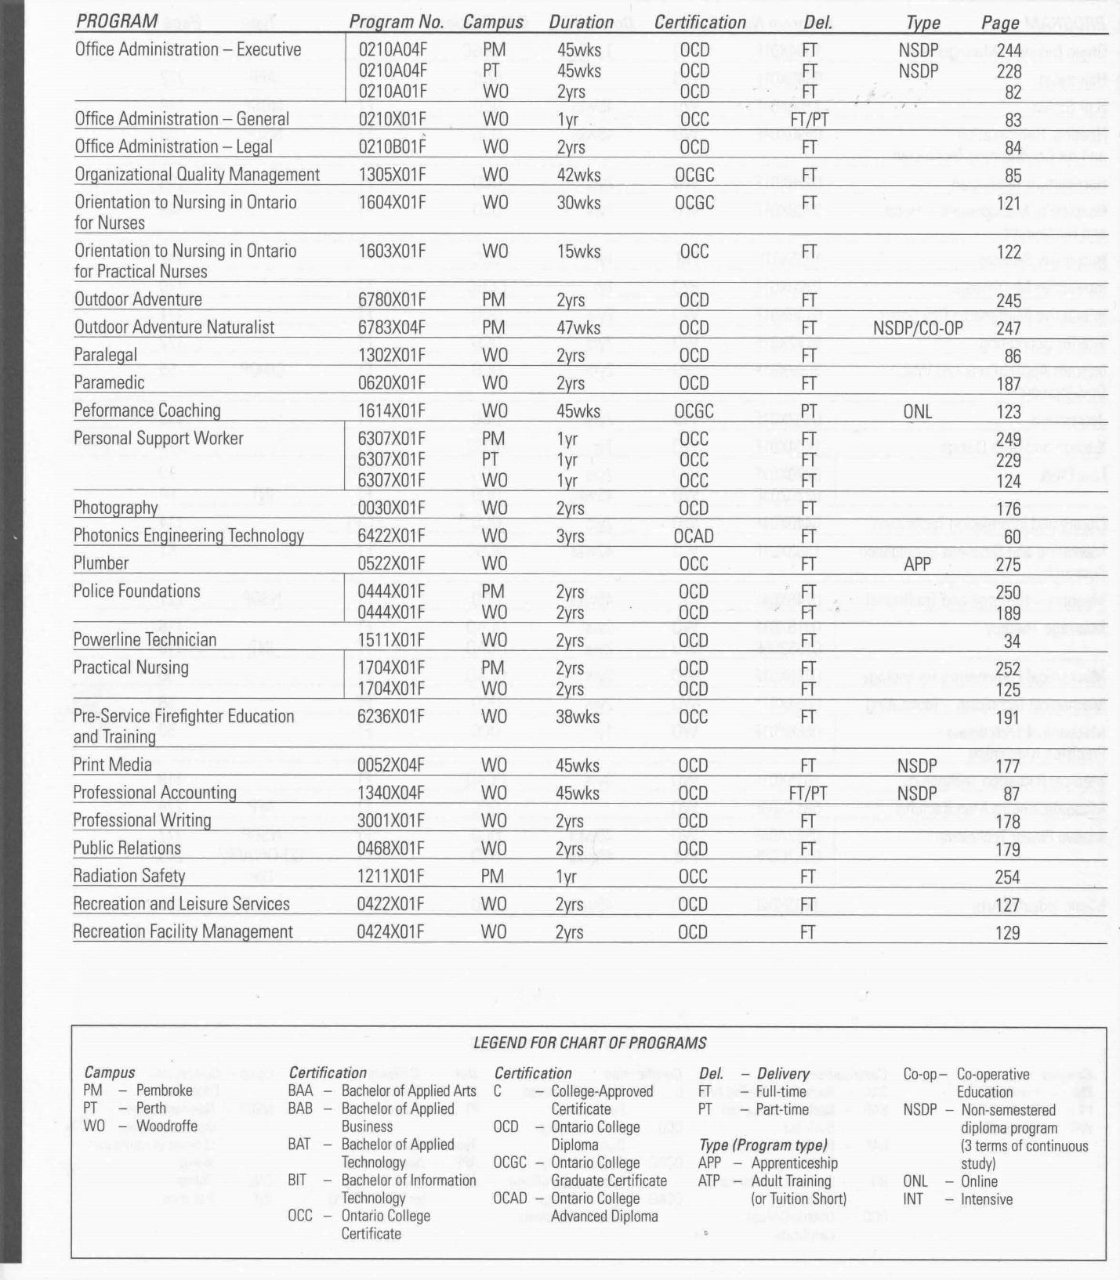
2011-2012 Calendar, p.12. Used by permission of Algonquin College

Work Sheet
Task 1: Mention the program number for the Print Media program.
Answer:

Task 2: What certification does the 2-year programs offer?
Answer:

Task 3: At how many different campuses does Algonquin College offer programs?
Answer:

Task 4: What programs are only offered at the Pembroke campus?
Answer:

Task 5: What are the differences between the Orientation to Nursing in Ontario for Nurses program and the Orientation to Nursing in Ontario for Practical Nurses program?
Answer:

Task 6: What would be the benefit of choosing to take the Executive Office Administration program at either the Pembroke or Perth campuses instead of at the Woodroffe campus?
Answer:

Task 7: Which program does not require attendance at any campus?
Answer:

Answer Key
Task 1: 0052X04F

Task 2: OCD or Ontario College Diploma

Task 3: Three (Pembroke, Perth, & Woodroffe)

Task 4: Outdoor Adventure, Outdoor Adventure Naturalist and Radiation Safety

Task 5:
Orientation to Nursing in Ontario for Nurses | Orientation to Nursing in Ontario for Practical Nurses
30 wks. | 15 wks.
OCGC | OCC

Task 6: One can complete it in less than a year (45 weeks). The program at Woodruff takes 2 years. Both give you an Ontario College Diploma.

Task 7: Performance Coaching (it’s online)

Performance Descriptors 1
Levels | Performance Descriptors | Needs Work | Completes task with support from practitioner | Completes task independently
A1.1 | Reads short texts to locate a single piece of information
 | Decodes words and makes meaning of sentences in a single text
 | Follows simple, straightforward instructional texts
A2.2 | Performs limited searches using one or two search criteria
 | Extracts information from tables and forms
 | Uses layout to locate information
 | Makes connections between parts of documents
 | Makes low-level inferences
B2.1 | Writes simple texts to request, remind or inform
 | Conveys simple ideas and factual information
 | Uses sentence structure, upper and lower case and basic punctuation
 | Uses highly familiar vocabulary

Performance Descriptors 2
This task: Was successfully completed Needs to be tried again

Learner Comments:

Instructor (print):

