

Task Title: Complaint Handling Policy

OALCF Cover Sheet – Practitioner Copy

Learner Name: __________________________________________
Date Started: ___________________________________________
Date Completed: _________________________________________
Goal Path: | Employment | Apprenticeship
Secondary School | Post Secondary | Independence
Successful Completion: Yes No

Task Description:
Use the College of Physiotherapists of Ontario – Complaints Process infographic to answer questions about how complaints are handled.
Main Competency/Task Group/Level Indicator
- Find and Use Information/Interpret documents/A2.2

Materials Required:
- Pen/pencil and paper or digital device

Learner Information
Complaints are handled differently by each workplace or organization. Understanding how complaints are investigated is important for protecting both customers and employees.
Scan the College of Physiotherapists of Ontario – Complaints Process infographic.

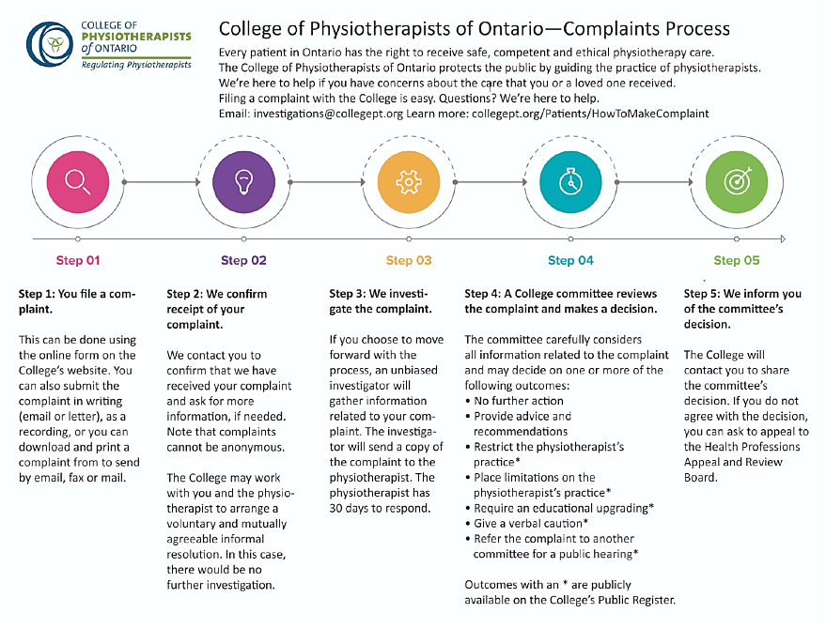

Work Sheet
Task 1: What are the five steps of complaint handling?
Answer:

______________________________________________________
Task 2: How long does a physiotherapist have to respond to a complaint that is being investigated?
Answer:

______________________________________________________
Task 3: What are two possible outcomes if the College committee reviews a complaint?
Answer:

______________________________________________________
Task 4: What can someone do if they do not agree with the committee’s decision?
Answer:

______________________________________________________

Answers
Task 1: What are the five steps of complaint handling?
Answer: Step 1: You file a complaint; Step 2: We confirm receipt of your complaint; Step 3: We investigate the complaint; Step 4: A College committee reviews the complaint and makes a decision; Step 5: We inform you of the committee’s decision.

Task 2: How long does a physiotherapist have to respond to a complaint that is being investigated?
Answer: 30 days.

Task 3: What are two possible outcomes if the College committee reviews a complaint?
Answer: Any two of the following:
- No further action
- Provide advice and recommendations
- Restrict the physiotherapist’s practice
- Place limitations on the physiotherapist’s practice
- Require an educational upgrading
- Give verbal caution
- Refer the complaint to another committee for a public hearing

Task 4: What can someone do if they do not agree with the committee’s decision?
Answer: If you do not agree with the decision, you can ask to appeal to the Health Professionals Appeal and Review board.

Performance Descriptors
Levels | Performance Descriptors | Needs Work | Completes task with support from practitioner | Completes task independently
A2.2 | uses layout to locate information
 | makes low-level inferences
 | makes connections between parts of documents

This task: Was successfully completed Needs to be tried again

Learner Comments:

Instructor (print): Learner (print):
_____________________ _____________________

