Task Title: Read microwave popcorn instructions Task-based Activity

Learner Name: ______________________ Date: _______________
Competency A: Find and Use Information
Task Group: A1 Read Continuous Text
Level Indicator: A1.1 Read brief texts to locate specific details

Milestone: #8
Milestone Name: Locate details on a product label

Successful: Yes □ No □
Goal Path: | □ Apprenticeship □ Employment □ Independence
 | □ Post-Secondary □ Secondary School Credit

Task Description: | Learner will locate information in the microwave popcorn product instructions
Notes:
Materials: | - Photocopy for student of microwave popcorn product information sheet  - Pencil or Pen
Supports Allowed: | Questions given in ASL (if needed). Enlarge the instruction and picture if needed for those who are Deaf-blind or have vision issues.

Instructor Notes:

ESKARGO (Skills Set):
- Reading Strategies- Decoding and Comprehension Enhancement

- Uses phonics and knowledge of word parts to decode words
- Develops list of sight words related to specific tasks
- Uses knowledge of basic grammar, predictable word patterns, and basic sentence structure in speech to understand phrases and sentences
- Uses knowledge of basic spelling conventions and simple punctuation to gather meaning from sentences
- Uses context cues and personal experience to gather meaning from the text
- Scans simple text to locate a single piece of information

- Forms and Conventions- Find Information/Research/Understand Types of Texts

- Reads text having familiar, everyday content
- Reads text with simple, concrete information in simple, familiar wording

- Comprehension- Read to Understand/Retell

- Reads signs, symbols and common sight words from everyday life

- Interpretation-Read and Apply Understanding

- Locates a single piece of information in short texts
- Follows simple, straightforward instructions

Task: Read the instructions on a bag of microwave popcorn to make a bag of popcorn

Instructions:
People who like to eat a bag of popped popcorn from a microwave may need to read instructions on a label or information sheet to learn how to make the product properly.
Look at the bag of microwave popcorn information.

- How long do you cook the popcorn in the microwave?
__________________________________________________

- Circle or highlight “This Side Up” on the microwave popcorn bag

- What can overcooking the popcorn cause?
___________________________________________________
- How do you open the popcorn bag after it has been cooked?
____________________________________________________
- Circle or highlight the phrase: “Children should not prepare without adult supervision”.

- Why do the directions “caution” the user about removing the bag and its contents from the microwave?
____________________________________________________
- For best results, what should you not do?
____________________________________________________
- Which part of the bag should you not handle?
____________________________________________________

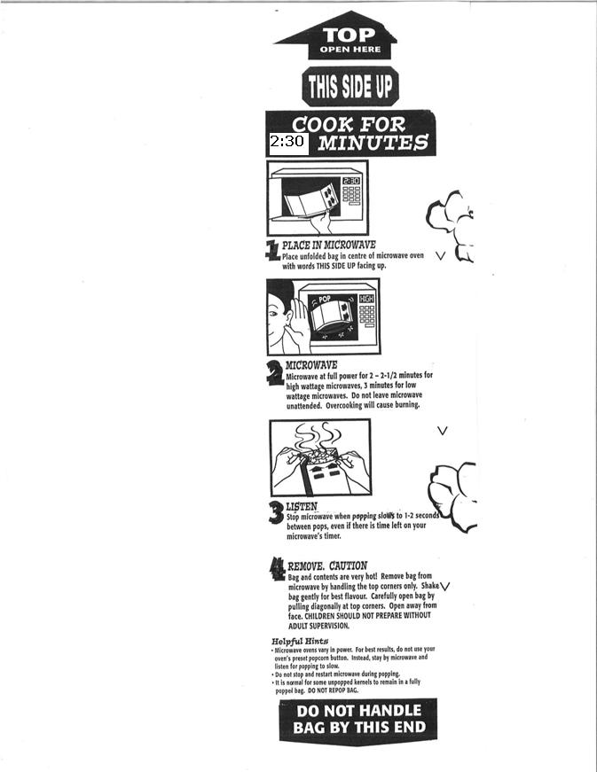

Answers:

- 2 to 2 ½ minutes
- This Side Up
- Popcorn burns
- Open it diagonally at top corners
- Children should not prepare without adult supervision
- The bag and contents are very hot
- Do not use your oven’s preset popcorn button
- The end of the bag

Passing grade: 7/8

Performance  Descriptors |  | Can’t do | Received help the from teacher | Can do independently
A1.1 | Reads short text to locate a single piece of information
 | Decodes words and makes meaning of sentences in a single text
 | Follow simple, straightforward instructional texts
 | Requires support to identify sources and to evaluate and integrate information

This task:
was successfully completed _____needs to be tried again_____
Learner Comments:

________________________ _______________________
Instructor (print) Learner Signature

