Practitioner submitted task: Prepared for the Project, Teaching to Fish (Build Tasks) Integrating OALCF Task Development within Ontario’s Literacy Programs (2014)

Task Title: Dealing with Complaints – Checklist for Staff

OALCF Cover Sheet – Practitioner Copy

Learner Name:
Date Started (m/d/yyyy):
Date Completed (m/d/yyyy):
Successful Completion: Yes ☐ No ☐
Goal Path: | Employment ☒ | Apprenticeship ☐
Secondary School ☐ | Post Secondary ☐ | Independence ☐
Task Description: Use a staff checklist for dealing with client complaints.
Competency: A: Find and Use Information
Task Groups: A1: Read continuous text
A2: Interpret documents
Level Indicators:
- A1.1: Read brief texts to locate specific details
- A1.2: Read texts to locate and connect ideas and information
- A2.1: Interpret very simple documents to locate specific details
Performance Descriptors: See chart on last page
Materials Required:
- “Dealing with complaints—checklist for staff” – attached
- Learner tasks – attached

Learner Information
In many workplaces employees must deal with customer complaints. Look at the “Dealing with complaints – checklist for staff.”
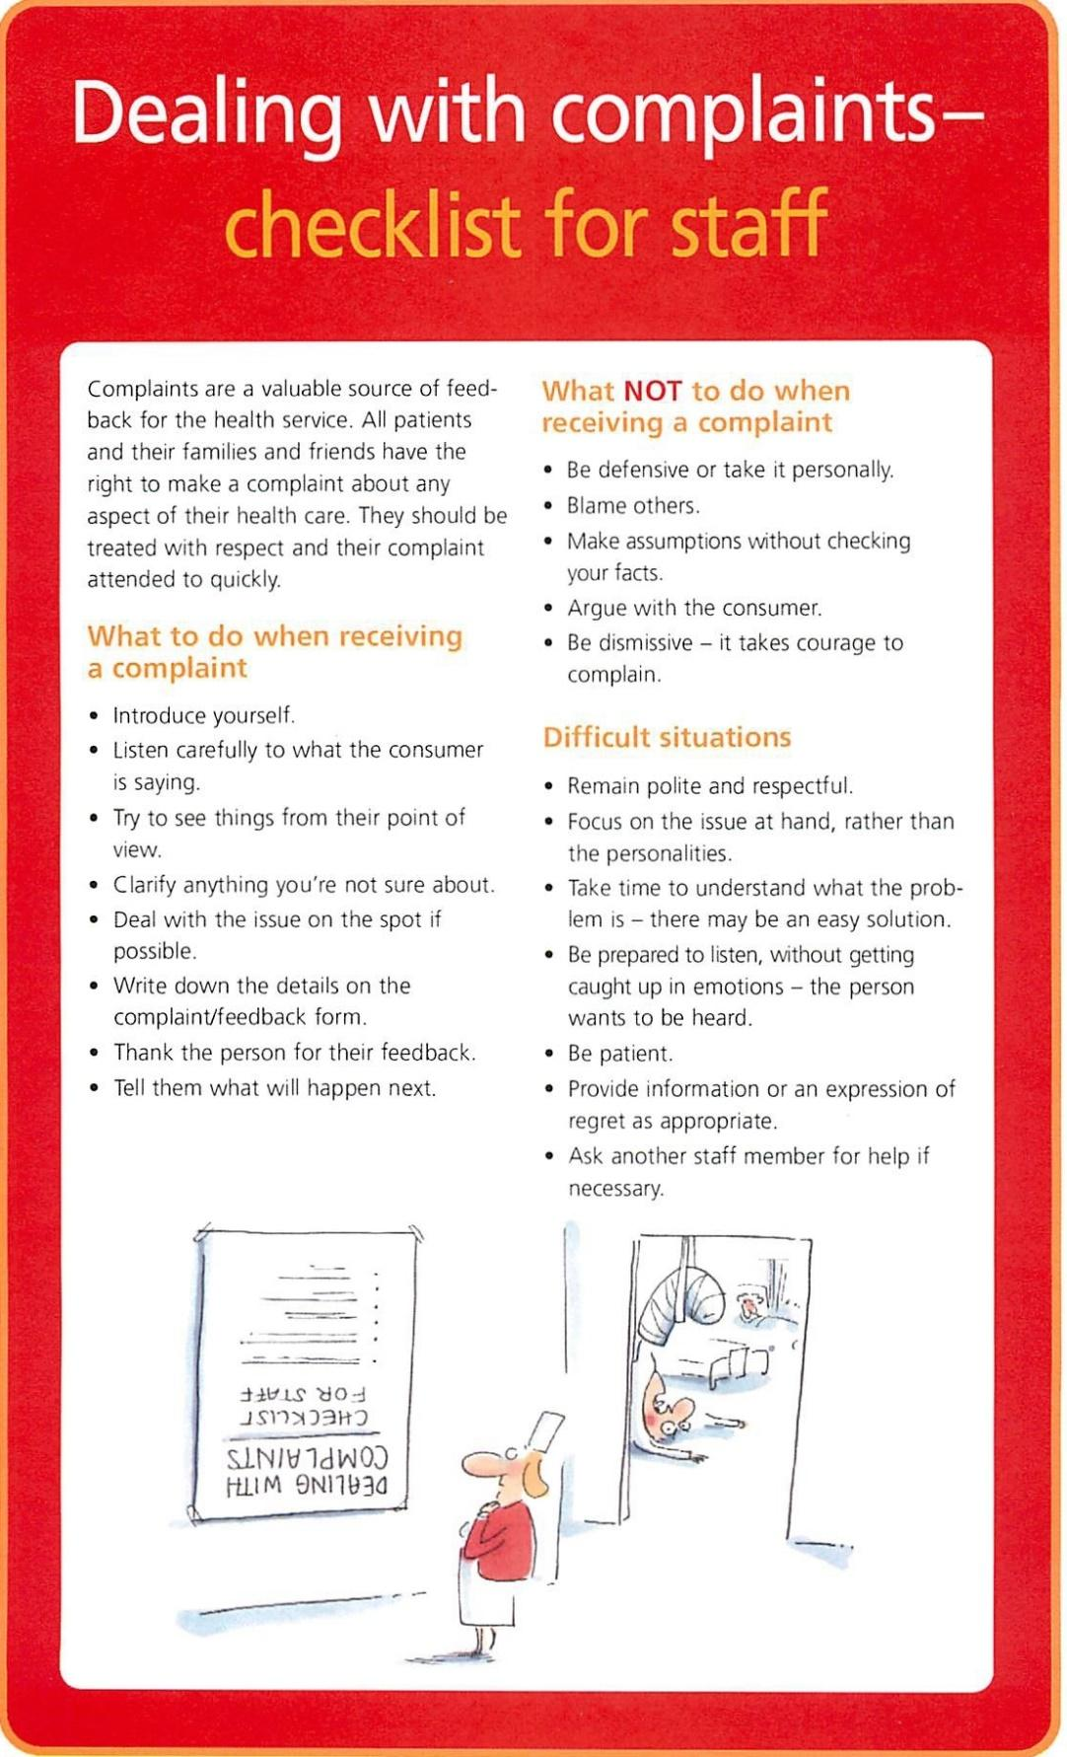

Work Sheet
Task 1: What are the three main categories for dealing with
customer complaints?
Answer:

Task 2: Who has the right to make a complaint about any aspect
of health care at this facility?
Answer:

Task 3: What are three things employees must NOT do when
receiving a complaint?
Answer:

Task 4: When an employee encounters a difficult situation, why is
it important to take time to understand what the problem
is?
Answer:

Task 5: Where should an employee write down the details of the
complaint?
Answer:

Answers
Task 1: What are the three main categories for dealing with customer complaints?
Answer: The three categories are:
- What to do when receiving a complaint
- What NOT to do when receiving a complaint
- Difficult situations.
Task 2: Who has the right to make a complaint about any aspect of
health care at this facility?
Answer: All patients and their families and friends have the right
to make a complaint about any aspect of their health
care.
Task 3: What are three things employees must NOT do when
receiving a complaint?
Any three of the following are acceptable:
- Be defensive or take it personally
- blame others
- make assumptions without checking your facts
- argue with the consumer
- be dismissive.
Task 4: When an employee encounters a difficult situation, why is it
important to take time to understand what the problem is?
Answer: It is important to take time to understand because there
may be an easy solution.
Task 5: Where should an employee write down the details of the complaint?
Answer: Write down the details on the complaint/feedback form.

Performance Descriptors
Levels | Performance Descriptors | Needs Work | Completes task with support from practitioner | Completes task independently
A1.1 | Reads short texts to locate a single piece of information
A1.1 | Decodes words and makes meaning of sentences in a single text
A1.1 | Follows simple, straightforward instructional texts
A2.1 | scans to locate specific details
A2.1 | identifies how lists are organized (e.g. sequential, chronological, alphabetical)
C1.1 | Adds, subtracts, multiplies and divides whole numbers and decimals
C1.1 | Recognizes values in number and word format
C1.1 | Identifies and performs required operation
C1.1 | Follows apparent steps to reach solutions
C1.1 | Interprets and represents costs using monetary symbols and decimals
C2.1 | Understands chronological order
C2.1 | Understands and uses common date format
C2.1 | Identifies and performs required operation

This task:
Was successfully completed ☐ Needs to be tried again ☐

Learner Comments:

Instructor (print): Learner Signature:

