

Task Title: Understanding a Delivery Manifest

OALCF Cover Sheet – Practitioner Copy

Learner Name:
Date Started:
Date Completed:
Goal Path: | Employment | Apprenticeship
Secondary School | Post Secondary | Independence
Successful Completion: Yes No

Task Description:
Learners will read to understand information contained on delivery manifests.

Main Competency/Task Group/Level Indicator:
- Find and Use Information/Interpret documents/A2.2
- Understand and Use Numbers/Manage data/C4.1

Materials Required:
- Access to a computer or other digital device (if preferred)
- Pen and paper (if preferred)

Learner Information
Delivery manifests are lists with details about a delivery or its contents that are used by delivery drivers. With the advance of technology, these manifests are often on handheld scanners but, in many cases, they are still printed as hard copies. Scan the Delivery Manifest.

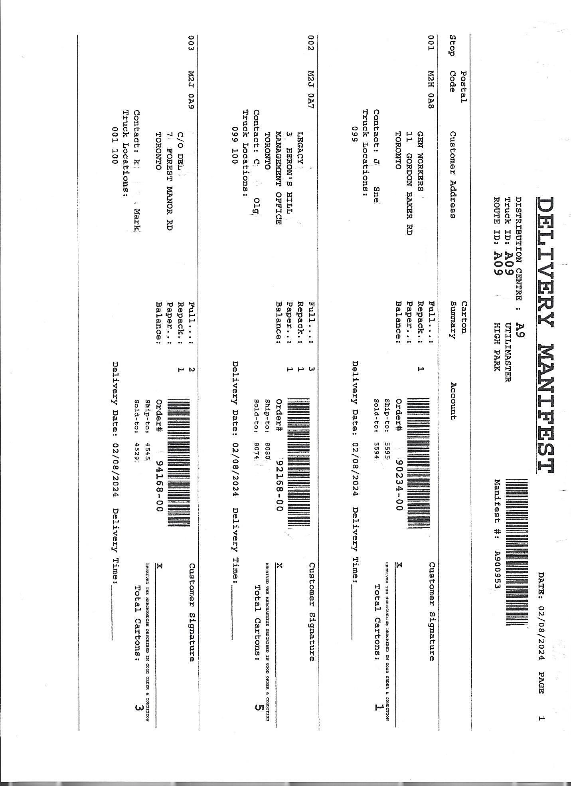

Work Sheet
Task 1: List five pieces of information that are included in this delivery manifest.
Answer:

Task 2: What is the name of the contact person at the second stop?
Answer:

Task 3: How many cartons in total are on the delivery manifest?
Answer:

Task 4: What is the city this delivery driver is delivering to?
Answer:
Task 5: What is the order number of the 3rd delivery?
Answer:

Answers
Task 1: List five pieces of information that are included in this delivery manifest.
Answer: Any five of the following:

- Date manifest was printed
- Page number of manifest
- Distribution Centre number
- Truck ID number and name
- Manifest number
- Route ID number and name
- Number of stops
- Postal code
- Customer address
- Contact person’s name
- Carton summary
- Account Information
  - Order #
  - Ship to account #
  - Sold to account #
- Delivery date
- Delivery time
- Customer Signature
- Total number of cartons
- Truck locations
- Scanner codes

Task 2: What is the name of the contact person at the second stop?
Answer: C Olg
Task 3: How many cartons in total are on the delivery manifest?
Answer: 9
Task 4: What is the city this delivery driver is delivering to?
Answer: Toronto
Task 5: What is the order number of the 3rd delivery?
Answer: 94168-00

Performance Descriptors
Levels | Performance Descriptors | Needs Work | Completes task with support from practitioner | Completes task independently
A2.2 | Performs limited searches using one or two search criteria
A2.2 | Extracts information from tables and forms
C4.1 | Adds, subtracts, multiplies, and divides whole numbers and decimals

This task: Was successfully completed Needs to be tried again

Learner Comments:

Instructor (print): Learner (print):

