

Task Title: Dietary Aide Menu Planning

OALCF Cover Sheet – Practitioner Copy

Learner Name:
Date Started:
Date Completed:
Goal Path: | Employment | Apprenticeship
Secondary School | Post Secondary | Independence
Successful Completion: Yes No

Task Description:
Read Canada’s Food Guide and Considerations to understand how to plan a healthy menu.
Main Competency/Task Group/Level Indicator:
- Find and Use Information/Read continuous text/A1.2
- Find and Use Information/Interpret documents/A2.1
- Understand and Use Numbers/Use measures/C3.1
Materials Required:
- Pen and Paper and/or digital device

Learner Information
Dietary Aides or Dietary Assistants, work to ensure patients staying in a healthcare facility maintain a healthy diet. Scan Canada’s Food Guide and Considerations.
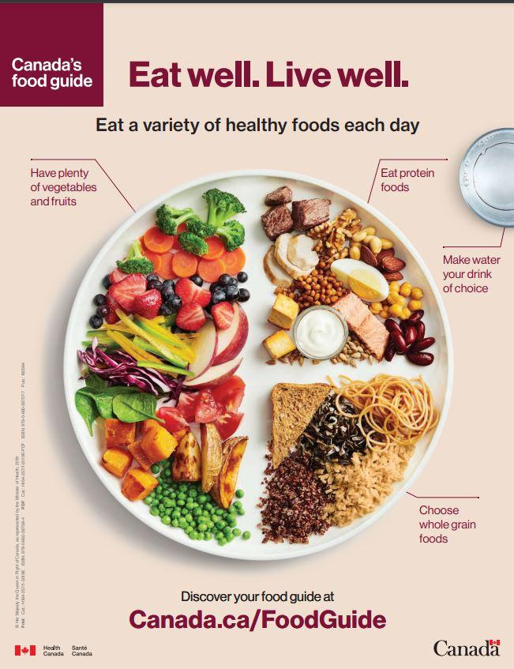

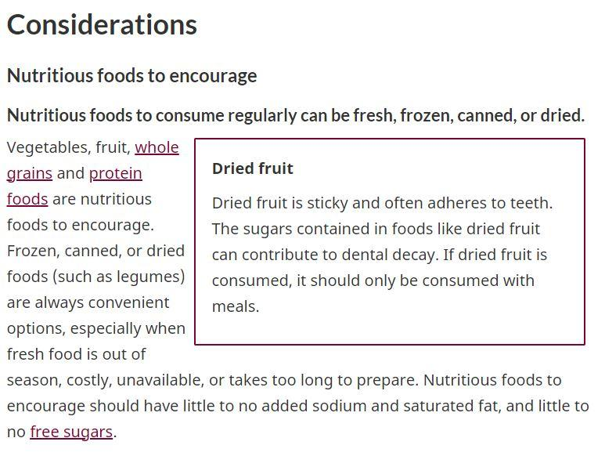

Work Sheet
Task 1: What fraction of a plate should be fruits and vegetables?
Answer:

Task 2: What fraction of a plate should be protein foods?
Answer:

Task 3: List two situations when it is good to choose frozen, canned, or dried foods instead of fresh.
Answer:

Task 4: List three ingredients that nutritious foods should not contain or contain little of.
Answer:

Task 5: Which liquid should people drink?
Answer:

Answers
Task 1: What fraction of a plate should be fruits and vegetables? (C3.1)
Answer: ½

Task 2: What fraction of a plate should be protein foods? (C3.1)
Answer: ¼

Task 3: List two situations when it is good to choose frozen, canned, or dried foods instead of fresh. (A1.2)
Answer: Any 2 of the following:
- When fresh food is out of season
- When fresh food is costly
- When fresh food is unavailable
- When preparing fresh food takes too long

Task 4: List three ingredients that nutritious foods should not contain or contain little of. (A1.2)
Answer: added sodium, saturated fats, and free sugars.

Task 5: Which liquid should people drink? (A2.1)
Answer: water should be the drink of choice

Performance Descriptors
Levels | Performance Descriptors | Needs Work | Completes task with support from practitioner | Completes task independently
A1.2 | Scans text to locate information
A1.2 | Locates multiple pieces of information simple texts
A1.2 | Makes low-level inferences
A2.1 | Scans to locate specific details
A2.1 | Locates specific details in simple documents such as labels and signs.
C3.1 | Interprets and represents measures using whole numbers, decimals, and simple, common fractions (e.g. ½, ¼)

This task: Was successfully completed Needs to be tried again

Learner Comments:

Instructor (print): Learner (print):

