**Task-based Activity Cover Sheet**

**Task Title:** Diluting a Cleaning Product Using a Ratio

|  |  |
| --- | --- |
| **Learner Name:** | |
| **Date Started: Date Completed:**  **Successful Completion:** Yes___ No___ | |
| **Goal Path:** Employment **✓** Apprenticeship **✓** Secondary School Post Secondary Independence **✓** | |
| **Task Description:**  The learner will use ratio and proportion to calculate mixtures and final products. | |
| **Competency:**  C: Understand and Use Numbers | **Task Group(s):**  C3:Use Measures |
| **Level Indicators:**  C3.2: Use measures to make one-step calculations | |
| **Performance Descriptors:** see chart on last page or click here. | |
| **Links to skill building activities:** see the last page or click here. | |
| **Materials Required:**   * Paper and pen * Calculator * Question sheet (attached) * Answer sheet (attached) | |
| **ESKARGO:**   * Uses common standard units (metres, inches) and non-standard units (e.g. paces, cupfuls, scoops) * Interprets and represents measures using symbols and abbreviations (e.g., inches as “,   centimetres as cm., pounds as lbs., kilograms as kilos or kg.)   * Rounds decimals * Adds, subtracts, multiples and divides multi-digit whole numbers and decimals * Understands and uses ratio and proportion   **Attitudes:**  Practitioner,  We encourage you to talk with the learner about attitudes required to complete this task set. The context of the task has to be considered when identifying attitudes. With your learner, please check one of the following:  □ Attitude is not important □ Attitude is somewhat important □ Attitude is very important | |

**Task Title:** Diluting a Cleaning Product Using a Ratio

Cleaners use products that need to be mixed using ratio and proportion. Look at the AllChem Glass Cleaner Concentrate label.

**Learner Information and Tasks:**

**Task 1:** Calculate how much water is required to dilute 250 mL of AllChem Glass Cleaner concentrate?

**Task 2:** Calculate how much AllChem Glass Cleaner concentrate is required if 1.45L of water is used?

**Task 3:** Calculate how much undiluted AllChem Glass Cleaner is needed to fill a 500 mL spray bottle with mixed solution?

**Task 4:** If 1000 mL of AllChem Glass Cleaner concentrate is used, calculate how much solution (water and cleaner) is made?

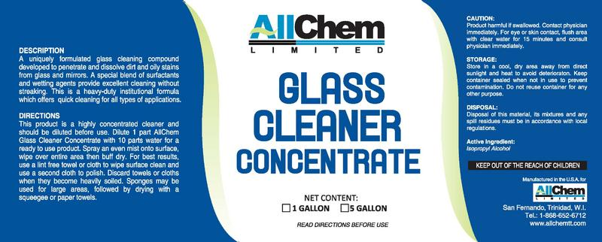

**Task Title:** Diluting a Cleaning Product Using a Ratio

**Answer Key**

**Task 1:** How much water is required to dilute 250 mL of AllChem Glass Cleaner Concentrate?

  x = **2500 mL of water is needed**

**Task 2:** How much AllChem Glass Cleaner concentrate is required if 1.45L of water is used?

  x=**0.145 L of AllChem Glass Cleaner is required.**

**Task 3:** How much undiluted AllChem Glass Cleaner is needed to fill a 500 mL spray bottle with mixed solution?

  x= ** mL of concentrate is required**

**Task 4:** If 1000mL of AllChem Glass Cleaner concentrate is used, how much solution (water and cleaner) is made?

  x=**11000 mL of mixed solution is made**

**Task Title:** Diluting a Cleaning Product Using a Ratio

|  |  |  |  |  |
| --- | --- | --- | --- | --- |
| **Performance Descriptors** | | **Needs Work** | **Completes task with support from practitioner** | **Completes task independently** |
| C3.2 | * calculates using numbers expressed as whole numbers, fractions, decimals, percentages and integers |  |  |  |
|  | * understands and uses ratio and proportion |  |  |  |
|  | * interprets and applies rates (e.g. km/hr) and ratios (e.g. map scales) |  |  |  |

**This task:** was successfully completed___ needs to be tried again___

|  |
| --- |
| **Learner Comments** |
|  |

**____________________________ _________________________**

**Instructor (print) Learner Signature**

**Skill Building Activities**

**Links to Online Resources:**

<http://www.mathtv.com/> - Ratios and Proportions

<https://www.khanacademy.org/math/cc-sixth-grade-math/cc-6th-ratios-prop-topic/cc-6th-ratio-word-problems/e/ratio_word_problems> - Practice questions on ratio

<https://www.khanacademy.org/math/pre-algebra/rates-and-ratios/ratios_and_proportions>

* 9 videos on rates and ratio, given in sequence

<http://www.bbc.co.uk/skillswise/factsheet/jo04clea-l1-f-using-ratios> - How to work out correct ratios for cleaning products

<http://www.housekeepingchannel.com/hcp_365-Dilution> - Dilution ratios, what do they mean?

**LearningHUB online courses available:**

* **Math, Independent Study (Assigned by practitioner after assessment)**
  + Data Analysis Assignment
* **Live Classes (SABA)** – Fractions in Everyday Life, GED Math Word Problems

**\*To access LearningHUB courses**, learners must register for the LearningHUB e-Channel program by completing the registration form on their website and completing the course selection (page 2 of the registration form): <https://www.learninghub.ca/get_registered.aspx>

**\*To Access LearningHUB Course Catalogue:**

<http://www.learninghub.ca/Files/PDF-files/HUBcoursecatalogue,%20December%2023,%202014%20revision.pdf>