Task Title: Finding Health Information on the Internet

OALCF Cover Sheet – Practitioner Copy

Learner Name:
Date Started (m/d/yyyy):
Date Completed (m/d/yyyy):
Successful Completion: Yes No
Goal Path: | Employment | Apprenticeship
Secondary School | Post Secondary | Independence
Task Description:
Learners will read about finding health information on the Internet.
Competency: A Find and Use Information
B Communicate Ideas and Information

Task Groups: A1 Read continuous text
B2 Write continuous text

Level Indicators:
- A1.2: Read texts to locate and connect ideas and information
- B2.1: Write brief texts to convey simple ideas and factual information

Performance Descriptors: See chart on last page
Materials Required:
- Evaluating Health Information Online handout
- Learner Information and Task sheet
- Pen and/or digital device

Learner Information

Many people today take an active role in managing their health by learning about health and disease on the Internet. Here is some sound advice on finding information you can trust.
Look at the handout “Health Information on the Internet” below:
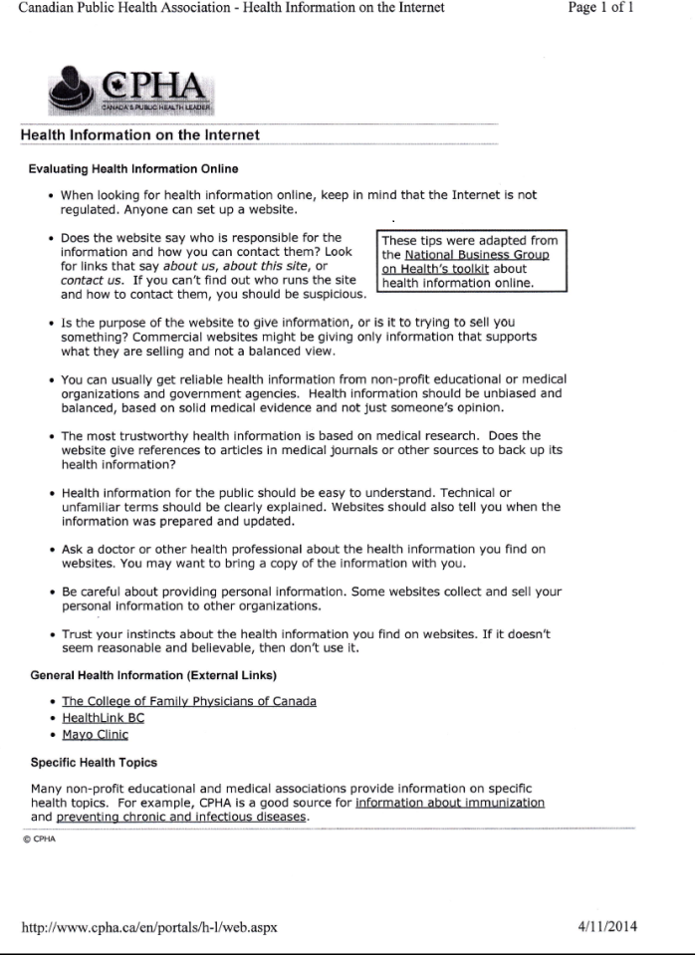

Work Sheet
Task 1: Who is allowed to put health information on the Internet?
Answer:

Task 2: You should be suspicious if …………………
Answer:

Task 3: Why might a commercial website not give balanced information?
Answer:

Task 4: Where can you usually get health information you can rely on?
Answer:

Task 5: What is the most trustworthy health information based on?
Answer:

Task 6: Why is the date that the information was prepared important?
Answer:

Task 7: Before you take any advice you find on a medical website, what would it be wise to do?
Answer:

Task 8: Some websites collect information from you. Why would it be wise not to give it to them?
Answer:

Task 9: If I found some health information and it just didn’t seem believable, you should tell me to ……………………….
Answer:

Answer Key
In addition to reading and writing skills, Tasks 3, 6 and 8 are also opportunities to demonstrate critical thinking.

Task 1: Anyone
Task 2: if you can’t find out who runs the site or how to contact them.
Task 3: It might be trying to sell you something
Task 4: Non-profit educational or medical organizations and government agencies
Task 5: Medical research
Task 6: Medical knowledge is continually changing (or any logical answer)
Task 7: Ask a doctor or other health professional about it.
Task 8: Any logical answer such as: they might use it to steal my identity, they might sell it to someone else who will use it to steal my identity, my privacy will be invaded, I will no longer have control over my private information, they might start hounding me to sell me something...
Task 9: trust my instinct

Performance Descriptors 1
Levels | Performance Descriptors | Needs Work | Completes task with support from practitioner | Completes task independently
A1.2 | Scans text to locate information
 | Locates multiple pieces of information in simple texts
 | Makes low-level inferences
 | Makes connections between sentences and between paragraphs in a single text
 | Obtains information from detailed reading
B2.1 | Conveys simple ideas and factual information

Performance Descriptors 2
This task: Was successfully completed Needs to be tried again
Learner Comments:

Instructor (print):

