OALCF Task Cover Sheet
Task Title: Finding Information Tasks
Learner Name:

Date Started: Date Completed:

Successful Completion: Yes___ No___
Goal Path: Employment ___ Apprenticeship Secondary School Post Secondary Independence___
Task Description:
Electricians interpret diagrams and read tables to plan work and complete tasks.
Competency:  A: Find and Use Information | Task Group(s):  A2: Interpret documents
Level Indicators:
A2.1: Interpret very simple documents to locate specific details
A2.2: Interpret simple documents to locate and connect information
A2.3: Interpret somewhat complex documents to connect, evaluate, and integrate information

Performance Descriptors: see chart on last page
Materials Required:
- Pencil
- Cable Chart
- Electrical Schematic
- Hot Water Tank label

Task Title: Finding Information Tasks
Electricians interpret diagrams and read tables to plan work and gather supplies. Use the Cable Chart, Electrical Schematic and Hot Water Tank label to complete the following tasks.

Wires are encased in a cable.

Learner Information and Tasks:
Task 1: Look at the Hot Water Tank label. Circle, underline, or highlight the upper allowable wattage rating.

Task 2: Review the Electrical Schematic. How many wires are required for the thermostat to function?
_________________________
Task 3: Refer to the Cable Chart to determine the minimum requirements for the following tasks. Identify the cable by its code.
- The cable to supply a dryer. ______________
- The cable to provide 100 amp service to a home. ________________
- The 3-wire cable that is required to connect 2 switches (one on main floor and the other on the second) to a light over the stairs. _________

Electrical Schematic
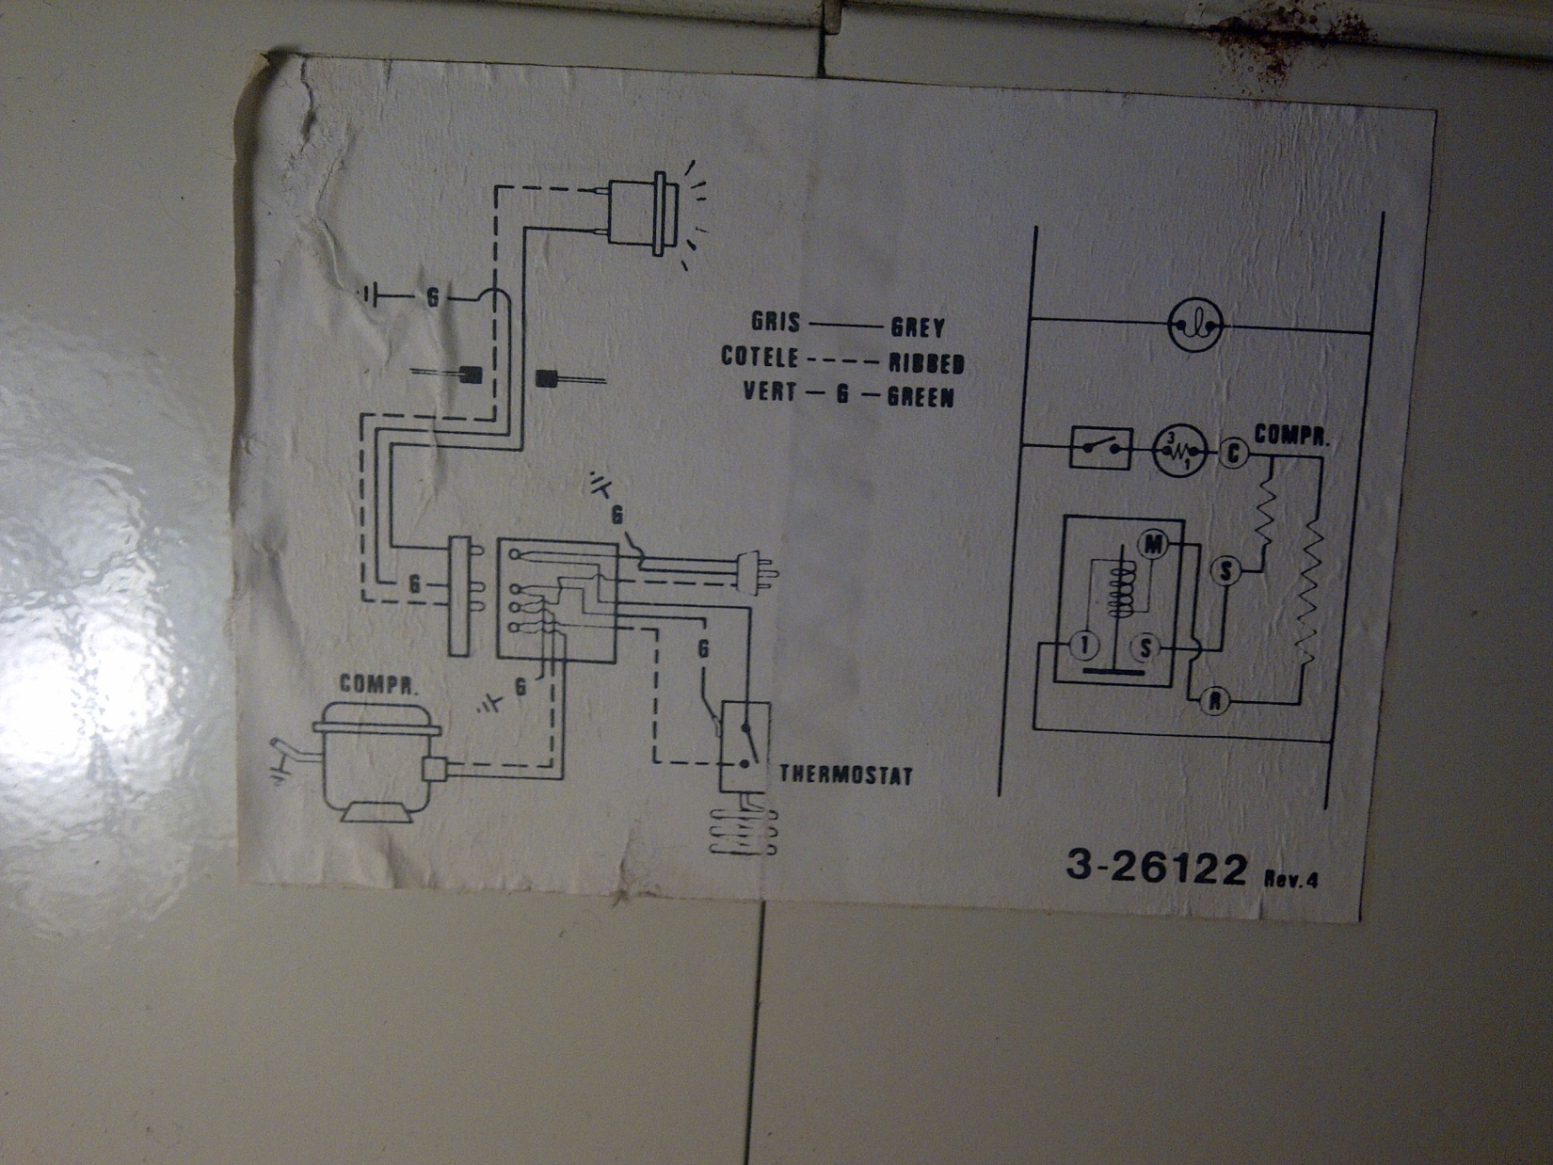

Hot Water Tank
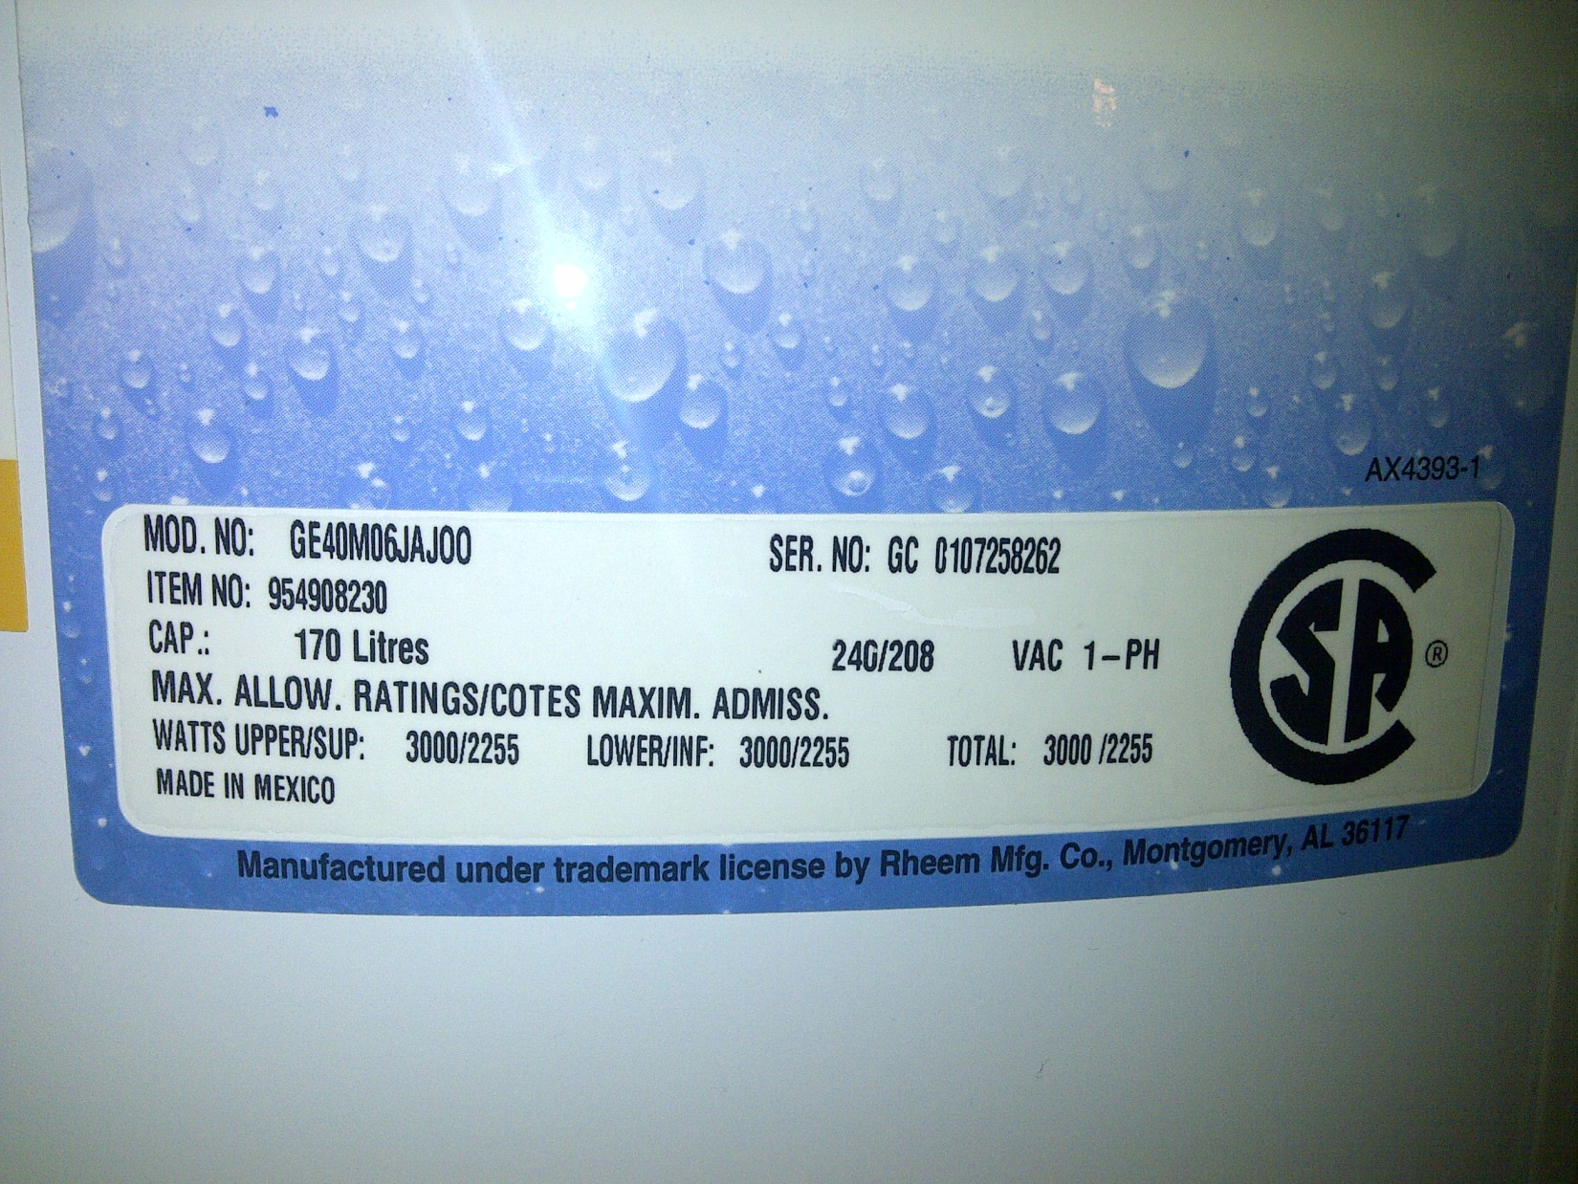

Cable Chart

Code | No. of Wires | Uses
#14-2 | 2 w/gnd | general lighting and receptacles
#14-3 | 3 w/gnd | 3-way switches, split receptacles
#12-2 | 2 w/gnd | kitchen and bath circuits
#12-3 | 3 w/gnd | 3-way switches on 20 amp services
#10-3 | 3 w/gnd | Dryers, cook top ovens
#4 |  | 70 amp services, 100 amp neutral conductor
#2 |  | main conductor for 100 amp services

Code: Gauge – number of wires. For example, #14-2 means 2 14 gauge wires.
Note: w/gnd means ‘with ground wire’. In these cases, the ground wire is not included in the wire count

Task Title: Finding Information Tasks
Answer Key
Task 1: 3000/2225
Task 2: 3
Task 3: A) #10-3
B) #2
C) #14-3

Task Title: Finding Information Tasks
Performance Descriptors |  | Needs Work | Completes task with support from practitioner | Completes task independently
A2.1 | - scans to locate specific details
 | - interprets brief text and common symbols
 | - locates specific details in simple documents, such as labels and signs
A2.2 | - performs limited searches using one or two search criteria
 | - extracts information from tables and forms
 | - uses layout to locate information
 | - makes low-level inferences
A2.3 | - performs complex searches using multiple search criteria
 | - integrates several pieces of information from documents
 | - uses layout to locate information
 | - makes inferences and draws conclusions from information displays

This task: was successfully completed___ needs to be tried again___

Learner Comments

____________________________ _________________________

Instructor (print) Learner Signature

