OALCF Task Cover Sheet
Task Title: Follow instructions to make a cake from a cake mix
Learner Name:

Date Started: Date Completed:

Successful Completion: Yes___ No___
Goal Path: Employment ✓ Apprenticeship___ Secondary School___ Post Secondary___ Independence ✓
Task Description: Learner will read and follow instructions for a cake-mix.
Competency:.  A. Find and Use Information.  B. Communicate Ideas and Information  C. Understand and Use Numbers | Task Group(s):  A1 Read continuous text  A2 Interpret documents  B1 Interact with others  B2 Write continuous text  C2 Manage Time  C3 Use Measures
Level Indicators:
A1.1: Read brief texts to locate specific details
A2.1: Interpret very simple documents to locate specific details
B1.1: Participate in brief interactions to exchange information with one other person
B2.1: Write brief texts to convey simple ideas and factual information
C2.1: Measure time and make simple comparisons and calculations
C3.1: Measure and make simple comparisons and calculations

Performance Descriptors: see chart on last page
Materials Required:
- Cake mix instructions (attached)
- Measuring cups, measuring spoons
- Cake pan
- Kitchen timer
- Oven

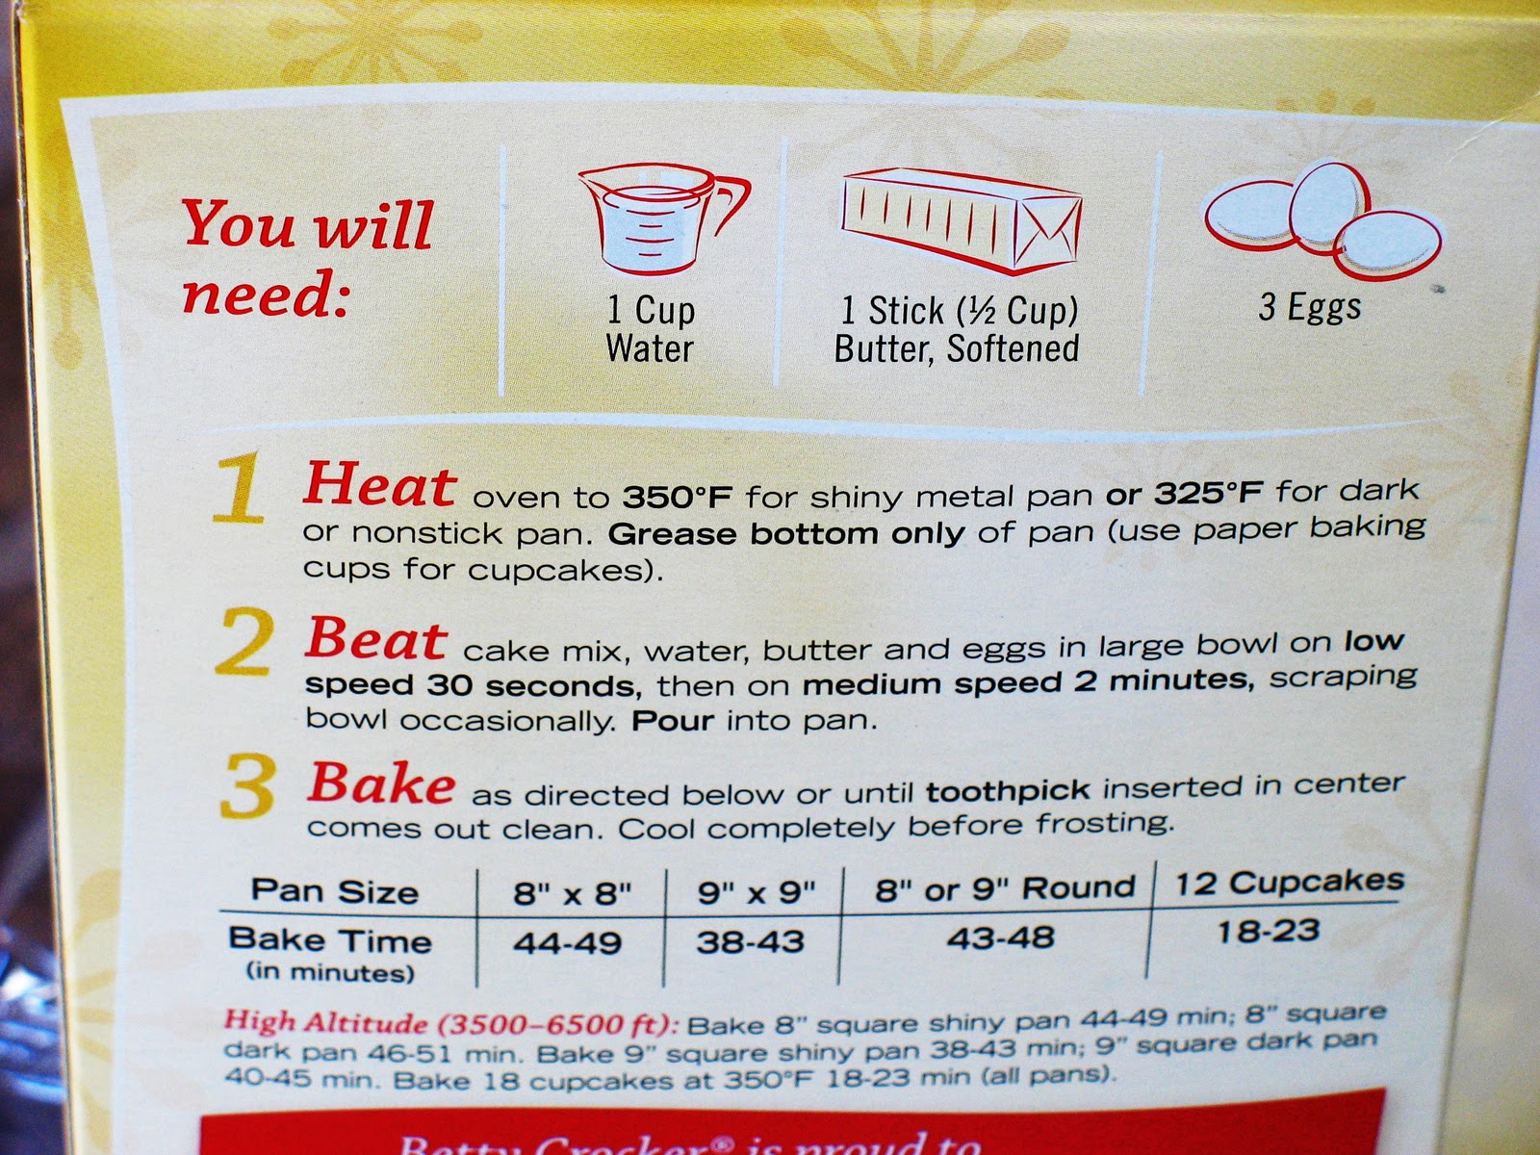
Task Title: Follow instructions to make a cake from a cake mix

You are baking a cake for a friend’s birthday party. You will be using a cake mix.

Task 1: Look at the cake mix and read the instructions for baking the cake out loud.

Answer these questions about the cake instructions:

Task 2: What three ingredients will you need to make the cake along with the cake mix?

Task 3: What part of the cake pan should you grease?

Task 4: How many cupcakes can you make with this cake mix?

Task 5: What temperature should you set your oven to if you are using a non-stick pan?

Task 6: If the cupcakes only take 18 minutes to cook, what time will the cupcakes be ready if it is 3:30p.m when they go into the oven?

Complete the following activities using the items supplied by your instructor:

Task 7: Show which measuring item you would use to measure the water.

Task 8: Show how far you would fill the measuring item with the water to follow the instructions on the cake mix.

Task 9: Set the timer for the amount of time you would mix the cake batter at medium speed.

Task 10: Measure the length and width of the cake pan. Determine how long you should bake the cake and set the timer for that amount of time.

Task 11: Explain (orally) in your own words how to make the cake.

Task Title: Follow instructions to make a cake from a cake mix
Answer Key

Task 2: What three ingredients will you need to make the cake along with the cake mix?
- Water
- Butter
- Eggs

Task 3: What part of the cake pan should you grease? Bottom only

Task 4: How many cupcakes can you make with this cake mix? 12

Task 5: What temperature should you set your oven to if you are using a non-stick pan? 325⁰ F

Task 6: If the cupcakes only take 18 minutes to cook, what time will the cupcakes be ready if it is 3:30p.m when they go into the oven? 3:48 p.m.

Task Title: Follow instructions to make a cake from a cake mix
Performance Descriptors |  | Needs Work | Completes task with support from practitioner | Completes task independently
A1.1 | - Reads short texts to locate a single piece of information
 | - Decodes words and makes meaning of sentences in a single text
 | - Follows simple, straightforward instructional texts
A2.1 | - Scans to locate specific details
 | - Interprets brief text and common symbols
 | - Identifies how lists are organized
B1.1 | - Chooses appropriate language in exchanges with clearly defined purposes
 | - Gives short, straightforward instructions or directions
 | - Speaks or signs clearly in a focused and organized way
B2.1 | - Writes simple texts to request, remind or inform
 | - Uses sentence structure, upper and lower case and basic punctuation
 | - Uses highly familiar vocabulary
C2.1 | - Identifies and performs required operation
 | - Measures time using common instruments, such as clocks, timers and stopwatches
 | - Interprets and represents time using whole numbers, decimals (e.g. .25, .5) and simple common fractions (e.g. ½, ¼ hour)
C3.1 | - Measures length, width, liquid volume and temperature
 | - Uses common measuring tools
 | - Understands numerical order
 | - Begins to interpret integers (e.g. temperature, elevation)
 | - Identifies and performs required operation
 | - Interprets and represents measures using whole numbers, decimals and simple, common fractions (e.g. ¼ ½)

This task: was successfully completed___ needs to be tried again___

Learner Comments

____________________________ _________________________

Instructor (print) Learner Signature

