

Task Title: Heat-Related Illnesses Infographic

OALCF Cover Sheet – Practitioner Copy

Learner Name:
Date Started:
Date Completed:
Goal Path: | Employment | Apprenticeship
Secondary School | Post Secondary | Independence
Successful Completion: Yes No

Task Description:
Read an infographic to stay informed about the symptoms of heat-related illnesses.

Main Competency/Task Group/Level Indicator:
- Find and Use Information/Interpret documents/A2.1-A2.2

Materials Required:
- Pencil/pen and paper and/or computer/digital device

Learner Information
Many jobs require workers to work outside throughout the year. During the summer months it is important for workers to be aware of heat-related illnesses. Staying informed about the symptoms of heat-related illness can prevent possible heat exhaustion and heat stroke. Scan the Heat-Related Illness infographic.
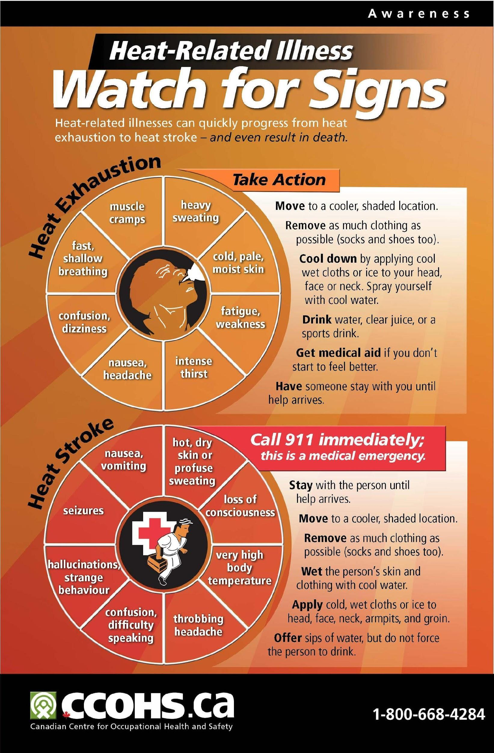

Work Sheet
Task 1: How can heat-related illnesses quickly progress?
Answer:

Task 2: Identify 4 symptoms of heat exhaustion.
Answer:

Task 3: Identify 3 actions to take if someone is experiencing heat exhaustion.
Answer:

Task 4: Identify 4 symptoms of a heat stroke.
Answer:

Task 5: Identify 3 actions to take if someone is experiencing heat stroke.
Answer:

Task 6: Which symptoms are the same for heat exhaustion and heat stroke?
Answer:

Answers
Task 1: How can heat-related illnesses quickly progress?
Answer: Heat-related illnesses can progress from heat exhaustion to a heat stroke and even death.
Task 2: Identify 4 symptoms of heat exhaustion.
Answer: Any 4 of the following:
- Heavy sweating
- Cold, pale, moist skin
- Fatigue, weakness
- Intense thirst
- Nausea, headache
- Confusion, dizziness
- Fast shallow breathing
- Muscle cramps
Task 3: Identify 3 actions to take if someone is experiencing heat exhaustion.
Answer: Any 3 of the following:
- Move to a cooler, shaded location.
- Remove as much clothing as possible (socks and shoes too).
- Cool down by applying cool wet cloths or ice to your head, face or neck. Spray yourself with cool water.
- Drink water, clear juice, or a sports drink.
- Get medical aid if you don’t start to feel better.
- Have someone stay with you until help arrives.
Task 4: Identify 4 symptoms of a heat stroke.
Answer: Any 4 of the following:
- Hot, dry skin or profuse sweating
- Loss of consciousness
- Very high body temperature
- Throbbing headache
- Confusion, difficulty speaking
- Hallucinations, strange behaviour
- Seizures
- Nausea vomiting
Task 5: Identify 3 actions to take if someone is experiencing heat stroke.
Answer: Any 3 of the following:
- Stay with the person until help arrives
- Move to a cooler, shaded location
- Remove as much clothing as possible (socks and shoes too)
- Wet the person’s skin and clothing with cool water
- Offer sips of water, but do not force the person to drink
Task 6: Which symptoms are the same for heat exhaustion and heat stroke?
Answer:
- Nausea
- Headache
- Confusion
- Sweating

Performance Descriptors
Levels | Performance Descriptors | Needs Work | Completes task with support from practitioner | Completes task independently
A2.1 | Scans to locate specific details
A2.1 | Interprets brief text and common symbols
A2.1 | Locates specific details in simple documents
A2.2 | Performs limited searched using one or two criteria
A2.2 | Makes connections between parts of documents
A2.2 | Uses layout to locate information

This task: Was successfully completed Needs to be tried again

Learner Comments:

Instructor (print): Learner (print):

