

Task Title: Mining Safety Part 1

# OALCF Cover Sheet – Practitioner Copy

**Learner Name:___________________________________________**

**Date Started:____________________________________________**

**Date Completed: _________________________________________**

|  |  |  |
| --- | --- | --- |
| **Goal Path:** | Employment | Apprenticeship |
| Secondary School | Post Secondary | Independence |

**Successful Completion:**  Yes No

**Task Description:**

Read a certification and training bulletin to understand mining safety in workplace operations.

**Main Competency/Task Group/Level Indicator:**

* Find and Use Information/Read continuous text/A1.2
* Find and Use Information/Interpret documents/A2.1

**Materials Required:**

* Pen/pencil and/or digital device

# Learner Information

The mining industry is made up of various occupations which include driving different pieces of equipment on and off the jobsite. In all occupations there is a focus on safety on the job.

Scan the **Overview of Joint Health and Safety Committee certification and mining safety training** bulletin**.**

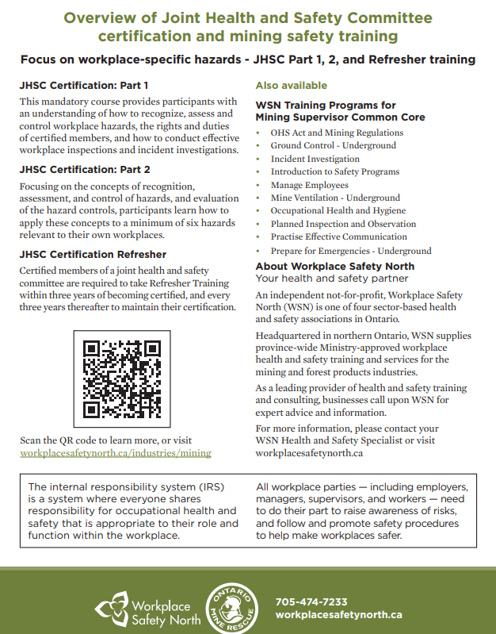

# Work Sheet

**Task 1: What is the focus of this bulletin?**

Answer:

**Task 2: How many Joint Health and Safety Committee certifications are there?**

Answer:

**Task 3: List the two things that participants must understand in the JHSC Certification: Part 1.**

Answer:

**Task 4: What are two ways to learn more?**

Answer:

**Task 5: What is the internal responsibility system (IRS)?**

Answer:

# 

# Answers

**Task 1: What is the focus of this bulletin?**

Answer: Workplace-specific hazards

**Task 2: How many Joint Health and Safety Committee certifications are there?**

Answer: Three

**Task 3: List the two things that participants must understand in the JHSC Certification: Part 1.**

Answer: Any two of the following:

* Recognize, assess and control workplace hazards
* The rights and duties of certified members
* How to conduct effective workplace inspections
* Incident investigations

**Task 4: What are two ways to learn more?**

Answer: Scan the QR code or visit workplacesafetynorth.ca/industries/mining

**Task 5: What is the internal responsibility system (IRS)?**

Answer: Where everyone shares responsibility for occupational health and safety that is appropriate to their role and function within the workplace.

# Performance Descriptors

| Levels | Performance Descriptors | Needs Work | Completes task with support from practitioner | Completes task independently |
| --- | --- | --- | --- | --- |
| A1.2 | Scans text to locate information |  |  |  |
|  | Locates multiple pieces of information in simple texts |  |  |  |
|  | Reads more complex texts to locate a single piece of information |  |  |  |
| A2.1 | Locates specific details in simple document, such as labels and signs |  |  |  |

This task: Was successfully completed Needs to be tried again

Learner Comments:

Instructor (print): Learner (print):