OALCF Task Cover Sheet

Task Title: Pre-Admission Testing Sample Questions – Fractions, Decimals and Percents

Learner Name:

Date Started: Date Completed:

Successful Completion: Yes_ No
Goal Path: Employment Apprenticeship Secondary School Post Secondary ✓ Independence
Task Description:
The learner will answer questions on fractions, decimals and percents from a college mathematics pre-admission sample test used to prepare students for a post-secondary mature applicant test.

Competency:  A: Read and Use Information  B: Communicate Ideas and Information  C: Understand and Use Numbers | Task Group(s):  A1: Read continuous text  B3: Complete and create documents  C1: Manage Money  C3: Use Measures  C4: Manage Data
Level Indicators:
A1.1: Read brief texts to locate specific details
B3.1a: Make straightforward entries to complete very simple documents
C1.2: Make low-level inferences to calculate costs and expenses that may include rates such as taxes and discounts
C3.2: Use measures to make one-step calculations
C4.2: Make low-level inferences to organize, make summary calculations and represent data

Performance Descriptors: see chart on last page
Materials Required:
• task sets and documents
• scientific calculator
• pencil/pen
• paper

Task Title: Pre-Admission Testing Sample Questions – Fractions, Decimals and Percents

Learner Information and Tasks:
The Secondary School Credits, Post Secondary and Apprenticeship paths require learners to complete math question sheets for class and on tests and exams. The following tasks are based on three areas of mathematics:
- Fractions
- Decimals
- Percents

Answer the tasks on a separate sheet of paper showing your calculations.
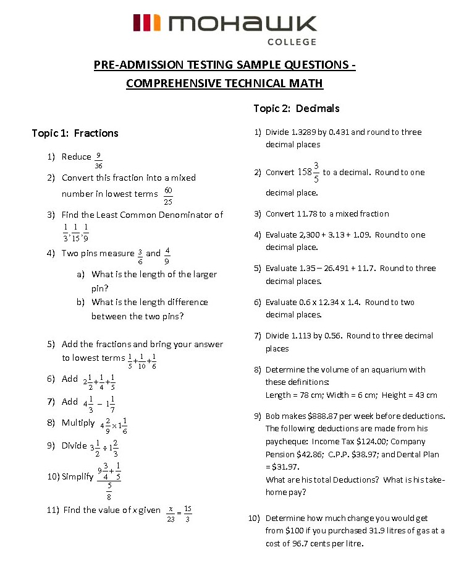Task Title: Pre-Admission Testing Sample Questions – Fractions, Decimals and Percents
Task Title: Pre-Admission Testing Sample Questions – Fractions, Decimals and Percents
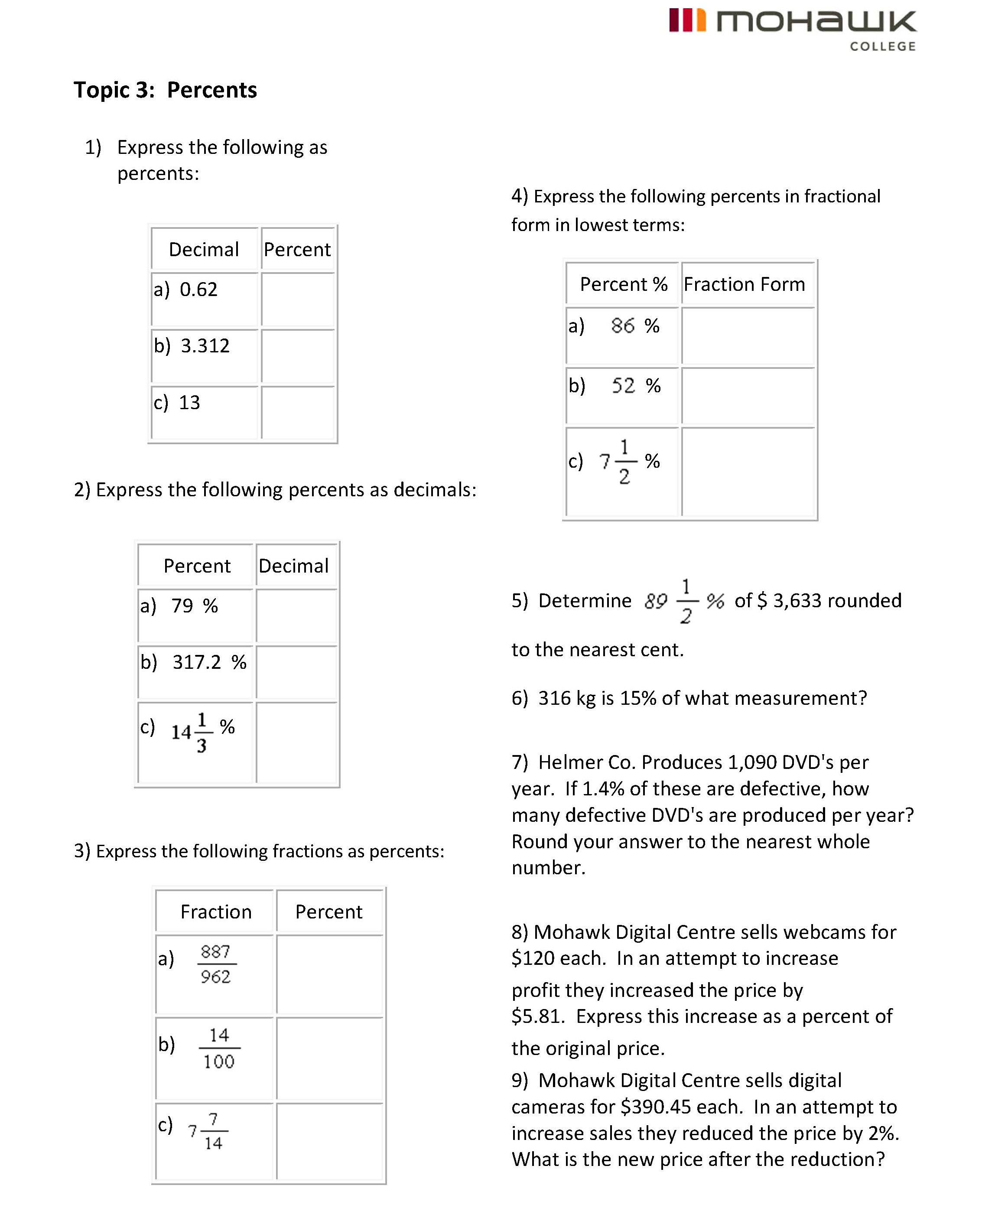

Task Title: Pre-Admission Testing Sample Questions – Fractions, Decimals and Percents

Answer Key

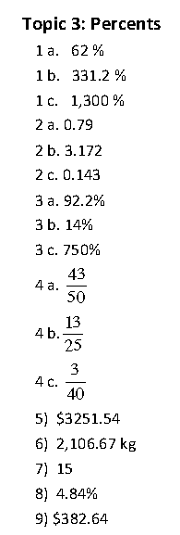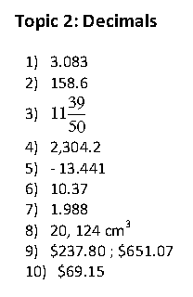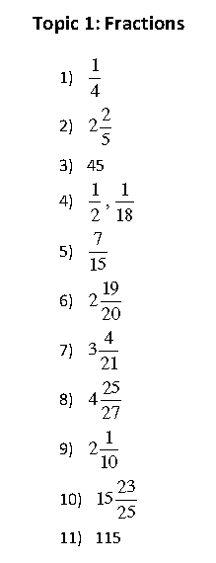

Task Title Pre-Admission Testing Sample Questions – Fractions, Decimals and Percents

Performance Descriptors |  | Needs Work | Completes task with support from practitioner | Completes task independently
A1.1 | - reads short text to locate a single piece of information
 | - follows simple, straightforward instructional texts
B3.1a | - makes a direct match between what is requested and what is entered
C1.2 | - calculates using numbers expressed as whole numbers, fractions, decimals, percentages and integers
 | - calculates percentages
 | - interprets and applies rates (e.g. $/kg, $/1)
 | - chooses and performs required operation(s); may make inferences to identify required operation(s)
 | - selects appropriate steps to reach solutions
 | - represents costs and rates using monetary symbols, decimals and percentages
 | -  interprets, represents and converts amounts using whole numbers, decimals, percentages, ratios and simple, common fractions (e.g. ½, ¼ )
C1.2 | - uses strategies to check accuracy (e.g. estimating, using a calculator, repeating a calculation, using the reverse operation)
C3.2 | - calculates using numbers expressed as whole numbers, fractions, decimals, percentages and integers
 | - interprets and represents area and volume using symbols and abbreviations (e.g. m3)
 | - interprets and applies rates (e.g. km/hr) and ratios (e.g. map scales)
 | - understands and uses formulas for finding the perimeter, area and volume of simple, common shapes
 | - chooses and performs required operation(s); may make inferences to identify required operation(s)
 | - selects appropriate steps to solutions
 | - interprets, represents and converts measures using whole numbers, decimals, percentages, ratios and simple, common fractions (e.g. ½, ¼)
C4.2 | - calculates using numbers expressed as whole numbers, fractions, decimals, percentages and integers

This task: was successfully completed
needs to be tried again

Learner Comments

Instructor (print) Learner Signature

