

Task Title: 10 Reasons to be Libro

# OALCF Cover Sheet – Practitioner Copy

**Learner Name: __________________________________________**

**Date Started: ___________________________________________**

**Date Completed: _________________________________________**

|  |  |  |
| --- | --- | --- |
| **Goal Path:** | Employment | Apprenticeship |
| Secondary School | Post Secondary | Independence |

**Successful Completion:**  Yes No

**Task Description:** Learners will read about Libro Credit Union to understand the services they provide.

**Main Competency/Task Group/Level Indicator:**

* Find and Use Information/Interpret documents/A2.1

**Materials Required:**

* Pen/pencil and paper and/or digital device

# Learner Information

Credit Unions and banks are financial institutions that offer different benefits to customers. Credit Unions are different from banks because customers at Credit Unions are owners.

Scan “10 Reasons to be Libro”.

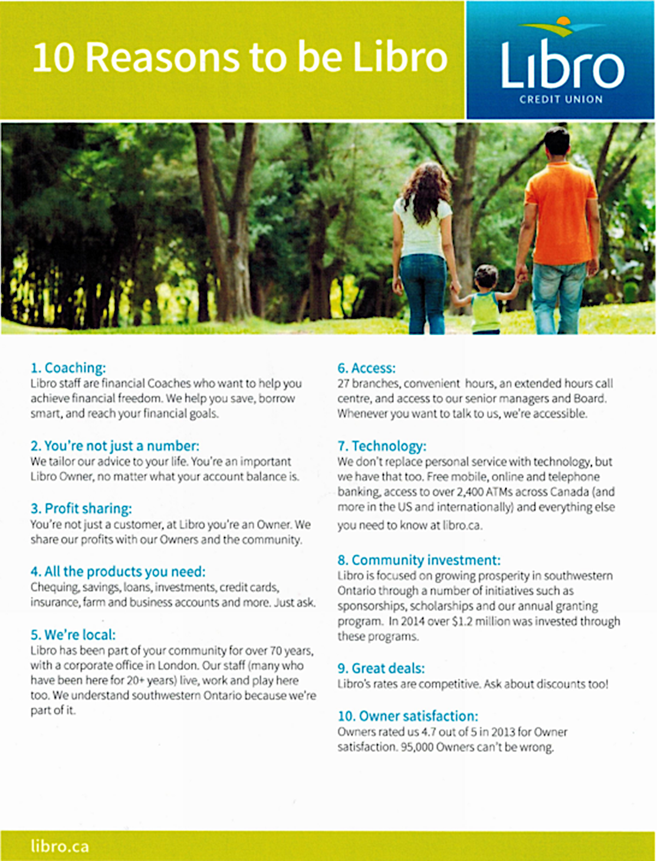

# Work Sheet

**Task 1: Who does Libro share their profits with?**

Answer:

**______________________________________________________**

**Task 2: Who are financial coaches?**

Answer:

**______________________________________________________**

**Task 3: How long has Libro been a part of the community of southwestern Ontario?**

Answer:

**______________________________________________________**

**Task 4: How much money did Libro invest in the community in 2014?**

Answer:

**______________________________________________________**

**Task 5: What is the owner satisfaction rating for Libro?**

Answer:

**______________________________________________________**

# Answers

**Task 1: Who does Libro share their profits with?**

Answer: Owners and the community

**Task 2: Who are financial coaches?**

Answer: Libro staff

**Task 3: How long has Libro been a part of the community of southwestern Ontario?**

Answer: Over 70 years

**Task 4: How much money did Libro invest in the community in 2014?**

Answer: Over 1.2 million dollars

**Task 5: What is the owner satisfaction rating for Libro?**

Answer: 4.7 out of 5

# Performance Descriptors

| Levels | Performance Descriptors | Needs Work | Completes task with support from practitioner | Completes task independently |
| --- | --- | --- | --- | --- |
| A2.1 | scans to locate specific details |  |  |  |
|  | interprets brief text and common symbols |  |  |  |

This task: Was successfully completed Needs to be tried again

Learner Comments:

Instructor (print): Learner (print):

**__________________ _________________**