

Task Title: Deposit Insurance Coverage

# OALCF Cover Sheet – Practitioner Copy

**Learner Name: __________________________________________**

**Date Started: ___________________________________________**

**Date Completed: _________________________________________**

|  |  |  |
| --- | --- | --- |
| **Goal Path:** | Employment | Apprenticeship |
| Secondary School | Post Secondary | Independence |

**Successful Completion:**  Yes No

**Task Description:** Learners will locate information about deposit insurance in Ontario to understand how credit unions work.

**Main Competency/Task Group/Level Indicator:**

* Find and Use Information/Read continuous text/A1.2

**Materials Required:**

* Pen/pencil and paper and/or digital device

# Learner Information

The Deposit Insurance Corporation of Ontario (DICO) is an Ontario Provincial Agency established under the Credit Unions Act. DICO’s role is to protect people from loss.

Scan “Deposit Insurance Coverage for Ontario Credit Unions”.

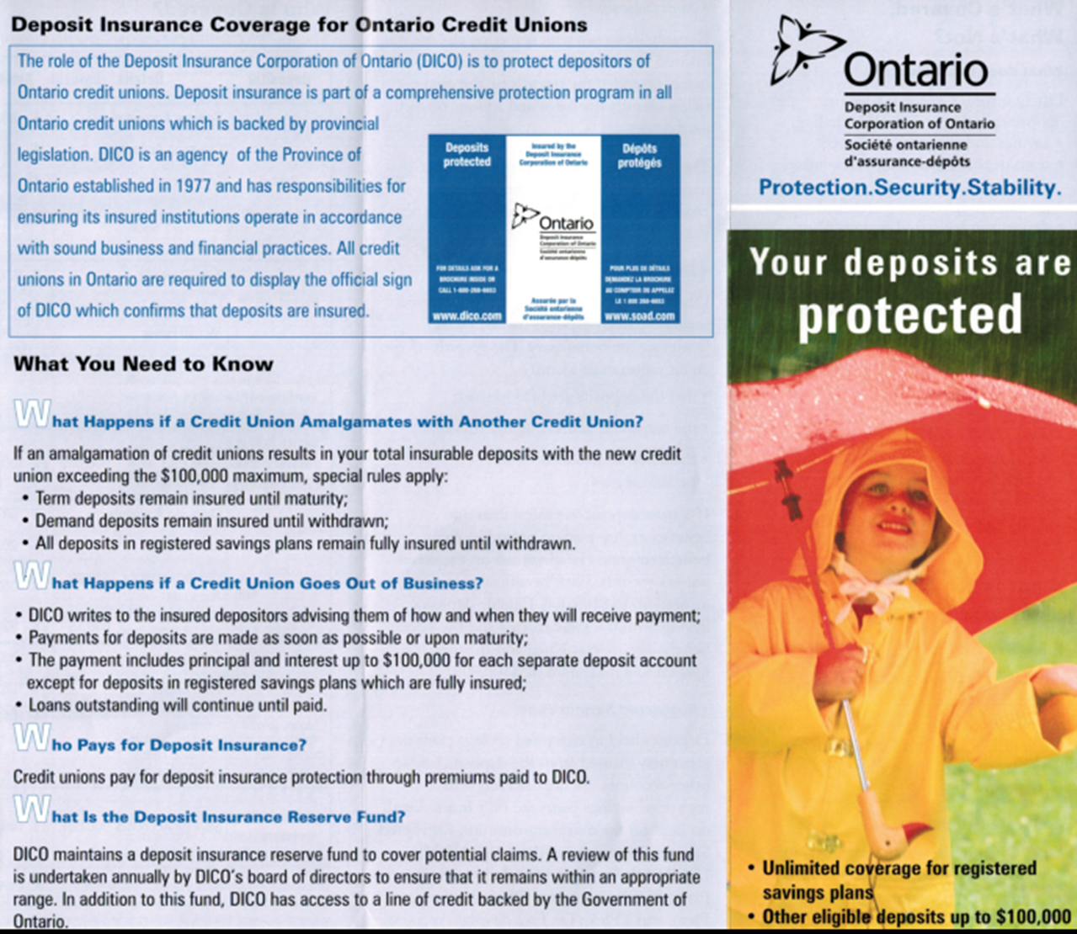

# Work Sheet

**Task 1:** **What are all credit unions in Ontario required to display?**

Answer:

**______________________________________________________**

**Task 2: How does a customer of a credit union find out about their payment if their Credit Union goes out of business?**

Answer:

**______________________________________________________**

**Task 3: Why does DICO keep a deposit insurance reserve fund?**

Answer:

**______________________________________________________**

**Task 4: How often does the board of directors of DICO review the fund?**

Answer:

**______________________________________________________**

# Answers

**Task 1: What are all credit unions in Ontario required to display?**

Answer: The official sign of DICO, which confirms that deposits are insured.

**Task 2: How does a customer of a credit union find out about their payment if their Credit Union goes out of business?**

Answer: DICO writes to the insured depositors advising them of how and when they will receive payment.

**Task 3: Why does DICO keep a deposit insurance reserve fund?**

Answer: To cover potential claims.

**Task 4: How often does the board of directors of DICO review the fund?**

Answer: Annually.

# Performance Descriptors

| Levels | Performance Descriptors | Needs Work | Completes task with support from practitioner | Completes task independently |
| --- | --- | --- | --- | --- |
| A1.2 | scans text to locate information |  |  |  |
|  | locates multiple pieces of information in simple texts |  |  |  |
|  | obtains information from detailed reading |  |  |  |
|  | begins to identify sources and evaluate information |  |  |  |

This task: Was successfully completed Needs to be tried again

Learner Comments:

Instructor (print): Learner (print):

**__________________ _________________**