

Task Title: Find a Coupon Expiry Date (Set 2)

# OALCF Cover Sheet – Practitioner Copy

**Learner Name: __________________________________________**

**Date Started: ___________________________________________**

**Date Completed: _________________________________________**

|  |  |  |
| --- | --- | --- |
| **Goal Path:** | Employment | Apprenticeship |
| Secondary School | Post Secondary | Independence |

**Successful Completion:**  Yes No

**Task Description:** The learner will locate coupon expiry dates in a variety of formats.

**Main Competency/Task Group/Level Indicator:**

* Find and Use Information/Interpret documents/A2.1

**Materials Required:**

* Pen/pencil and paper and/or digital device

# Learner Information

Coupons can save shoppers money. Most coupons have an expiry date, and cannot be used after that date.

Look at the coupons.

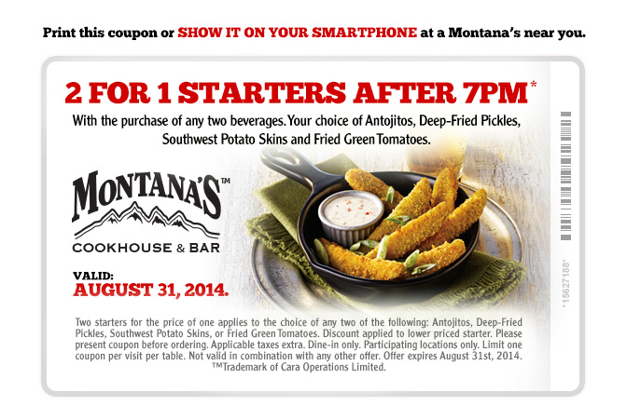

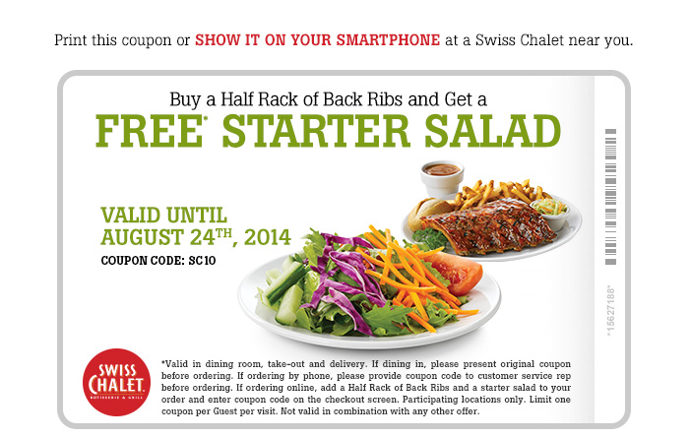



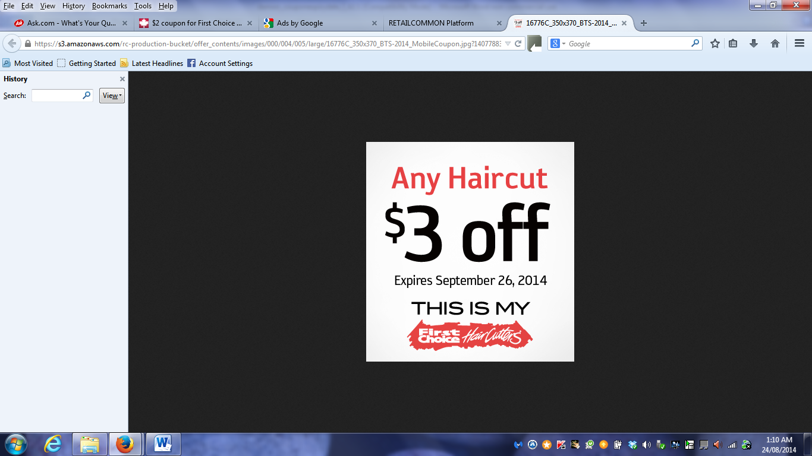



# Work Sheet

**Task 1: Until when was the Montana’s coupon valid?**

Answer:

**______________________________________________________**

**Task 2: Until when was the Swiss Chalet coupon valid?**

Answer:

**______________________________________________________**

**Task 3: When did the First Choice coupon expire?**

Answer:

**______________________________________________________**

**Task 4: When could you use the Jysk coupon?**

Answer:

**______________________________________________________**

**Task 5: When could you use the Mary Brown coupon?**

Answer:

**______________________________________________________**

# Answers

**Task 1: Until when was the Montana’s coupon valid?**

Answer: August 31, 2014

**Task 2: Until when was the Swiss Chalet coupon valid?**

Answer: August 24th, 2014

**Task 3: When did the First Choice coupon expire?**

Answer: September 26, 2014

**Task 4: When could you use the Jysk coupon?**

Answer: Aug 21st - 27th, 2014

**Task 5: When could you use the Mary Brown coupon?**

Answer: June 16 - September 7, 2014

# Performance Descriptors

| Levels | Performance Descriptors | Needs Work | Completes task with support from practitioner | Completes task independently |
| --- | --- | --- | --- | --- |
| A2.1 | Scans to locate specific details |  |  |  |
|  | Interprets brief text and common symbols |  |  |  |
|  | Locates specific details in simple documents, such as labels and signs |  |  |  |
|  | Requires support to identify sources and to evaluate and integrate information |  |  |  |

This task: Was successfully completed Needs to be tried again

Learner Comments:

Instructor (print): Learner (print):

**__________________ _________________**