

Task Title: Follow a Flow Chart

OALCF Cover Sheet – Practitioner Copy

Learner Name: __________________________________________
Date Started: ___________________________________________
Date Completed: _________________________________________

Goal Path: | Employment | Apprenticeship
Secondary School | Post Secondary | Independence
Successful Completion: Yes No

Task Description: Use a flowchart to follow the process of an Amazon book order.
Main Competency/Task Group/Level Indicator:
- Find and Use Information/Interpret documents/A2.3
Materials Required:
- Pen/pencil and paper and/or digital device

Learner Information

Flow charts are often used by companies to help their customers understand the steps in a process that might be difficult to follow.

Scan the “Amazon Book Order Process”.

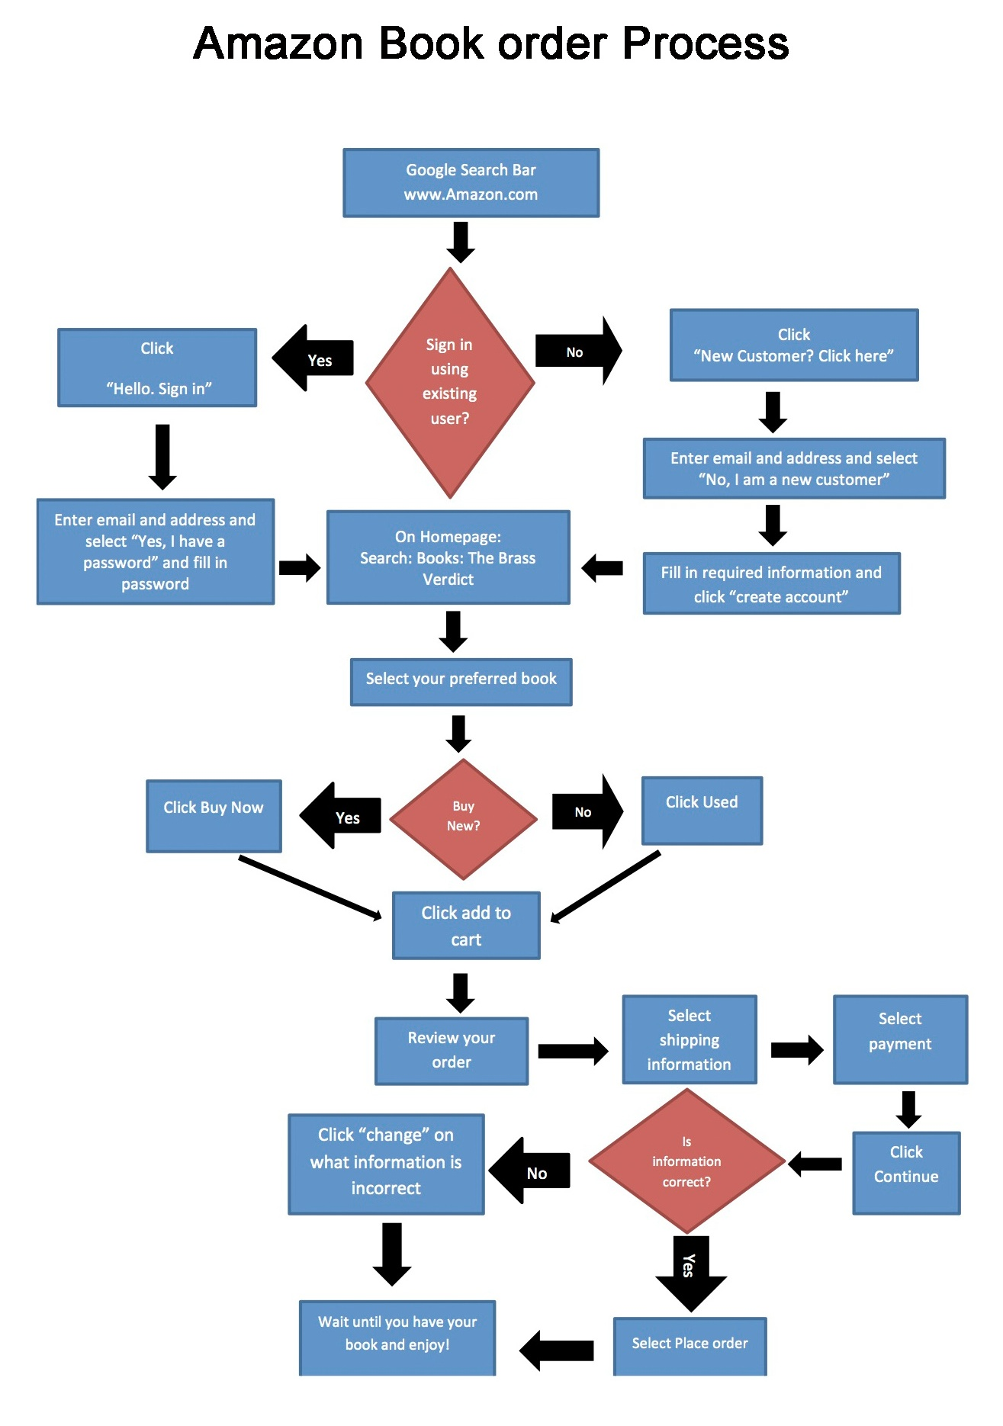

Work Sheet
Task 1: What will you click if you are not an existing Amazon user?
Answer:

______________________________________________________
Task 2: What search criteria will you use when searching for a book?
Answer:

______________________________________________________
Task 3: Which choice do you need to make directly after you have selected your preferred book?
Answer:

______________________________________________________
Task 4: What will you click if you notice your address information is incorrect after selecting payment?
Answer:

______________________________________________________

Answers
Task 1: What will you click if you are not an existing Amazon user?
Answer: New Customer
- Follow flowchart to “Sign in using existing user?”
- “No”
- Click “New Customer? Click here”

Task 2: What search criteria will you use when searching for a book?
Answer: Follow flowchart to “On Homepage: Search: Books: The Brass Verdict”

Task 3: Which choice do you need to make directly after you have selected your preferred book?
Answer: New or Used
- Follow flowchart to “Select your preferred book”
- “Buy New?”
- “Yes” or “No”
- Choose New (buy now) or Used

Task 4: What will you click if you notice your address information is incorrect after selecting payment?
Answer: Click “change” on address information
- Follow flowchart to “Select payment”
- “Click Continue”
- “Is information correct?”
- “No”
- Click “change” on the what the information is incorrect

Performance Descriptors
Levels | Performance Descriptors | Needs Work | Completes task with support from practitioner | Completes task independently
A2.3 | manages unfamiliar elements (e.g. vocabulary, context, topic) to complete tasks
 | integrates several pieces of information from documents
 | uses layout to locate information
 | identifies the purpose and relevance of documents
 | makes inferences and draws conclusions from information displays

This task: Was successfully completed Needs to be tried again
Learner Comments:

Instructor (print): Learner (print):
__________________ _________________

