

Task Title: Healthy Plate

# OALCF Cover Sheet – Practitioner Copy

**Learner Name: __________________________________________**

**Date Started: ___________________________________________**

**Date Completed: _________________________________________**

|  |  |  |
| --- | --- | --- |
| **Goal Path:** | Employment | Apprenticeship |
| Secondary School | Post Secondary | Independence |

**Successful Completion:**  Yes No

**Task Description:** The learner will review Canada Food Guide recommendations and create a sample meal plan based on these guidelines.

**Main Competency/Task Group/Level Indicator:**

* Find and Use Information/Read continuous text/A1.2
* Communicate Ideas and Information/Complete and create documents/B3.2a

**Materials Required:**

* Pen/pencil and paper and/or digital device

# Learner Information

*Canada's Food Guide* offers many suggestions for making healthy food choices. However, these guidelines may not be appropriate for everyone. Many people make different food choices because of health conditions (e.g. diabetes or food allergies), religious requirements or observances, or lack of access to healthy food. Everyone’s situation is different.

Read “How to Make a Healthy Meal”.

**How to Make a Healthy Meal**

Use the proportions of foods on the Canada’s food guide plate as a tool to help you make healthy meals or snacks.

Step 1: Make half your plate vegetables and fruits. Vegetables and fruits should always make up the largest proportion of the foods you eat throughout the day.

Step 2: Make one-quarter of your plate whole grain foods.

Step 3: Make one-quarter of your plate protein foods. Choose protein foods that come from plants more often.

Figure 1. Canada's food guide plate

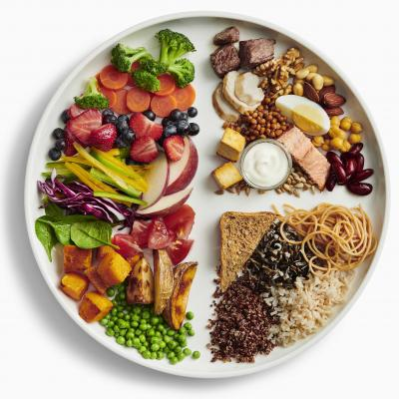

The healthy food choices shown on the plate are only examples. The size and amount of each food shown on the plate is not meant to show how much to eat at one time.

You can choose a variety of healthy foods that you enjoy. Healthy food choices can be fresh, frozen, canned or dried.

Every day, choose a variety of

* vegetables and fruit, including
  + dark green vegetables such as kale and bok choy each day
  + orange vegetables such as carrots and sweet potato most days
* whole grain foods, such as
  + oats
  + wild rice
  + whole wheat pasta
* protein foods such as
  + eggs
  + nuts and seeds
  + fish and shellfish
  + beans, peas, and lentils
  + lean red meats, including wild game
  + lower fat dairy products such as milk and yogurt
  + fortified soy beverages, tofu, soybeans and other soy products

Making healthy drink choices is as important as your food choices. Make water your drink of choice.

Healthy drink options other than water can include

* white milk (unsweetened lower fat milk)
* unsweetened fortified plant-based beverages

Source: https://food-guide.canada.ca/en/tips-for-healthy-eating/adults/

# Work Sheet

**Task 1: Based on the Healthy Plate recommendations, how much of a plate should contain protein foods?**

Answer:

**______________________________________________________**

**Task 2: Based on the Healthy Plate recommendations, what should you try to make your drink of choice?**

Answer:

**______________________________________________________**

**Task 3: Based on the Healthy Plate recommendations and food suggestions, create a daily meal plan. Assume all food you wish to include is available.**

|  |  |  |  |  |
| --- | --- | --- | --- | --- |
|  | **Fruit/**  **Veg.** | **Protein** | **Grain** | **Other** |
| Breakfast |  |  |  |  |
| Snack |  |  |  |  |
| Lunch |  |  |  |  |
| Snack |  |  |  |  |
| Dinner |  |  |  |  |
| Snack |  |  |  |  |

# Answers

**Task 1: Based on the Healthy Plate recommendations, how much of a plate should contain protein foods?**

Answer: One quarter

**Task 2: Based on the Healthy Plate recommendations, what should you try to make your drink of choice?**

Answer: Water

**Task 3: Based on the Healthy Plate recommendations and food suggestions, create a daily meal plan. Assume all food you wish to include is available.**

Answers will vary. Note that learners may give other examples of fruit/vegetables, protein and grains besides the ones listed in the article. For example, they may include other green or orange vegetables, e.g., broccoli, brussels sprouts, squash….

# Performance Descriptors

| Levels | Performance Descriptors | Needs Work | Completes task with support from practitioner | Completes task independently |
| --- | --- | --- | --- | --- |
| A1.2 | scans text to locate information |  |  |  |
|  | locates multiple pieces of information in simple texts |  |  |  |
|  | makes low-level inferences |  |  |  |
|  | follows the main events of descriptive, narrative and informational texts |  |  |  |
|  | obtains information from detailed reading |  |  |  |
|  | begins to identify sources and evaluate information |  |  |  |
| B3.2a | uses layout to determine where to make entries |  |  |  |
|  | begins to make some inferences to decide what information is needed, where and how to enter information |  |  |  |
|  | begins to make some inferences to decide what information is needed, where and how to enter the information |  |  |  |
|  | makes entries using a limited range of vocabulary |  |  |  |

This task: Was successfully completed Needs to be tried again

Learner Comments:

Instructor (print): Learner (print):

**__________________ _________________**