

Task Title: Ontario’s Insurable Deposits Coverage B

OALCF Cover Sheet – Practitioner Copy

Learner Name:___________________________________________
Date Started (m/d/yyyy):__________________________________
Date Completed (m/d/yyyy): _______________________________
Successful Completion: Yes No
Goal Path: | Employment | Apprenticeship
Secondary School | Post Secondary | Independence

Task Description: The learner will read a brochure to gain understanding of the deposit insurance program functions of the Financial Services Regulatory Authority of Ontario (FSRA).

Main Competency/Task Group/Level Indicator:
- Find and Use Information/Interpret documents/A2.2
- Understand and Use Numbers/Manage money/C1.1

Materials Required:
- Pencil/pen and/or digital device

Learner Information
Ontario’s Financial Services Regulatory Authority (FSRA)’s deposit insurance program protects insurable deposits held with Ontario credit unions and caisses populaires. Deposit insurance is part of a comprehensive depositor protection program that ensures the safety and soundness of credit unions and caisses populaires. FSRA now handles the deposit insurance functions previously performed by the Deposit Insurance Corporation of Ontario (DICO).

Scan the “FSRA Deposit Insurance Reserve Fund (DIRF)” advertising brochure.

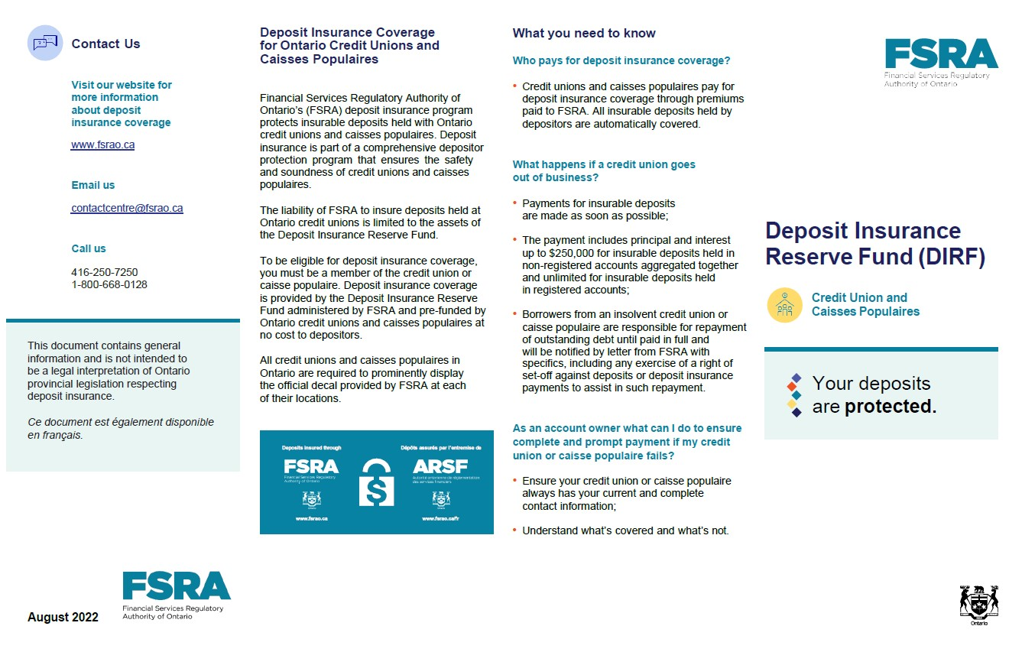
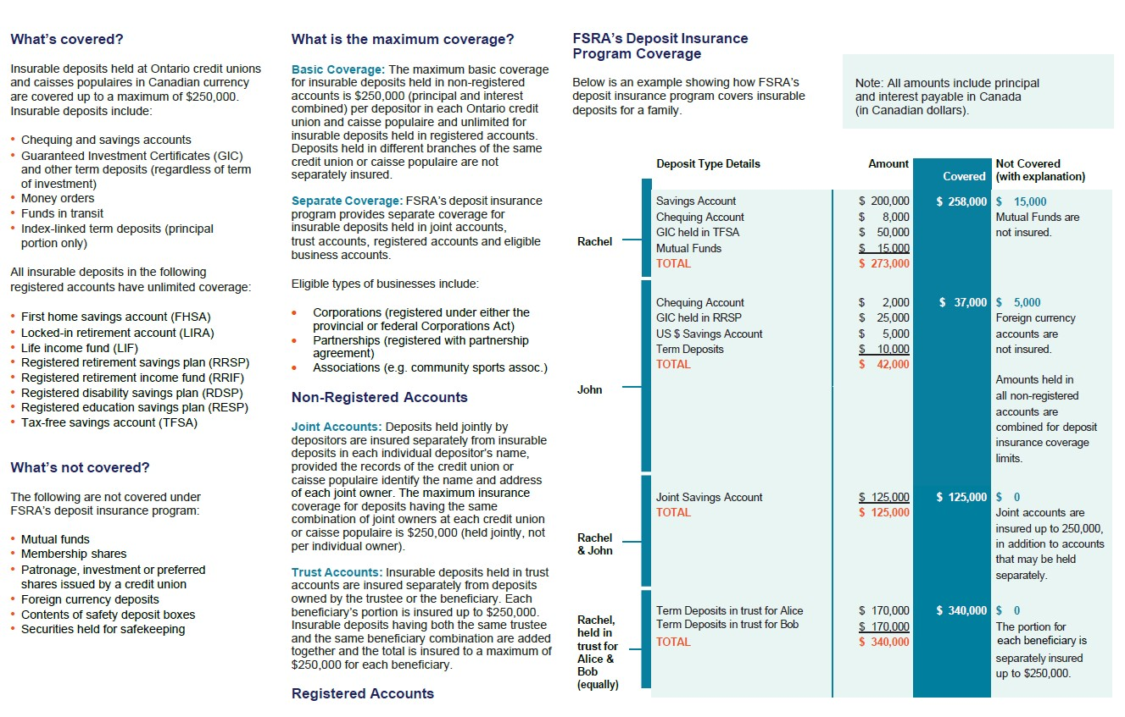

Work Sheet
Task 1: Depositor Rachel has deposits totalling $273,000. Why is the total insured only $258,000?
Answer:

______________________________________________________
Task 2: Rachel also has Term Deposits held in trust for Alice and Bob totalling $340,000. Why is the total amount insured?
Answer:

_____________________________________________________
Task 3: Depositor John has $42,000 in various accounts. Why is only $37,000 insured?
Answer:

______________________________________________________
Task 4: Why is John and Rachel’s joint account fully covered?
Answer:

_____________________________________________________________
Task 5: Another customer has $2,500 in a Savings Account, $25,000 in Mutual Funds and $124,000 in RRSP Accounts. Calculate how much of this customer’s deposits are insured.
Answer:
______________________________________________________
Answers
Task 1: Depositor Rachel has deposits totalling $273,000. Why is the total insured only $258,000?
Answer: Mutual Funds are not insured.

Task 2: Rachel also has Term Deposits held in trust for Alice and Bob totalling $340,000. Why is the total amount insured?
Answer: The portion for each beneficiary is separately insured up to $250,000

Task 3: Depositor John has $42,000 in various accounts. Why is only $37,000 insured?
Answer: Foreign currency accounts (e.g., US $ Savings Account) are not covered.
Task 4: Why is John and Rachel’s joint account fully covered?
Answer: Joint accounts are covered up to $250,000 in addition to accounts that may be held separately.

Task 5: Another customer has $2,500 in a Savings Account, $25,000 in Mutual Funds and $124,000 in RRSP Accounts. Calculate how much of this customer’s deposits are insured.
Answer: $124,000 + $2,500 = $126,500

Performance Descriptors
Levels | Performance Descriptors | Needs Work | Completes task with support from practitioner | Completes task independently
A2.2 | Performs limited searches using one or two search criteria
 | Extracts information from tables and forms
 | Uses layout to locate information
 | Makes connections between parts of documents
 | Makes low-level inferences
 | Begins to identify sources and evaluate information
C1.1 | Adds, subtracts, multiplies, and divides whole numbers and decimals
 | Identifies and performs required operation
 | Follows apparent steps to reach solutions
This task: Was successfully completed Needs to be tried again
Learner Comments:

Instructor (print): Learner Signature:
_______________________ _______________________

