

Task Title: Out for Breakfast

OALCF Cover Sheet – Practitioner Copy

Learner Name:___________________________________________
Date Started (m/d/yyyy):__________________________________
Date Completed (m/d/yyyy): _______________________________
Successful Completion: Yes No

Goal Path: | Employment | Apprenticeship
Secondary School | Post Secondary | Independence

Task Description: Learners will read a restaurant menu and answer questions about costs.

Main Competency / Task Group / Level Indicator:
- Find and Use Information/Interpret documents/A2.2
- Understand and Use Numbers/Manage money/C1.2

Materials Required:
- Pen, pencil and/or digital device
- Calculator, if allowed by instructor

Learner Information/Instructions
Scan “Frannie’s Breakfast Menu”.

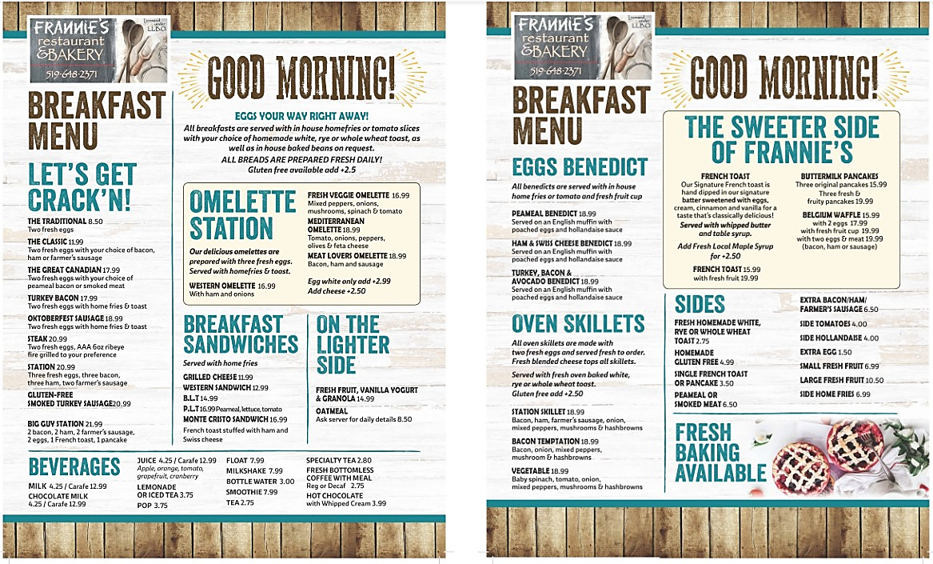

Work Sheet
Task 1: If you order a Fresh Veggie Omelette and an orange juice, how much will the subtotal (before tax) of your bill be?
Answer:
_____________________________________________________________
Task 2: How much would it cost (before tax) for a western omelette with cheese?
Answer:
_____________________________________________________________
Task 3: How much would the total bill be for a Bacon Temptation oven skillet with an extra egg, French Toast with fresh local maple syrup, and two cups of coffee, including 13% tax?
Answer:

_____________________________________________________________
Task 4: Which costs more, the B.L.T. or the P.L.T.?
Answer:
_____________________________________________________________
Task 5: What is the difference in cost (before tax) between a Station Skillet with Gluten free toast and one with whole wheat toast?
Answer:

_____________________________________________________________
Task 6: If you ordered a Mediterranean Omelette and you wanted to add tomatoes, how much would the subtotal be?
Answer:

_____________________________________________________________
Task 7: You are having breakfast with five of your friends. You each order The Classic and coffee. If you split the bill evenly, including tax, how much would each of you pay?
Answer:

_____________________________________________________________

Answers
Task 1: If you order The Great Canadian and an orange juice, how much will the subtotal (before tax) of your bill be?
Answer: $17.99 + $4.25 = $22.24
Task 2: How much would it cost (before tax) for a western omelette with cheese?
$16.99 + $2.50 = $19.49
Task 3: How much would the total bill be for a Bacon Temptation oven skillet with an extra egg, French Toast with fresh local maple syrup, and two cups of coffee, including 13% tax?
Answer: $18.99 + $1.50 + $15.99+ $2.50+ $2.75 + $2.75 = $44.48
$44.48 x .13 (13%) = $5.78
$44.48 + $5.78 = $50.26
Task 4: Which costs more, the B.L.T. or the P.L.T.?
Answer: The P.L.T. ($16.99 vs. $14.99)
Task 5: What is the difference in cost (before tax) between a Station Skillet with gluten free toast and one with whole wheat toast?
($18.99 +$2.50) - $18.99 = $2.50
Task 6: If you ordered a Mediterranean Omelette and you wanted to add tomatoes, how much would the subtotal be?
$18.99 + $4.00 = $22.99
Task 7: You are having breakfast with five of your friends. You each order The Classic and coffee. If you split the bill evenly, including tax, how much would each of you pay?
- $11.99 + $2.75 = $14.74
- $14.74 x .13 = $1.92
- $14.74 + $1.92 = $16.66
OR
- $11.99 + $2.75 = $14.74
- $14.74 x 6 = $88.44
- $88.44 x .13 = $11.50
- $88.44 + $11.50 = $99.94
- $99.94 ÷ 6 = $16.66

Performance Descriptors
Levels | Performance Descriptors | Needs Work | Completes task with support from practitioner | Completes task independently
A2.2 | Performs limited searches using one or two search criteria
 | Extracts information from tables and forms
 | Uses layout to locate information
 | Makes connections between parts of documents
 | Makes low-level inferences
C1.2 | Calculates using numbers expressed as whole numbers, fractions, decimals, percentages and integers
 | Calculates percentages
 | Chooses and performs required operation(s); may make inferences to identify required operation(s)
 | Selects appropriate steps to reach solutions
 | Represents costs and rates using monetary symbols, decimals and percentages

This task: Was successfully completed Needs to be tried again

Learner Comments:

Instructor (print): Learner (print):
________________________ _______________________

