

Task Title: Payday Loans and Cash Advances

OALCF Cover Sheet – Practitioner Copy

Learner Name: __________________________________________
Date Started: ___________________________________________
Date Completed: _________________________________________

Goal Path: | Employment | Apprenticeship
Secondary School | Post Secondary | Independence
Successful Completion: Yes No

Task Description: The learner will calculate the true costs of payday loans and cash advances.
Main Competency/Task Group/Level Indicator:
- Find and Use Information/Interpret documents/A2.2
- Understand and Use Numbers/Manage money/C1.2
Materials Required:
- Pen/pencil and paper and/or digital device
- Calculator or digital device with calculator function (optional)

Learner Information
Sometimes when people are running short on money due to sudden expenses, they will get a payday loan or cash advance.

Scan the “Cost of Borrowing” and “How much will $300 cost you for two weeks?”

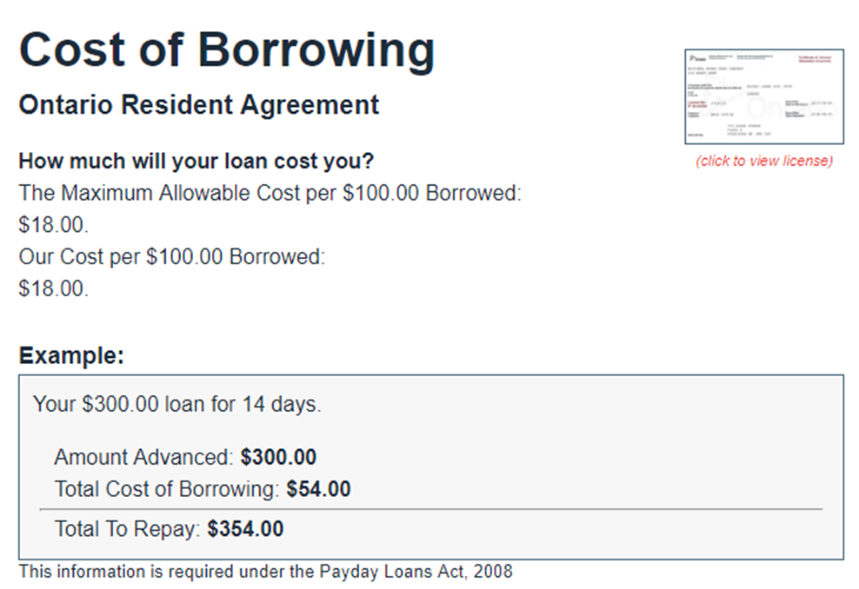
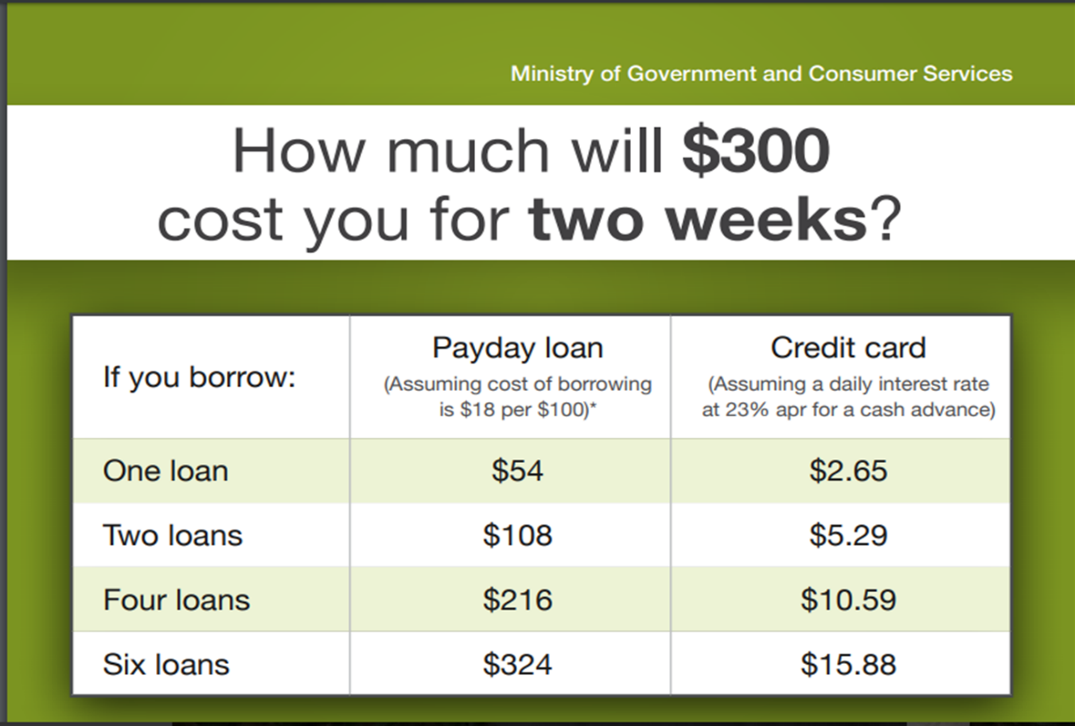

Work Sheet
Task 1: If a customer takes out a $300 pay day loan for 14 days, how much will they have to pay back in total?
Answer:

______________________________________________________
Task 2: A customer takes out a $100 cash advance and will pay it back in 14 days. Calculate the total amount the customer would have to pay back.
Answer:

______________________________________________________
Task 3: A customer takes out a $400 pay day loan for 2 weeks. Calculate the interest they would pay at the end of the 2 weeks.
Answer:

______________________________________________________

Answers
Task 1: If a customer takes out a $300 pay day loan for 14 days, how much will they have to pay back in total?
Answer: $300 (original loan) + $54 interest = $354

Task 2: A customer takes out a $100 cash advance and will pay it back in 14 days. Calculate the total amount the customer would have to pay back.
Answer: $100 (cash advance) + $18 interest = $118

Task 3: A customer takes out a $400 pay day loan for 2 weeks. Calculate the interest they would pay at the end of the 2 weeks.
Answer: 4 x $18 = $72 interest

Performance Descriptors
Levels | Performance Descriptors | Needs Work | Completes task with support from practitioner | Completes task independently
A2.2 | performs limited searches using one or two search criteria
 | extracts information from tables and forms
 | uses layout to locate information
 | makes connections between parts of documents
C1.2 | calculates using numbers expressed as whole numbers, fractions, decimals, percentages and integers
 | chooses and performs required operations; makes inferences to identify operations
 | selects appropriate steps to reach solutions
 | represents costs and rates using monetary symbols, decimals, and percentages
 | uses strategies to check accuracy
This task: Was successfully completed Needs to be tried again

Learner Comments:

Instructor (print): Learner (print):
__________________ _________________

