

Task Title: Read a Mall Directory

OALCF Cover Sheet – Practitioner Copy

Learner Name: __________________________________________
Date Started: ___________________________________________
Date Completed: _________________________________________

Goal Path: | Employment | Apprenticeship
Secondary School | Post Secondary | Independence
Successful Completion: Yes No

Task Description: The learner will plan a shopping trip based on a mall layout, list of stores, and tasks to be accomplished.
Main Competency/Task Group/Level Indicator:
- Find and Use Information/Interpret documents/A2.2
- Communicate Ideas and Information/Complete and create documents/B3.2a
- Understand and Use Numbers/Manage time/C2.2
- Manage Learning/E.1
Materials Required:
- Pen/pencil and paper and/or digital device

Learner Information
When going to a mall, you may want to plan your route so you can manage your time and efficiently go to multiple stores.

Scan the “Shopping Mall Directory” and “Store Directory” for Yourtown Shopping Mall.

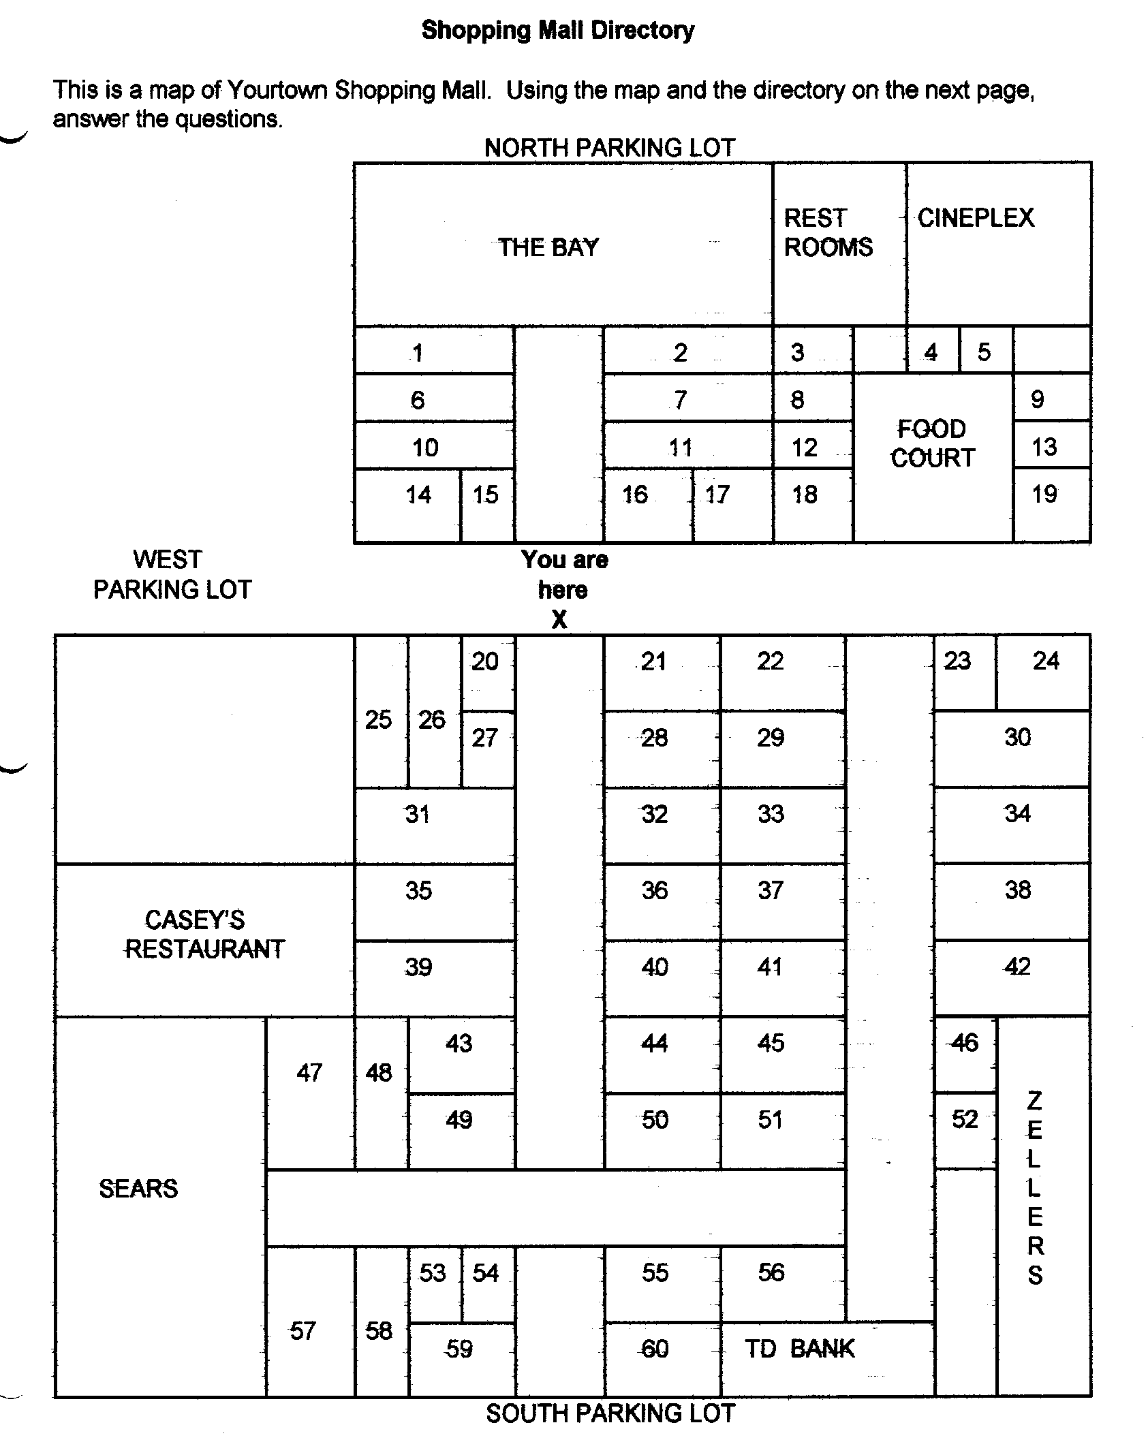
Store Directory
Specialty Stores:
The Body Shop 23
Dufferin Games 32
Fabric Land 30
Grand & Toy Stationery 38
Pet Paradise 55
Shopper’s Drug Mart 47

Food:
A & W 13
Baskin Robbins 19
Bulk Barn 60
Casey’s Restaurant
China Wok 4
Coffee Time 59
Cultures 9
Kentucky Fried Chicken 12
Laura Secord Candy 20
Marvellous Muffins 18
New York Fries 3
Pita Pizzazz 8
Pizza Hut 5
Second Cup Coffee 24

Household:
Dollar Store 6
Living Lighting 14
Pot Pourri 51

Jewellery:
Ardene’s 53
People’s Jewellers 16

Ladies Wear:
Alia 36
Au Coton 58
Bootlegger 50
Cleo’s 29
Cotton Ginny 26
Fairweather 35
Fran’s Lingerie 46
Laura’s Dress Shop 34
Northern 31
Reitman’s 17
Ricki’s 28
Smart Set 41
Suzy Shier 56
Tabi 11
The Gap 39

Men’s Wear:
Bootlegger 50
Grafton’s 37
Jack Fraser 44
Northern 31
Tip Top 21

Shoes:
Agnew Shoes 1
Naturalizer 25

Sports:
Champs 42
Sport Chek 57

Bookstores:
Coles Bookstore 43
WH Smith Bookstore 33
Newstand 54

Cards, Gifts:
Browser’s Nook 27
Carlton Cards 15
Dollar Store 6
It Store 52

Children’s Wear:
Disney Store 49
The Gap–Kids 39
Young Canada 45

Department Stores:
The Bay
Sears
Zellers

Electronics:
Bell Telephone Store 2
Black’s Camera 22
Jumbo Video 7
Music World 10
Radio Shack 40
Sam The Record Man 48

Work Sheet
Task 1: List the stores you would visit if you wanted to:
- look at digital cameras at an electronics store
- purchase a desk lamp
- buy a box of chocolates
- buy a child’s game
- buy a man’s tie
- buy a new pair of running shoes
- buy a birthday card.
Answer:

______________________________________________________
Task 2: Circle the stores you would like to visit on the “Shopping Mall Directory”.
Answer: No response required here.

Task completed: Yes No
______________________________________________________
Task 3: Plan your route by drawing lines between the stores you will visit, starting and ending at the “You are Here X” point in the map. If possible, you want to find the shortest route between all the stores. You do not want to walk back and forth through the mall multiple times.
Answer: No response required here.

Task completed: Yes No
______________________________________________________
Task 4: You plan to arrive at the mall at 9am. It will take 5 minutes to walk from the parking lot to the first store. You want to spend 10 minutes in each store. It will take approximately 5 minutes to walk from one store to the next. What time will you finish your shopping and return to your car?
Answer:

______________________________________________________
Task 5: Complete the Learner Self-Evaluation below.

Learner Self- Evaluation

I understand how the directory is organized. Yes  No 
I could read the names of the stores easily. Yes  No 
I found my way around the map easily. Yes  No 
I now know how to find a particular store when I go shopping. Yes  No 
I will feel much more comfortable when I go to the mall. Yes  No 
Other Comments:

______________________________________________________

Answers
Task 1: List the stores you would visit if you wanted to:
- look at digital cameras at an electronics store
- purchase a desk lamp
- buy a box of chocolates
- buy a child’s game
- buy a man’s tie
- buy a new pair of running shoes
- buy a birthday card.
Answers will vary. The learner should select a store from each of the categories that matches each product.
Task 2: Circle the stores you would like to visit on the “Shopping Mall Directory”.
Answers will vary but should match the list of stores given in Task 1.
Task 3: Plan your route by drawing lines between the stores you will visit, starting and ending at the “You are Here X” point in the map. If possible, you want to find the shortest route between all the stores. You do not want to walk back and forth through the mall multiple times.
Answers will vary. The route selected should be straightforward and connect all the stores the learner has identified.
Task 4: You plan to arrive at the mall at 9am. It will take 5 minutes to walk from the parking lot to the first store. You want to spend 10 minutes in each store. It will take approximately 5 minutes to walk from one store to the next. What time will you finish your shopping and return to your car?
Answers will vary depending on the route the learner has chosen. A sample timeline is as follows. Based on the time requirements, the learner should arrive at their car at 11am.
9:00am-9:05am: walk from parking lot to first store
9:05am-9:15am: Look for digital camera at electronics store
9:15am-9:20am: Walk from electronics store to lighting store
9:20am-9:30am: Look for desk lamps
9:30am-9:35am: Walk from lamp store to chocolate store
9:35am-9:45am: Look for chocolates
9:45am-9:50am: walk from chocolate store to toy store
9:50am-10:00am: look at toys
10:00am-10:05am: walk from toy store to clothing store
10:05am-10:15am: look for tie
10:15am-10:20am: walk from clothing store to sport store
10:20am-10:30am: look for running shoes
10:30am-10:35am: walk from sport store to card store
10:35am-10:45am: look at birthday cards
10:45am-11:00am: walk from card store to parking lot

Arrive at car at approximately 11:00am

Task 5: Complete the Learner Self-Evaluation below.
Answers will vary.

Performance Descriptors
Levels | Performance Descriptors | Needs Work | Completes task with support from practitioner | Completes task independently
A2.2 | performs limited searches using one or two search criteria
 | extracts information from tables and forms
 | locates information in simple graphs and maps
 | uses layout to locate information
 | makes connections between parts of documents
 | makes low-level inferences
 | begins to identify sources and evaluate information
B3.2a | uses layout to determine where to make entries
 | begins to make some inferences to decide what information is needed, where and how to enter the information
C2.2 | makes simple estimates
E.1 | begins to monitor own learning

This task: Was successfully completed Needs to be tried again

Learner Comments:

Instructor (print): Learner (print):
__________________ _________________

