

Task Title: Reading a Community Organization Update

OALCF Cover Sheet – Practitioner Copy

Learner Name: __________________________________________
Date Started: ___________________________________________
Date Completed: _________________________________________

Goal Path: | Employment | Apprenticeship
Secondary School | Post Secondary | Independence
Successful Completion: Yes No

Task Description: The learner will read an annual update from a community organization and answer questions about programs offered.
Main Competency/Task Group/Level Indicator:
- Find and Use Information/Read continuous text/A1.2
Materials Required:
- Pen/pencil and paper and/or digital device

Learner Information
Non-profit organizations offer a variety of community services. They frequently provide updates about how often resources are used and where there might be additional needs.
Scan the excerpt from “2024 A Year in Review – Safe’n’Sound”.

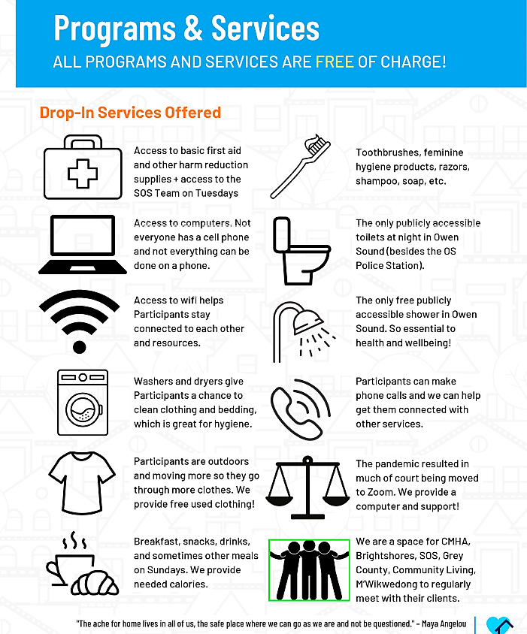
2024 A Year in Review – Safe’n’Sound

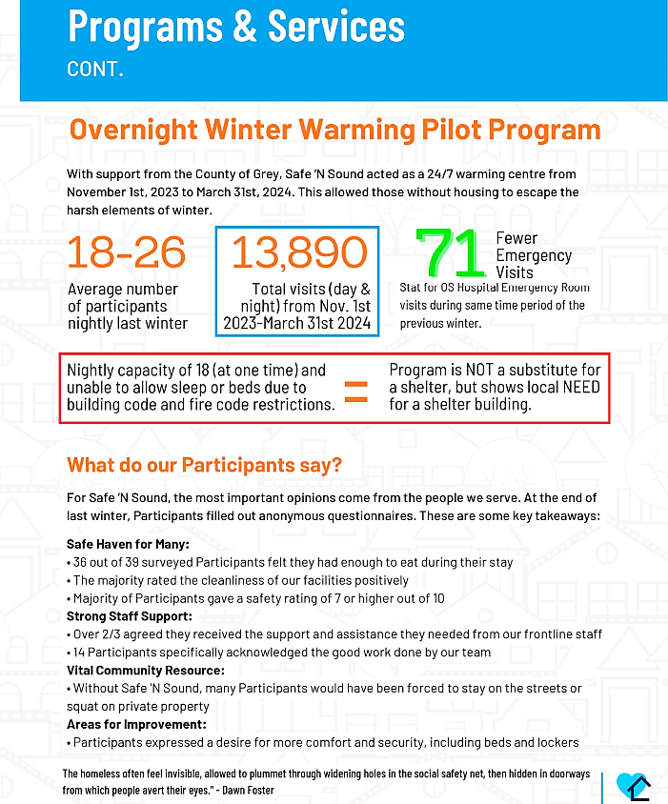

Work Sheet
Task 1: List six (6) drop-in services that are provided by Safe’n’Sound.
Answer:

______________________________________________________
Task 2: Which organizations use Safe’n’Sound to meet with their clients?
Answer:

______________________________________________________
Task 3: How many visits were there between November 1, 2024 and March 31, 2024 during the overnight winter warming pilot program?
Answer:

______________________________________________________
Task 4: When surveyed, what did participants suggest for improving the winter warming pilot program?
Answer:

______________________________________________________

Answers
Task 1: List six (6) drop-in services that are provided by Safe’n’Sound.
Answer: Any 6 of:
- First aid and harm reduction supplies
- Access to computers
- Access to wifi
- Access to washers and dryers
- Clothing
- Food
- Hygiene products
- Public toilet access at night
- Public shower access
- Phones
- Support for zoom calls (court support)
- Meeting space for clients to connect with other agencies (e.g. CMHA)

Task 2: Which organizations use Safe’n’Sound to meet with their clients?
Answer: CMHA, Brightshores, SOS, Grey County, Community Living, M’Wikwedong

Task 3: How many visits were there between November 1 2024 and March 31 2024 during the overnight winter warming pilot program?
Answer: 13,890 total visits (including daytime)

Task 4: When surveyed, what did participants suggest for improving the winter warming pilot program?
Answer: Participants expressed a desire for more comfort and security, including beds and lockers

Performance Descriptors
Levels | Performance Descriptors | Needs Work | Completes task with support from practitioner | Completes task independently
A1.2 | scans text to locate information
 | locates multiple pieces of information in simple texts
 | makes low-level inferences
 | makes connections between sentences and between paragraphs in a single text
 | reads more complex texts to locate a single piece of information
 | follows the main events of descriptive, narrative and informational text
 | obtains information from detailed reading
 | begins to identify sources and evaluate information

This task: Was successfully completed Needs to be tried again

Learner Comments:

Instructor (print): Learner (print):
__________________ _________________

