

Task Title: Role of College Library Services

OALCF Cover Sheet – Practitioner Copy

Learner Name: __________________________________________
Date Started: ___________________________________________
Date Completed: _________________________________________

Goal Path: | Employment | Apprenticeship
Secondary School | Post Secondary | Independence
Successful Completion: Yes No

Task Description: The learner will read a longer text about the role of Library Services at an Ontario College, and answer comprehension questions.
Main Competency/Task Group/Level Indicator:
- Find and Use Information/Read continuous text/A1.3
- Communicate Ideas and Information/Write Continuous Text/B2.3
Materials Required:
- Pen/pencil and paper and/or digital device

Learner Information
College and University libraries make decisions about which materials to purchase, replace, or remove from their collections.
Scan “Conestoga Library Services: Collection Development Practices”.

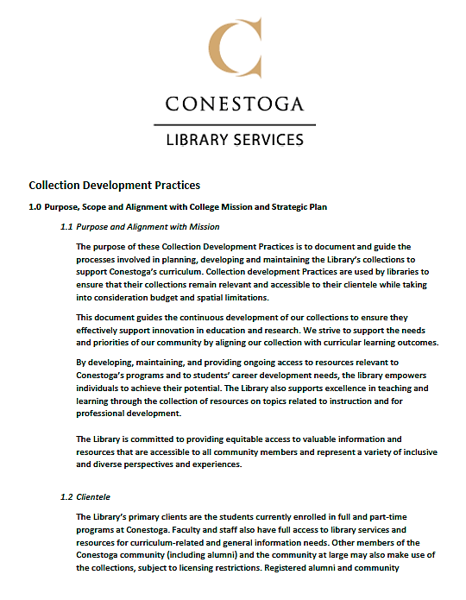

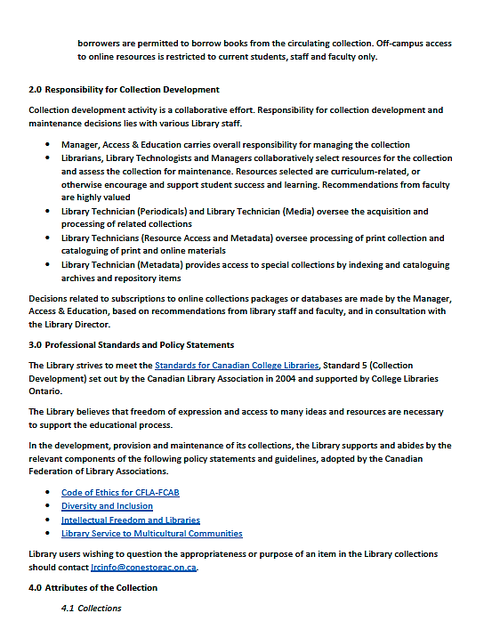

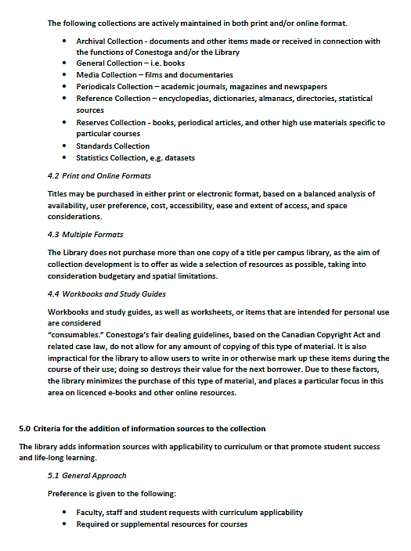

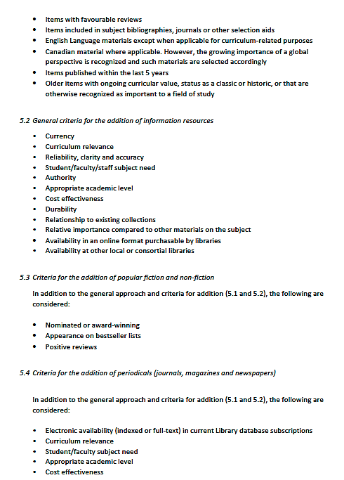

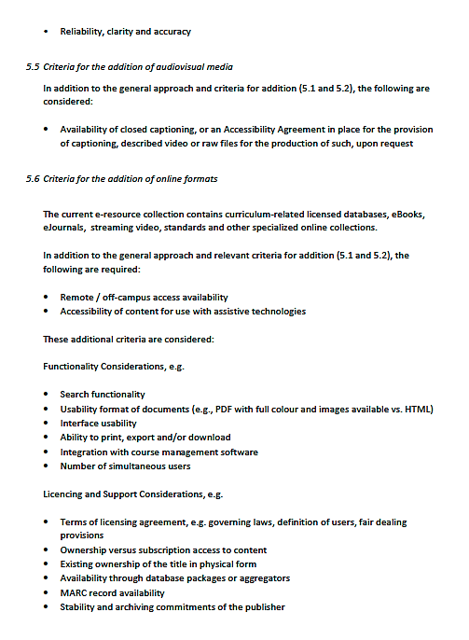

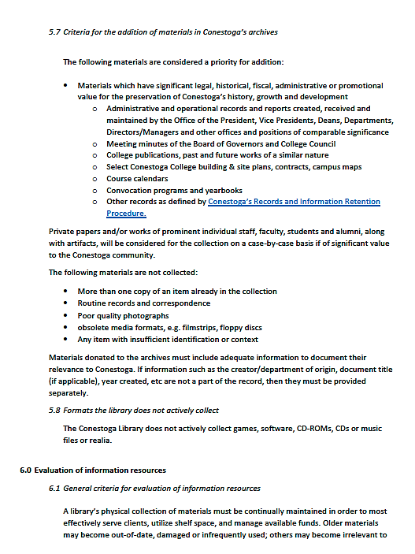

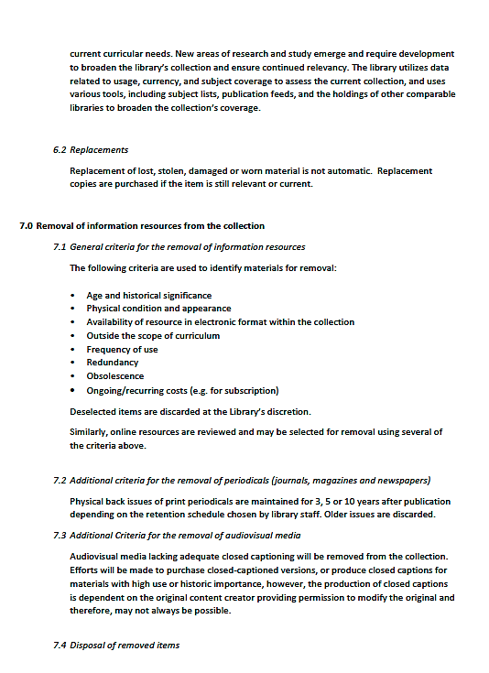

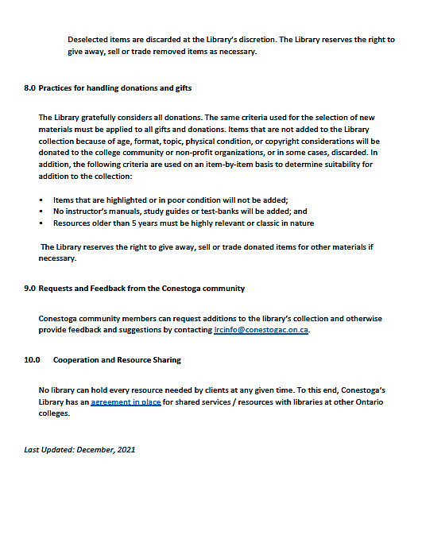

Source: https://lib.conestogac.on.ca/about-us/cd-practices

Work Sheet
Task 1: List the groups of people who have access to library resources and describe the type of access given to each group.
Answer:

______________________________________________________
Task 2: List the criteria considered for adding new periodicals to the library collection.
Answer:

______________________________________________________
Task 3: There are several criteria for removing resources from the library collection. Write an opinion paragraph of at least five (5) sentences explaining why you agree or disagree with at least three (3) of these criteria.
Answer:

______________________________________________________
Task 4: Write an opinion paragraph of at least five (5) sentences exploring additional criteria you believe could be used to determine removal of library resources.
Answer:

______________________________________________________
Answers
Task 1: List the groups of people who have access to library resources and describe the type of access given to each group.
Answer:
- Full and part-time Conestoga students: full access including off-campus access to online resources
- Faculty and staff: full access including off-campus access to online resources
- Other members of the Conestoga community (including alumni): subject to licensing restrictions; no off-campus access to online resources
- Community at large: no off-campus access to online resources

Task 2: List the criteria considered for adding new periodicals to the library collection.
Answer:
- Electronic availability
- Curriculum relevance
- Student/faculty subject need
- Appropriate academic level
- Cost effectiveness
- Reliability, clarity and accuracy

Task 3: There are several criteria for removing resources from the library collection. Write an opinion paragraph of at least five (5) sentences explaining why you agree or disagree with at least three (3) of these criteria.
Answers will vary, and may include opinions such as
- Age and historical significance: Older books are not necessarily less important and/or relevant to a modern audience. This may be particularly true for students studying history, classics, philosophy, etc.
- Physical condition and appearance: Worn books should be replaced instead of removed. The learner may ask whether there is a process for replacement of materials in poor condition. Books may also be in poor condition because they are used more frequently; this could be argued as a case for maintaining these resources in the library collection.
- Availability of resources in electronic format: The learner may defend paper/print copies of resources as not everyone prefers or is comfortable using electronic resources.
- Outside the scope of the curriculum: Many resources could still be useful, and curricula are subject to change; needed resources that align with course curricula are, therefore, also subject to change.
- Frequency of use: A resource may still have importance even if it is used by a relatively small number of people.
- Obsolescence: There may be research and historical reasons for which keeping obsolete texts remains valid and important.
- Ongoing/recurring costs: The learner may question whether resources can be allocated to these costs to ensure certain resources stay within the collection. They may speculate about things like group/bulk purchases.

Task 4: Write an opinion paragraph of at least five (5) sentences exploring additional criteria you believe could be used to determine removal of library resources.
Answers will vary but could include
- Survey of students/faculty to determine resource need/use before removal.
- Consultations with departments to determine most needed resources before considering removal.
- Partnering with other institutions to give students access to additional resources if removal of resources is necessary from one College’s collection.
- Consultations about funding to look at when/how resource removal is considered.

Performance Descriptors
Levels | Performance Descriptors | Needs Work | Completes task with support from practitioner | Completes task independently
A1.3 | integrates several pieces of information from texts
 | manages unfamiliar elements (e.g. vocabulary, context, topic) to complete tasks
 | identifies the purpose and relevance of texts
 | skims to get the gist of longer texts
 | begins to recognize bias and points of view in texts
 | infers meaning which is not explicit in texts
 | uses organizational features, such as headings, to locate information
 | follows the main events of descriptive, narrative, informational and persuasive texts
B2.3 | writes texts to present information, summarize, express opinions, present arguments, convey ideas or persuade
 | manages unfamiliar elements (e.g. vocabulary, context, topic) to complete tasks
B2.3 cont’d | selects and uses vocabulary, tone and structure appropriate to the task
 | organizes and sequences writing to communicate effectively
 | uses a variety of vocabulary, structures and approaches to convey main ideas with supporting details

This task: Was successfully completed Needs to be tried again
Learner Comments:

Instructor (print): Learner (print):
__________________ _________________

