

Task Title: Skilled Trades Earnings Infographics

# OALCF Cover Sheet – Practitioner Copy

**Learner Name: __________________________________________**

**Date Started: ___________________________________________**

**Date Completed: _________________________________________**

|  |  |  |
| --- | --- | --- |
| **Goal Path:** | Employment | Apprenticeship |
| Secondary School | Post Secondary | Independence |

**Successful Completion:**  Yes No

**Task Description:** The learner will find information about salary differences between men and women in skilled trades, and perform a calculation.

**Main Competency/Task Group/Level Indicator:**

* Find and Use Information/Interpret documents/A2.2
* Understand and Use Numbers/Manage money/C1.1

**Materials Required:**

* Pen/pencil and paper and/or digital device

# Learner Information

When researching a career, it is important to learn about the expected salary you will earn. In some careers, there is a significant difference between average earnings for men and women.

Scan the infographic sections from “How Much do they Make?”

**How Much do they Make?**

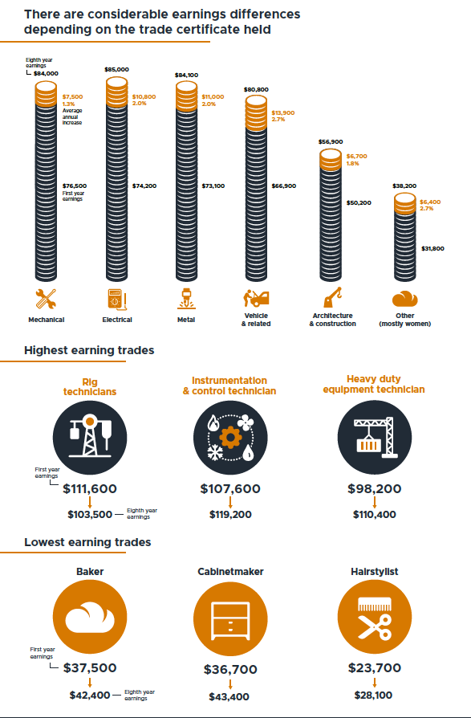

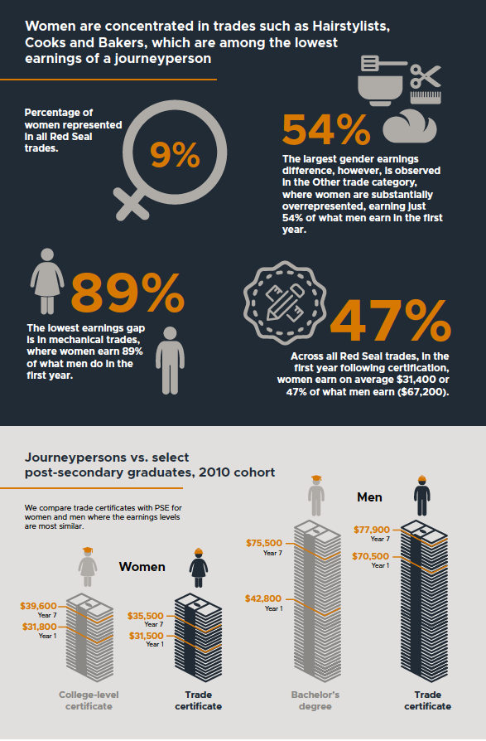

# Work Sheet

**Task 1: List the lowest-earning trades.**

Answer:

**______________________________________________________**

**Task 2: What percentage of Red Seal trades are held by women?**

Answer:

**______________________________________________________**

**Task 3: Across all Red Seal trades, how much do women earn on average in their first year after certification compared to men?**

Answer:

**______________________________________________________**

**Task 4: Calculate how much more men earn than women, based on average earnings at year 7 for people with a trade certificate.**

Answer:

**______________________________________________________**

# Answers

**Task 1: List the lowest-earning trades.**

Answer: Baker, cabinetmaker, hairstylist.

**Task 2: What percentage of Red Seal trades are held by women?**

Answer: 9%

**Task 3: Across all Red Seal trades, how much do women earn on average in their first year after certification compared to men?**

Answer: On average, women earn $31,400; men earn $67,200 (on average, women earn 47% of what men earn)

**Task 4: Calculate how much more men earn than women, based on average earnings at year 7 for people with a trade certificate.**

Answer: $77,900 - $35,500 = $42,400

# Performance Descriptors

| Levels | Performance Descriptors | Needs Work | Completes task with support from practitioner | Completes task independently |
| --- | --- | --- | --- | --- |
| A2.2 | performs limited searches using one or two search criteria |  |  |  |
|  | extracts information from tables and forms |  |  |  |
|  | locates information in simple graphs and maps |  |  |  |
|  | uses layout to locate information |  |  |  |
|  | makes connections between parts of documents |  |  |  |
|  | makes low-level inferences |  |  |  |
|  | begins to identify sources and evaluate information |  |  |  |
| C1.1 | adds, subtracts, multiplies and divides whole numbers and decimals |  |  |  |
|  | recognizes values in number and word format |  |  |  |
|  | identifies and performs required operation |  |  |  |
|  | follows apparent steps to reach solutions |  |  |  |
|  | interprets and represents costs using monetary symbols and decimals |  |  |  |
|  | uses strategies to check accuracy (e.g. estimating, using a calculator, repeating a calculation, using the reverse operation) |  |  |  |

This task: Was successfully completed Needs to be tried again

Learner Comments:

Instructor (print): Learner (print):

**__________________ _________________**