

Task Title: Use “Best Before” Dates to Select Food

OALCF Cover Sheet – Practitioner Copy

Learner Name: __________________________________________
Date Started: ___________________________________________
Date Completed: _________________________________________

Goal Path: | Employment | Apprenticeship
Secondary School | Post Secondary | Independence
Successful Completion: Yes No

Task Description: The learner will locate and read “best before dates on various products to determine freshness of food.
Main Competency/Task Group/Level Indicator:
- Understand and Use Numbers/Manage time/C2.1
Materials Required:
- Pen/pencil and paper and/or digital device

Learner Information
Consumers check “best before” dates on food in stores to ensure what they are buying is fresh. They may also check food items on their shelves and in their refrigerators at home to decide when they should be discarded.
Scan the “Best Before Date Labels”.

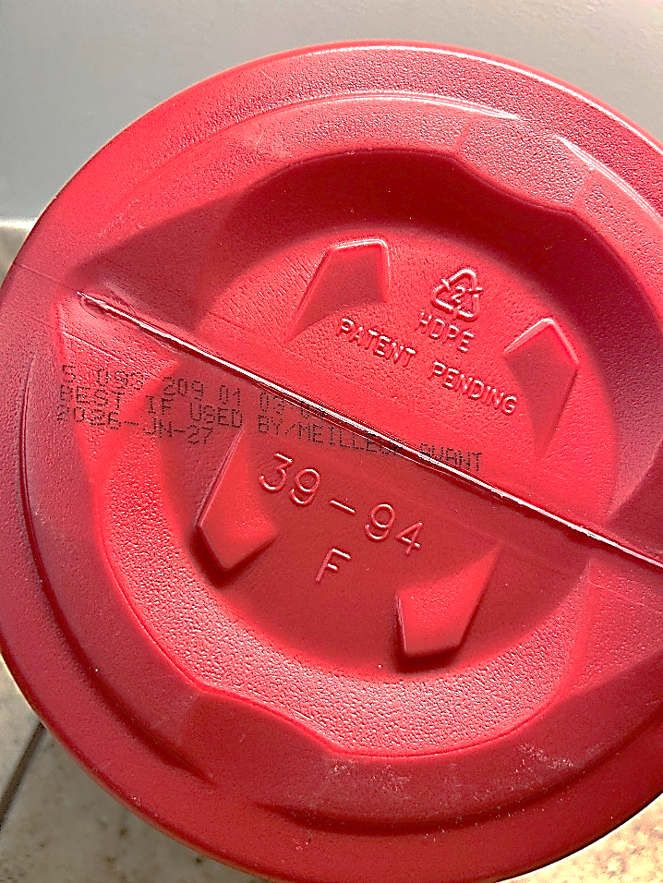
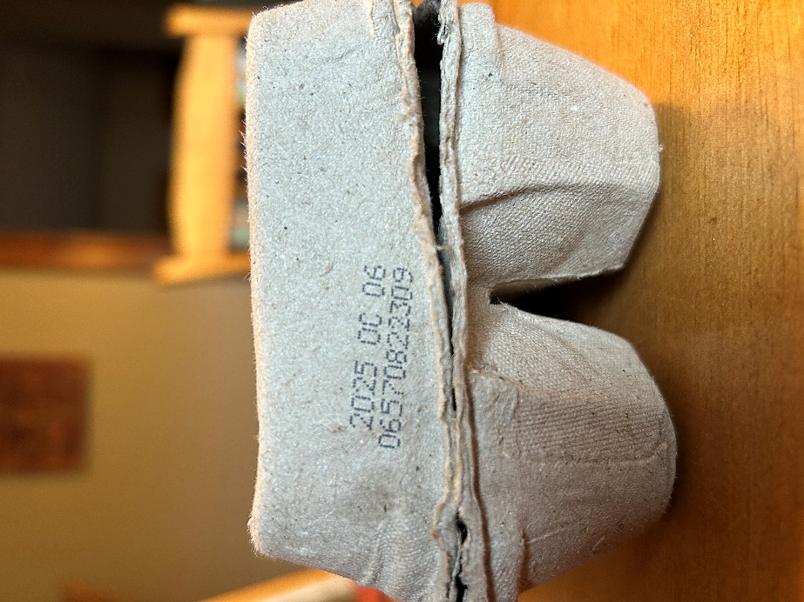
Best Before Date Labels

Coffee Eggs
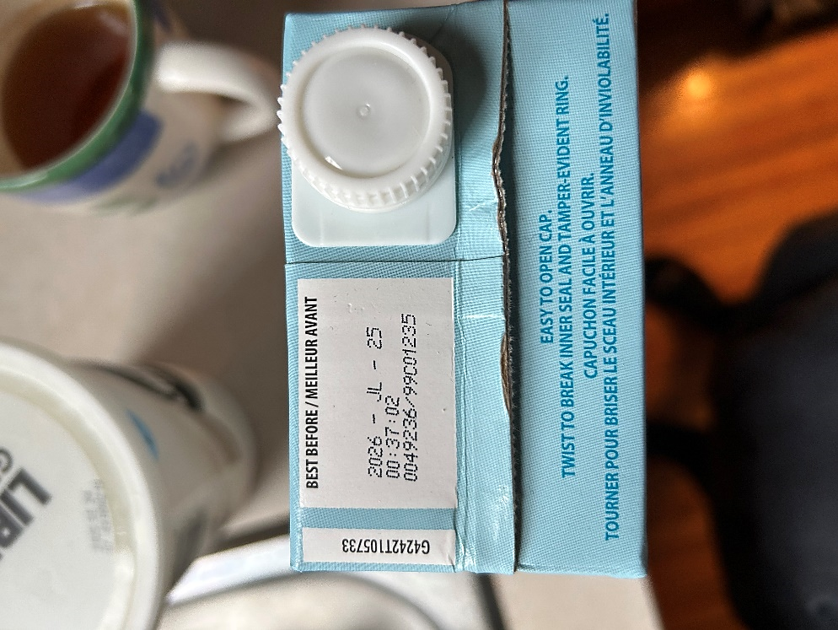
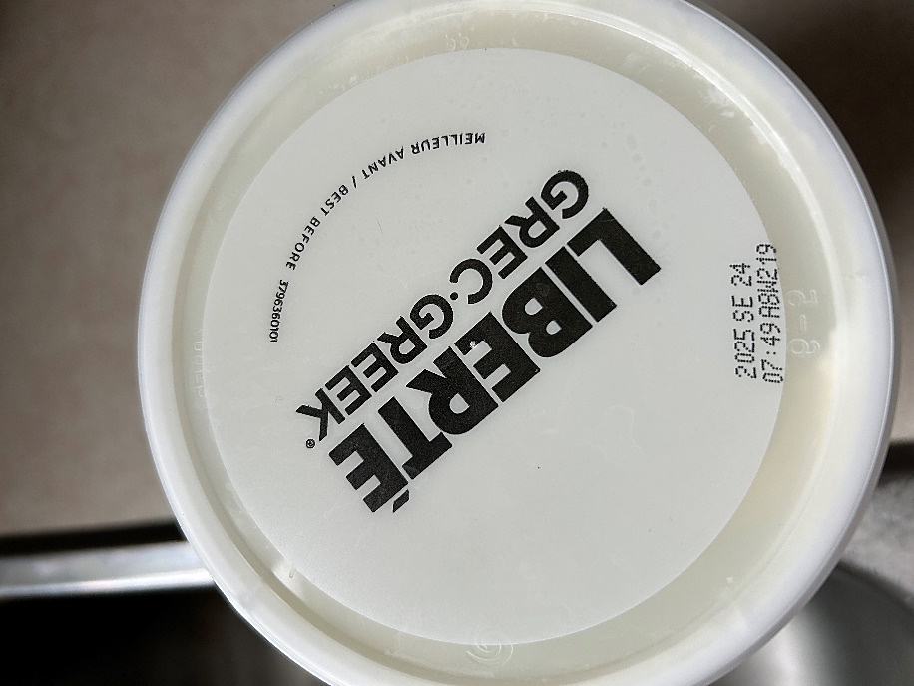
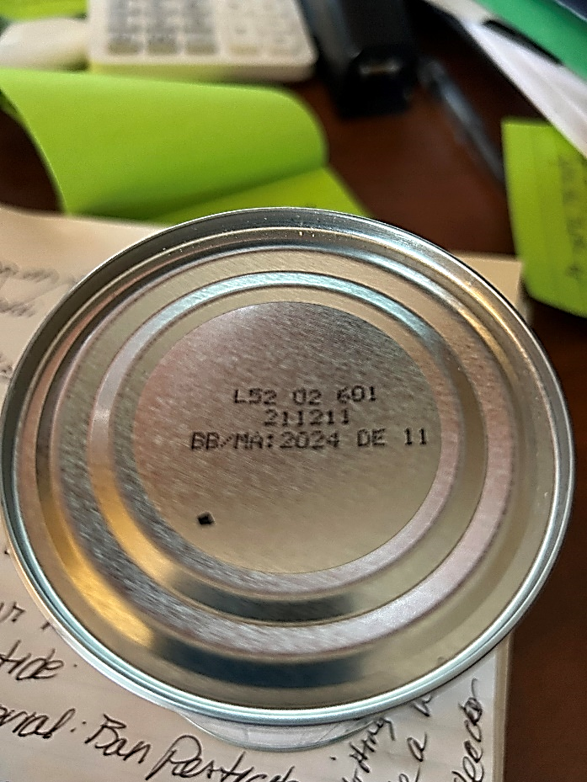
Yogurt Canned Mandarins
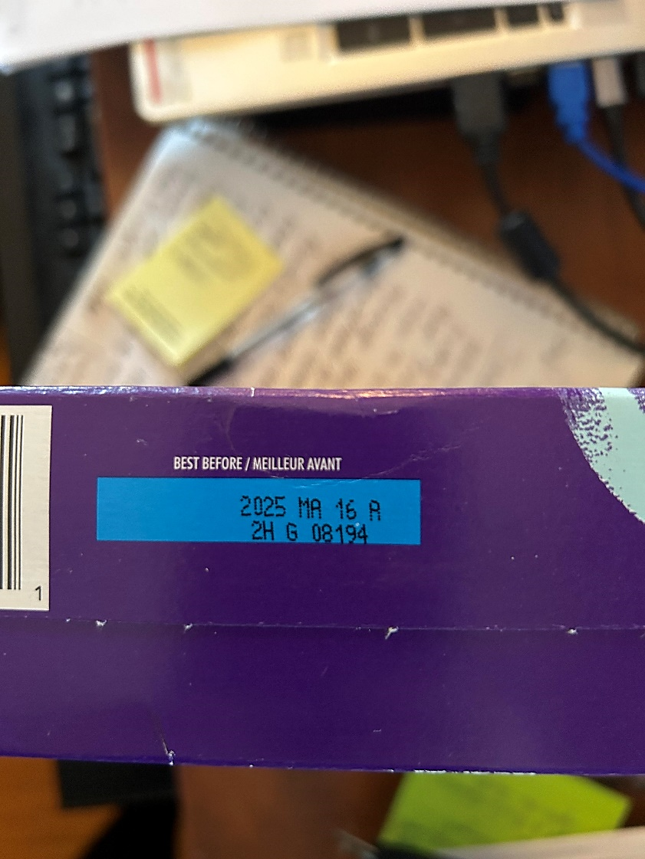

Crackers Chicken Broth

Work Sheet
Task 1: What food was best before December 11, 2024?
Answer:
______________________________________________________
Task 2: What food was best before September 24, 2025?
Answer:
______________________________________________________
Task 3: Which food should be eaten before July 25, 2026?
Answer:
______________________________________________________
Task 4: What date are the eggs best before?
Answer:
______________________________________________________
Task 5: What month in 2026 is the coffee best before?
Answer:
______________________________________________________
Task 6: When were the crackers best before?
Answer:

______________________________________________________

Answers

Task 1: What food was best before December 11, 2024?
Answer: Canned Mandarins

Task 2: What food was best before September 24, 2025?
Answer: Yogurt (Liberte Greek Yogurt)

Task 3: Which food should be eaten before July 25, 2026?
Answer: Chicken Broth

Task 4: What date are the eggs best before?
Answer: October 6, 2025

Task 5: What month in 2026 is the coffee best before?
Answer: June

Task 6: When were the crackers best before?
Answer: May 16, 2025

Performance Descriptors
Levels | Performance Descriptors | Needs Work | Completes task with support from practitioner | Completes task independently
C2.1 | understands and uses common date formats
 | represents dates and times using standard conventions

This task: Was successfully completed Needs to be tried again

Learner Comments:

Instructor (print): Learner (print):
__________________ _________________

