

Task Title: Using a Monthly Calendar

# OALCF Cover Sheet – Practitioner Copy

**Learner Name: __________________________________________**

**Date Started: ___________________________________________**

**Date Completed: _________________________________________**

|  |  |  |
| --- | --- | --- |
| **Goal Path:** | Employment | Apprenticeship |
| Secondary School | Post Secondary | Independence |

**Successful Completion:**  Yes No

**Task Description:** The learner will write appointments and activities on a monthly calendar.

**Main Competency/Task Group/Level Indicator:**

* Communicate Ideas and Information/Complete and create documents/B3.1a
* Understand and Use Numbers/Use measures/C3.1

**Materials Required:**

* Pen/pencil and paper and/or digital device

# Learner Information

Many people record appointments and activities on a monthly calendar.

Scan the “September 2025” calendar.

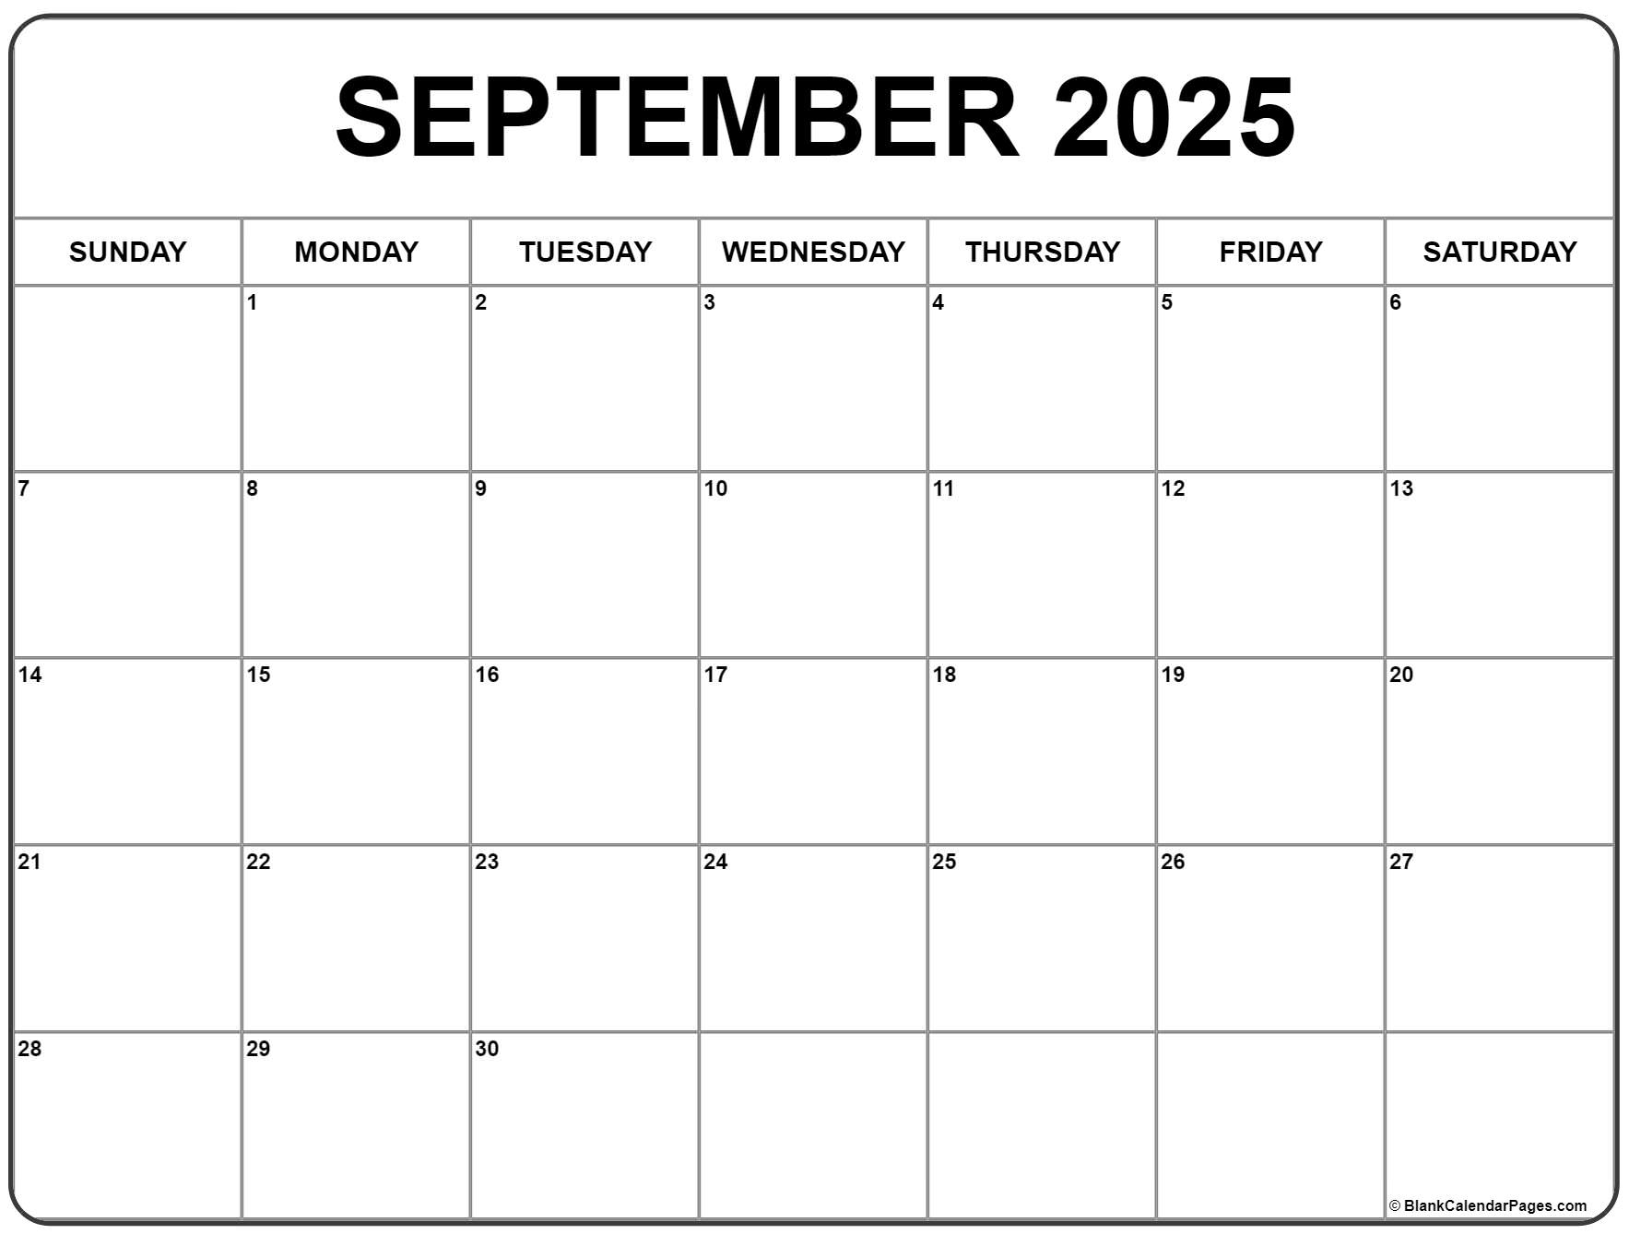

# Work Sheet

**Task 1: You have a doctor’s appointment on Tuesday, September 16th at 11:30am. Write this appointment in the calendar.**

Answer: No written response required here.

Task completed: Yes:

**Task 2: Baseball practice is every Saturday morning at 10:30am. Write this in the calendar.**

Answer: No written response required here.

Task completed: Yes:

**Task 3: You borrowed library books on September 12th. They are due two weeks later. Write the due date in the calendar.**

Answer: No written response required here.

Task completed: Yes:

**Task 4: You are working from 1pm to 6pm every Monday except the last Monday of the month. Write these shifts in the calendar.**

Answer: No written response required here.

Task completed: Yes:

Answers

# Performance Descriptors

| Levels | Performance Descriptors | Needs Work | Completes task with support from practitioner | Completes task independently |
| --- | --- | --- | --- | --- |
| B3.1a | makes a direct match between what is requested and what is entered |  |  |  |
|  | makes entries using familiar vocabulary |  |  |  |
| C2.1 | recognizes values in number and word format |  |  |  |
|  | understands chronological order |  |  |  |
|  | understands and uses common date formats |  |  |  |
|  | represents dates and times using standard conventions |  |  |  |

This task: Was successfully completed Needs to be tried again

Learner Comments:

Instructor (print): Learner (print):

**__________________ _________________**