

Task Title: Using a POS (Point of Sale) Terminal

# OALCF Cover Sheet – Practitioner Copy

**Learner Name:**

**Date Started:**

**Date Completed:**

|  |  |  |
| --- | --- | --- |
| **Goal Path:** | Employment | Apprenticeship |
| Secondary School | Post Secondary | Independence |

**Successful Completion:**  Yes No

**Task Description:** The learner reads a Point Of Sale (POS) terminal screen to answer questions about a restaurant.

**Main Competency/Task Group/Level Indicator:**

* Find and Use Information/Interpret documents/A2.2
* Understand and Use Numbers/Manage money/C1.1

**Materials Required:**

* Pen/pencil and paper and/or digital device

# Learner Information

# To work in the service industry, you may need to use a POS (sometimes called Point of Service or Point of Sale) terminal to serve your customers. This will help you take orders, send orders to the kitchen and help giving customers their bill.

# Scan the document “POS (Point of Service).”

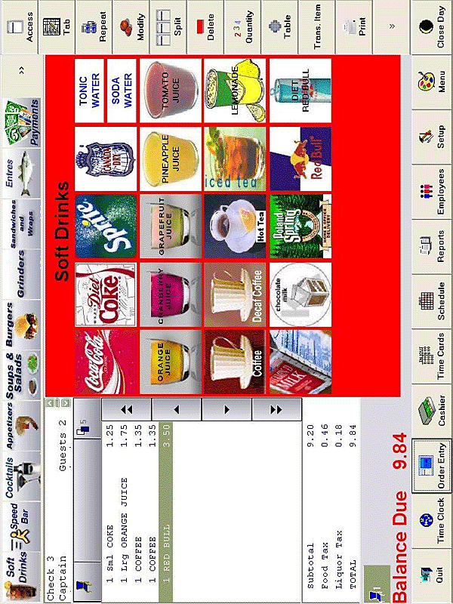**POS (Point of Service)**

# Work Sheet

**Task 1: What three hot drinks can be served?**

Answer:

**______________________________________________________**

**Task 2: What are the names of the two taxes that are charged?**

Answer:

**______________________________________________________**

**Task 3: Circle, highlight or underline the subtotal of the bill.**

Answer:

**______________________________________________________**

**Task 4: A customer would like to order two coffees. How much will it cost?**

Answer:

**______________________________________________________**

**Task 5: What are three juices that can be served?**

Answer:

**______________________________________________________**

**Task 6: A customer is ready to pay their bill. Circle a button that will allow them to pay.**

Answer:

**______________________________________________________**

# Answers

**Task 1: What three hot drinks can be served?**

Answer: coffee, decaf coffee and hot tea.

**Task 2: What are the names of the two taxes that are charged?**

Answer: food tax and liquor tax.

**Task 3: Circle, highlight or underline the subtotal of the bill.**

Answer: $9.20

**Task 4: A customer would like to order two coffees. How much will it cost?**

Answer: $2.70

**Task 5: What are three juices that can be served?**

Answer: And three of: orange, cranberry, grapefruit, pineapple, tomato.

**Task 6: A customer is ready to pay their bill. Circle a button that will allow them to pay.**

Answer: Learner will circle the button marked “payments” or “cashier”.

# Performance Descriptors

| Levels | Performance Descriptors | Needs Work | Completes task with support from practitioner | Completes task independently |
| --- | --- | --- | --- | --- |
| A2.2 | performs limited searches using one or two search criteria |  |  |  |
|  | extracts information from tables and forms |  |  |  |
|  | locates information in simple graphs and maps |  |  |  |
|  | uses layout to locate information |  |  |  |
|  | makes connections between parts of documents |  |  |  |
|  | makes low-level inferences |  |  |  |
| C1.1 | adds and subtracts whole numbers and decimals |  |  |  |
|  | understands numerical order |  |  |  |
|  | recognizes values in number and word format |  |  |  |
|  | identifies and performs required operation |  |  |  |
|  | follows apparent steps to reach solutions |  |  |  |
|  | interprets and represents costs using monetary symbols and decimals |  |  |  |

This task: Was successfully completed Needs to be tried again

Learner Comments:

Instructor (print): Learner (print):

**__________________ _________________**