Prepared for: Cementing Integration Project – QUILL Learning Network 2015

Task Title: Read a brief note from a co-worker

OALCF Cover Sheet – Practitioner Copy

Learner Name:
Date Started (m/d/yyyy):
Date Completed (m/d/yyyy):
Successful Completion: Yes ☐ No ☐
Goal Path: | Employment ☒ | Apprenticeship ☒
Secondary School ☐ | Post Secondary ☐ | Independence ☐
Task Description: Learner will read a brief email from a co-worker and
answer questions orally or in writing
Competency: A: Find and Use Information
Task Groups: A1: Read continuous text
Level Indicators:
- A1.1: Read brief texts to locate specific details
Performance Descriptors: See chart on last page
Links to skill building activities: see the last page or click here
Materials Required:
- Photocopy of email (attached) for learner
- Pencil

ESKARGO:
- Reading Strategies – Decoding and Comprehension Enhancement
- Uses phonics and knowledge of word parts to decode words
- Uses knowledge of basic grammar, predictable word patterns, and basic sentence structure in speech to understand phrases and sentences
- Uses knowledge of basic spelling conventions and simple punctuation to gather meaning from sentences
- Uses context cues and personal experience to gather meaning from the text
- Scans simple text to locate a single piece of information
- Forms and Conventions – Find Information/Research/Understand Types of Texts
- Reads sentences up to one paragraph
  - Reads text having familiar, everyday content
  - Reads text with simple, concrete information in simple, familiar wording
- Comprehension – Read to Understand/Retell
  - Reads signs, symbols and common sight words from everyday life
  - Makes meaning of sentences in a single text
- Interpretation – Read and Apply Understanding
  - Locates a single piece of information in short texts
- Follows the sequence of events in simple texts
  - Follows simple, straightforward instructions
Attitudes:
Practitioner,
We encourage you to talk with the learner about attitudes required to complete this task set. The context of the task has to be considered when identifying attitudes. With your learner, please check one of the following:

☐ Attitude is not important ☐ Attitude is somewhat important
☐ Attitude is very important

Learner Information
Employees often communicate with other employees by email. Read the email.
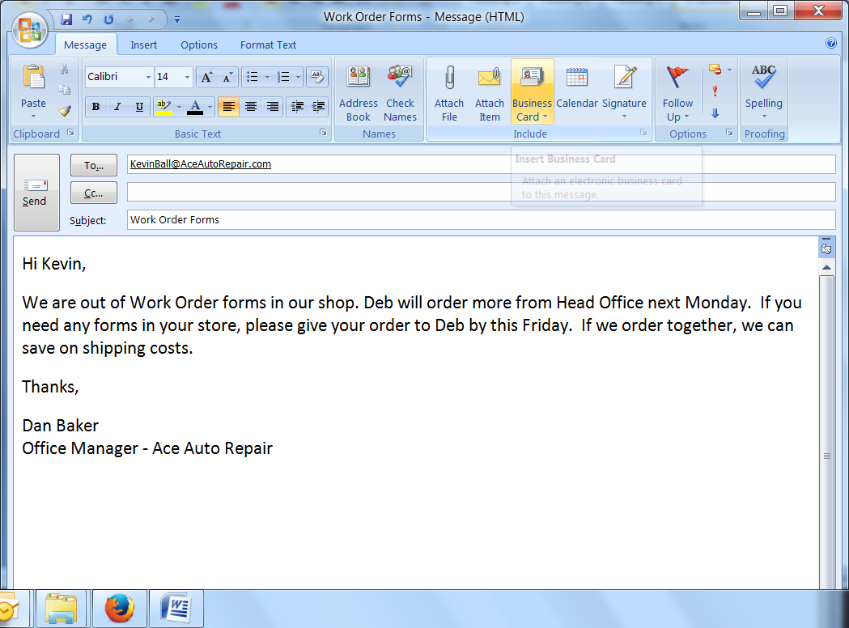

Work Sheet
Task 1: Who wrote this email?
Answer:

Task 2: To whom was the email sent?
Answer:

Task 3: What forms does Dan’s shop need?
Answer:

Task 4: Who will order the forms?
Answer:

Task 5: When will the forms be ordered?
Answer:

Task 6: When does Deb need Kevin’s order?
Answer:

Task 7: What costs will Dan and Kevin save on if they order
together?
Answer:

Answers
Task 1: Who wrote this email?
Dan or Dan Baker
Task 2: To whom was the email sent?
Kevin
Task 3: What forms does Dan’s shop need?
Work Order forms
Task 4: Who will order the forms?
Deb
Task 5: When will Deb order the forms?
(Next) Monday
Task 6: When does Deb need Kevin’s order?
By this Friday
Task 7: What costs will Dan and Kevin save on if they order together?
Shipping costs

Performance Descriptors
Levels | Performance Descriptors | Needs Work | Completes task with support from practitioner | Completes task independently
A1.1 | Reads short texts to locate a single piece of information
A1.1 | Decodes words and makes meaning of sentences in a single text
A1.1 | Follow simple, straightforward instructional texts
A1.1 | Follows the sequence of events in straightforward chronological texts
A1.1 | Requires support to identify sources and to evaluate and integrate information

This task:
Was successfully completed ☐ Needs to be tried again ☐
Learner Comments:

Instructor (print): Learner Signature:

Skill Building Activities
Links to online resources:
- BBC Skillswise – “Instructions” – http://www.bbc.co.uk/skillswise/topic/instructions - learn to recognize instructional texts; practise following instructions in the game
- Skill Plan’s, “Measure Up” - http://www.skillplan.ca/measure-up , (select “English”, “Choice of Activities”, “Practice”, “Reading”, and “Notes, Letters, Memos”) – tasks to practise following the sequence of events, and following simple, straightforward instructions, in notes, letters, and memos
- GCF LearnFree – “Practice Reading” Games - http://www.gcflearnfree.org/reading/practicereading/play - choose a category (e.g. conversation, commands, writing) from the top row of icons, and the “texts” icon from the bottom row, to practise reading comprehension; read passages of text and respond to question
- Literacytools – “Writing Notes” - http://www.literacytools.ie/pages/actions/viewPdfFile.cfm?pId=177 – learn how to write instructions in a brief note or message; by learning to write notes, the learner can also develop skills for reading notes
LearningHUB Courses Available:
- Live Classes (SABA) - “Reading Comprehension”
- Essential Skills, Independent Study, Short Courses
  - Improving Your Job Skills (Module 2- Communication)
- Reading & Writing, Independent Study (Assigned by practitioner after assessment)
  - Reading Level 1, Assignment: all lessons teach essential reading strategies required to read and understand brief texts (e.g. Finding Main Ideas, Working with Order, Using Context Clues, etc.)
  - Reading Level 1, Assignment 2: You Have a Message, Getting the Details, What Should I Do, How to Read a Message, Action Plan
*To access LearningHUB courses, learners must register for the LearningHUB e-Channel program by completing the registration form on their website and completing the course selection (page 2 of the registration form): https://www.learninghub.ca/user/register
*To Access LearningHUB Course Catalogue:
https://www.learninghub.ca/sites/default/files/TLH%20Course%20Catalogue%20%20Mar19%20F.pdf

