

Task Title: Read a Brief Note from a Co-Worker

OALCF Cover Sheet – Practitioner Copy
Learner Name:___________________________________________
Date Started (m/d/yyyy):__________________________________
Date Completed (m/d/yyyy): _______________________________
Successful Completion: Yes ☐ No ☐
Goal Path: | Employment ☒ | Apprenticeship ☒
Secondary School ☐ | Post Secondary ☐ | Independence ☐

Task Description: Learner will read a brief email from a co-worker and
answer questions.

Main Competency / Task Group / Level Indicator:
- Find and Use Information / Read continuous text / A1.1: Read brief texts to locate specific details

Performance Descriptors: See chart on last page

Materials Required:
- Photocopy of email (attached) for learner
- Pencil

Learner Information
Employees often communicate with other employees by email.
Read the email.
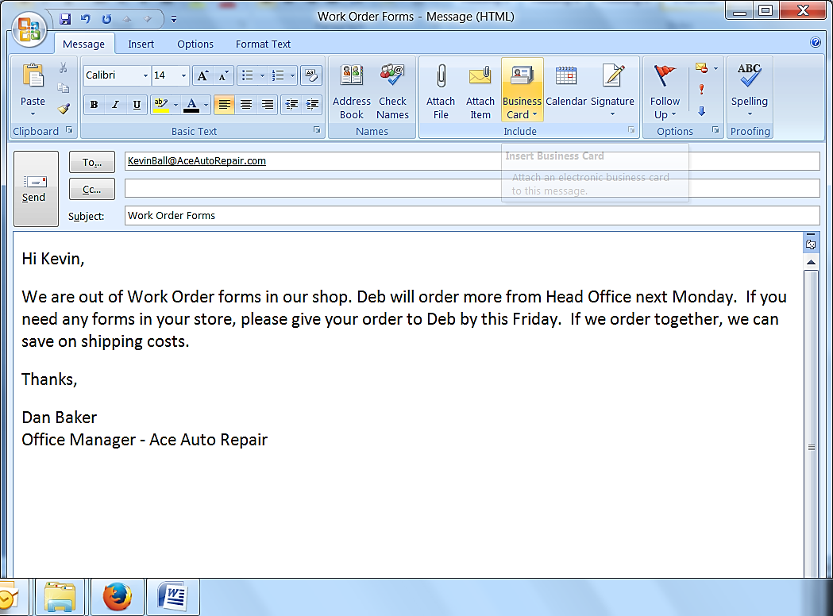

Work Sheet
Task 1: Who wrote this email?
Answer:
_____________________________________________________________
Task 2: To whom was the email sent?
Answer:
_____________________________________________________________
Task 3: What forms does Dan’s shop need?
Answer:
_____________________________________________________________
Task 4: Who will order the forms?
Answer:
_____________________________________________________________
Task 5: When will the forms be ordered?
Answer:
_____________________________________________________________
Task 6: When does Deb need Kevin’s order?
Answer:
_____________________________________________________________
Task 7: What costs will Dan and Kevin save on if they order
together?
Answer:

_____________________________________________________________

Answers
Task 1: Who wrote this email?
Dan or Dan Baker
Task 2: To whom was the email sent?
Kevin
Task 3: What forms does Dan’s shop need?
Work Order forms
Task 4: Who will order the forms?
Deb
Task 5: When will Deb order the forms?
(Next) Monday
Task 6: When does Deb need Kevin’s order?
By this Friday
Task 7: What costs will Dan and Kevin save on if they order together?
Shipping costs

Performance Descriptors
Levels | Performance Descriptors | Needs Work | Completes task with support from practitioner | Completes task independently
A1.1 | Reads short texts to locate a single piece of information
 | Decodes words and makes meaning of sentences in a single text
 | Follow simple, straightforward instructional texts
 | Follows the sequence of events in straightforward chronological texts
 | Requires support to identify sources and to evaluate and integrate information

This task: Was successfully completed ☐ Needs to be tried again ☐
Learner Comments:

Instructor (print): Learner Signature:
___________________ __________________

