OALCF Task Cover Sheet
Task Title: Reading for Health

Learner Name:

Date Started: Date Completed:

Successful Completion: Yes___ No___
Goal Path: Employment___ Apprenticeship___ Secondary School √ Post Secondary √ Independence √

Task Description:
In this task the learner is required to answer comprehension questions using their own words and then write a response, expressing an opinion.
Independence Path learners will need to be able to read and understand health-related information for themselves or their families. Secondary/Post-Secondary Path learners will need to be able to answer simple comprehension questions and give an opinion in written form.
Competency:  A: Find and Use Information  B: Communicate Ideas and Information | Task Group(s):  A1: Read continuous text  A2: Interpret documents  B2: Write continuous text
Level Indicators:
A1.2: Read texts to locate and connect ideas and information
A1.3: Read longer texts to connect, evaluate, and integrate ideas and information
A2.1: Interpret very simple documents to locate specific details
B2.1: Write brief texts to convey simple ideas and factual information
Performance Descriptors: see chart on last page

Materials Required:
- Information sheet (attached)
- Question sheet
- Pen/pencil
- Skill building activities could include providing the learner with information on other diseases, such as childhood/ communicable diseases. However, topics must be familiar and include everyday content and personal and/or general relevance. Text should have concrete information in one page (short paragraphs)

Task Title: Reading for Health

Task Description: The learner reads two articles, both on health-related topics.

Learner Instructions:
Read the two articles and give your opinion by answering the questions below in writing. You may refer to a dictionary for any words you do not understand. Use correct sentences when writing your answers.

- What does the word “symptoms” mean?
_____________________________________________________________________

- What are some symptoms of the flu?
_________________________________________________________________________

- What should you do if you think you have the flu?
__________________________________________________________________________
___________________________________________________________________________

- What is a vaccine?
___________________________________________________________________________
___________________________________________________________________________

- Who should take the flu vaccine? Why?
_____________________________________________________________________________
_____________________________________________________________________________
______________________________________________________________________________

- Do you agree or disagree that people should take the flu vaccine?
_________________________________________________________________________________
_________________________________________________________________________________
__________________________________________________________________________________
__________________________________________________________________________________

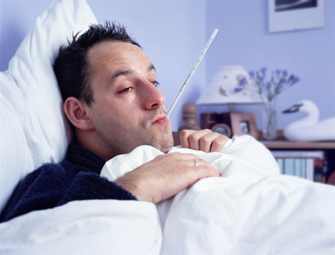

Beware….. the Flu!

In Canada, about 2,000 people die from the flu every year. However, most people get sick for only a week or two.

When you have the flu, sometimes your muscles ache and you might have a headache and the chills. You should stay in bed and drink lots of fluids like juice and water. Some adults take pills like Tylenol for the flu, but you should not give children any pills without checking first with your doctor.

There is a vaccine you can get to prevent the flu. Most senior citizens get this shot. Other adults or children with serious health problems should take the vaccine as well.

T’is the Season for Colds

There are over 2,000 types of viruses that cause colds. The cold virus gets into your nose. You will get the virus on your hands and then if you touch your nose, the virus will get into your nose. That is why it is so important to keep your hands clean. If you do have a cold, and you have to blow your nose, always wash your hands after doing so. You can spread your cold to others by not keeping your hands clean. If you have a cold, it is not a good idea to share your things with others.

If you have a cold, it is a good idea to make sure you get plenty of rest. You can take medicine like Tylenol for a cold. If you have a cold for too long, check with your doctor in case you get something more severe, like pneumonia.

Questions for “T’is the Season for Colds!”

- How many types of cold viruses are there?
______________________________________________________________________________________

_______________________________________________________________________________________

- What does the word “virus” mean?
______________________________________________________________________________________

________________________________________________________________________________________

- Is “virus” a noun or verb?
_______________________________________________________________________________________

- Why is it important to keep your hands clean?
_______________________________________________________________________________________

_______________________________________________________________________________________

- What might happen if your cold lasts for a long period of time and keeps getting worse?
________________________________________________________________________________________

_________________________________________________________________________________________

________________________________________________________________________________________

- Which do you think is worse, a cold or the flu? Give two reasons why.
_________________________________________________________________________________________

_________________________________________________________________________________________

__________________________________________________________________________________________

Task Title: Reading for Health
Performance Descriptors |  | Needs Work | Completes task with support from practitioner | Completes task independently
A1.2: | - Makes connections between sentences and between paragraphs in a single text.
 | - Scans text to locate information.
 | - Locates multiple pieces of information in simple texts.
 | - Follows the main events of descriptive, narrative, and informational texts.
 | - Obtains information from detailed reading.
A1.3: | - Manages unfamiliar elements (e.g. vocabulary, context, topic) to complete tasks.
 | - Compares or contrasts information between two or more texts.
 | - Follows the main events of descriptive, narrative, informational, and persuasive texts.
 | - Obtains information from detailed reading.
A2.1: | - Scans to locate specific details.
B2.1: | - Writes simple texts to request, remind, or inform.
 | - Conveys simple ideas and factual information.
 | - Uses sentence structure, upper and lower case, and basic punctuation.

This task: was successfully completed___ needs to be tried again___

Learner Comments

____________________________ _________________________

Instructor (print) Learner Signature

