

Task Title: Red Seal Program Brochure

OALCF Cover Sheet – Practitioner Copy

Learner Name:
Date Started:
Date Completed:
Goal Path: | Employment | Apprenticeship
Secondary School | Post Secondary | Independence
Successful Completion: Yes No

Task Description:
Read and interpret information on a brochure to answer questions about the Red Seal Program.
Main Competency/Task Group/Level Indicator:
- Find and Use Information/Interpret documents/A2.2
- Communicate Ideas and Information/Write continuous text/B2.2
Materials Required:
- Pen/pencil and paper and/or digital device

Learner Information
The Red Seal program sets the standards for workers in the skilled trades in Canada. There are more than 400 skilled trades in Ontario. About 54 of these are designated Red Seal trades. Tradespeople who pass the Red Seal exam receive a Red Seal endorsement on their trade certificate. Scan the Red Seal Program brochure.

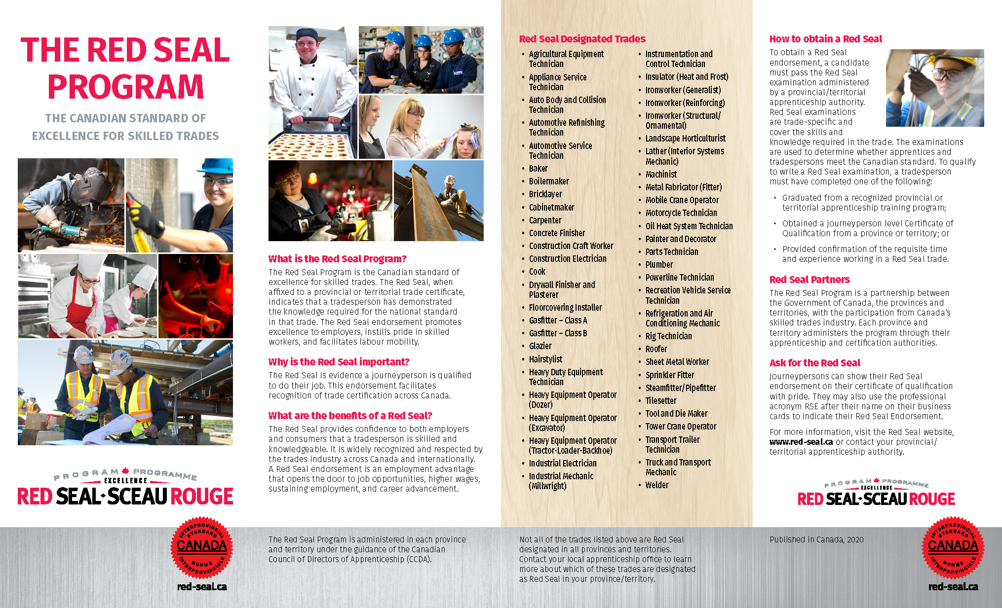

Work Sheet
Task 1: List 3 Red Seal designated trades.
Answer:

Task 2: Which type of training program must a worker complete to write the Red Seal exam?
Answer:

Task 3: List 3 employment advantages to a Red Seal endorsement.
Answer:

Task 4: How can someone learn more about which trades are designated as Red Seal in Ontario?
Answer:

Task 5: In your own words, write a paragraph of 3-5 sentences explaining why a tradesperson might want a Red Seal Endorsement.
Answer:

Answers
Task 1: List 3 red seal designated trades.
Answer: Any 3 of the following:
- Agricultural Equipment Technician
- Appliance Service Technician
- Auto Body and Collision Technician
- Automotive Refinishing Technician
- Automotive Service Technician
- Baker
- Boilermaker
- Bricklayer
- Cabinetmaker
- Carpenter
- Concrete Finisher
- Construction Craft Worker
- Construction Electrician
- Cook
- Drywall Finisher and Plasterer
- Floorcovering Installer
- Gasfitter – Class A
- Gasfitter – Class B
- Glazier
- Hairstylist
- Heavy Duty Equipment Technician
- Heavy Equipment Operator (Dozer)
- Heavy Equipment Operator (Excavator)
- Heavy Equipment Operator (Tractor-Loader-Backhoe)
- Industrial Electrician
- Industrial Mechanic (Millwright)
- Instrumentation and Control Technician
- Insulator (Heat and Frost)
- Ironworker (Generalist)
- Ironworker (Reinforcing)
- Ironworker (Structural/Ornamental)
- Landscape Horticulturist
- Lather (Interior Systems Mechanic)
- Machinist
- Metal Fabricator (Fitter)
- Mobile Crane Operator
- Motorcycle Technician
- Oil Heat System Technician
- Painter and Decorator
- Parts Technician
- Plumber
- Powerline Technician
- Recreation Vehicle Service Technician
- Refrigeration and Air Conditioning Mechanic
- Rig Technician
- Roofer
- Sheet Metal Worker
- Sprinkler Fitter
- Steamfitter/Pipefitter
- Tilesetter
- Tool and Die Maker
- Tower Crane Operator
- Transport Trailer Technician
- Truck and Transport Mechanic
- Welder

Task 2: Which type of training program must a worker complete to write the Red Seal exam?
Answer: A recognized apprenticeship training program

Task 3: List 3 employment advantages to a Red Seal endorsement.
Answer: Any 3 of the following:
- opens the door to job opportunities
- higher wages
- sustaining employment
- career advancement

Task 4: How can someone learn more about which trades are designated as Red Seal in Ontario?
Answer: Multiple options:
- Contact the local apprenticeship office / certification authority
- Visit the red seal website – www.red-seal.ca

Task 5: In your own words, write a paragraph of 3-5 sentences explaining why a tradesperson might want a Red Seal Endorsement.
Answer: multiple options – responses should be written in learners’ own words
- Shows that a worker has demonstrated the knowledge required for the national standard in the trade
- Promotes excellence to employers
- Provides confidence to employers and consumers that a tradesperson is skilled and knowledgeable
- Widely recognized and respected by the trades industry across Canada and internationally
- An employment advantage – opens the door to job opportunities, higher wages, sustaining employment, career advancement
- Evidence a journeyperson is qualified for the job

Performance Descriptors
Levels | Performance Descriptors | Needs Work | Completes task with support from practitioner | Completes task independently
A2.2 | Performs limited searches using one or two search criteria
A2.2 | Makes low-level inferences
A2.2 | Begins to identify sources and evaluate information
B2.2 | Writes texts to explain and describe
B2.2 | Connects ideas using paragraph structure
B2.2 | Begins to organize writing to communicate effectively
This task: Was successfully completed Needs to be tried again

Learner Comments:

Instructor (print): Learner (print):

