Task-based Activity Cover Sheet
Task Title: Refrigeration and Air Conditioning Installation
Learner Name:

Date Started: Date Completed:

Successful Completion: Yes___ No___
Goal Path: Employment___ Apprenticeship_✓_ Secondary School Post Secondary Independence___
Task Description:
Understand how to use the internet to search, locate, and use information related to safe product installation.
Competency:  A: Find and Use Information  B: Communicate Ideas and Information  C: Understand and Use Numbers  D: Use Digital Technology  E: Manage Learning | Task Group(s):  A1: Read continuous text  A2: Interpret Documents  B2: Write continuous text  C4: Manage data
Level Indicators:
A1.2: Read texts to locate and connect ideas and information
A2.3: Interpret somewhat complex documents to connect, evaluate and integrate information
B2.1: Write brief texts to convey simple ideas and factual information
C4.1: Make simple comparisons and calculations
D.2: Perform well-defined, multi-step digital tasks
D.3: Experiment and problem-solve to perform multi-step digital tasks
Performance Descriptors: see chart on last page
Materials Required:
- Computer with internet access
- Valid e-mail address
- Pencil or pen

Task Title: Refrigeration and Air Conditioning Installation
Refrigeration and Air Conditioning mechanics routinely read a variety of installation, repair, and maintenance manuals. Mechanics may also use the internet to visit manufacturers' websites to access recent technical service bulletins, recall notices, frequently asked questions and specifications.
Look at the Lennox XC25 installation manual found at http://www.hvacpartsshop.com/manuals/XC25%20SERIES.pdf
Learner Information and Tasks:
Task 1: List the two different dimensions between the XC25-036 and the XC25-048.

Task 2: What is the liquid line diameter for a XC25-060 with a line size of 3/8” and total linear length of 75 feet?

Task 3: When testing for leaks, how much is a trace amount of HFC-410A?

Task 4: When working with the route control wires, where does the low voltage wiring enter through?

Task 5: Search the internet for the “advantages of online manuals”. What feature in online manuals can mechanics use to quickly find answers to their problems?
Task Title: Refrigeration and Air Conditioning Installation
Answer Key
Task 1: XC25-036 “Dim D” is 38.88 inches
XC25-048 “Dim D” is 32.50 inches

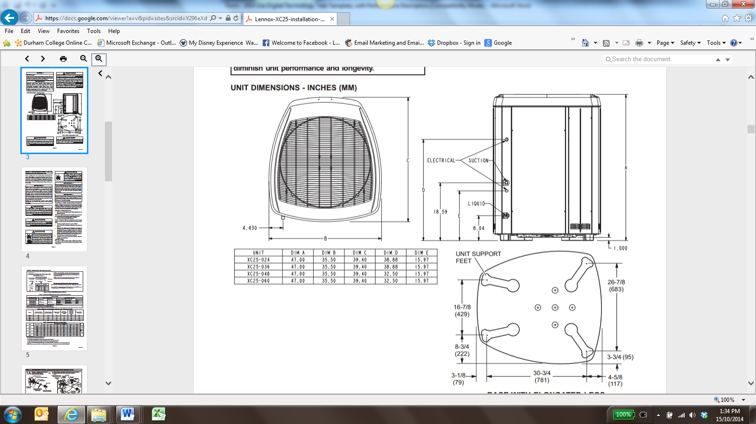
Page 3
Image as of October 2014
Task 2: 36
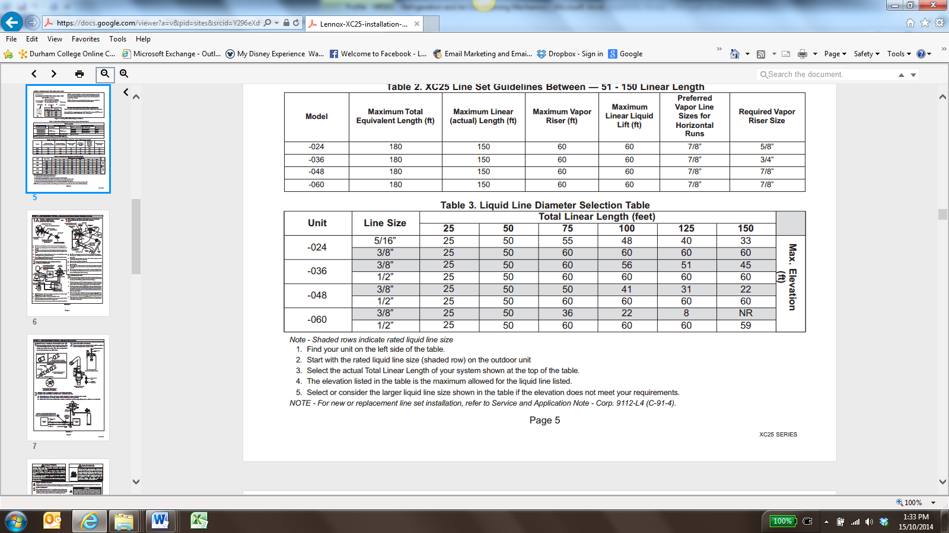
Page 5
Image as of October 2014
Task 3: A trace amount is a maximum of two ounces (57 g) refrigerant or three pounds (31 kPa) pressure.
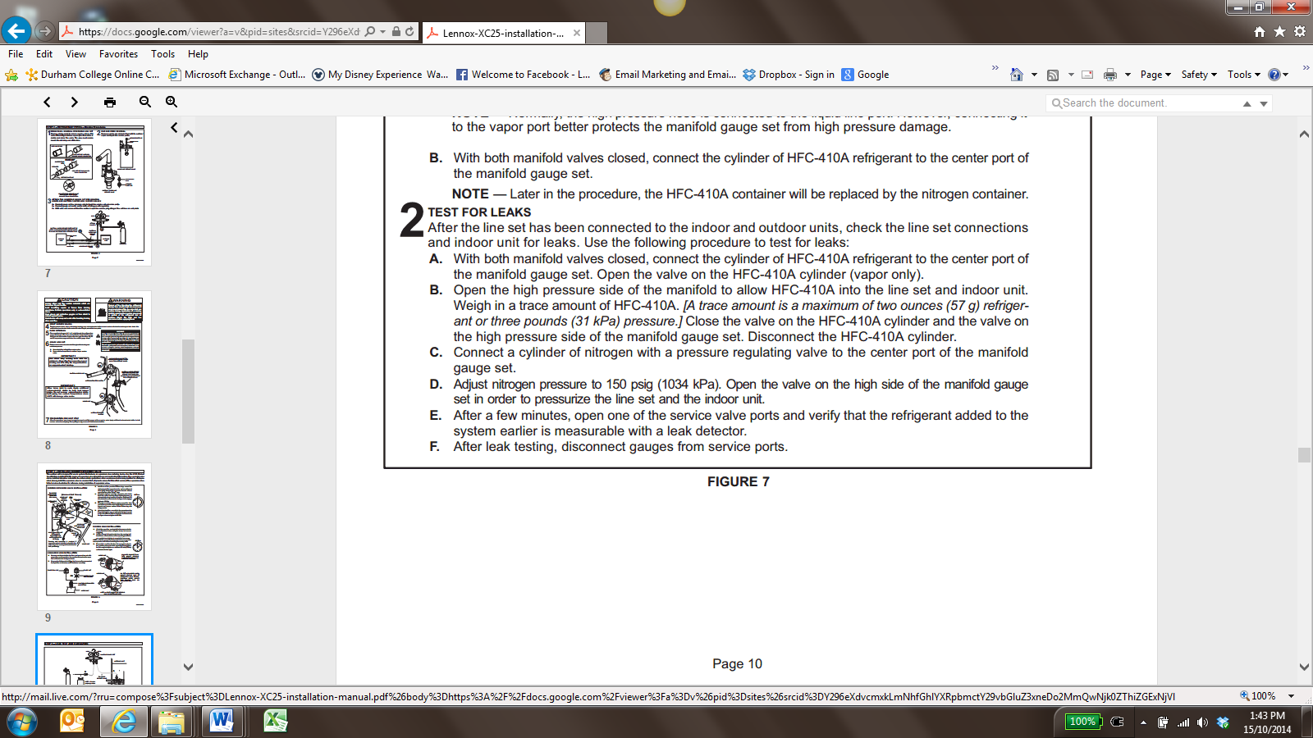
Page 10 (2.B)
Image as of October 2014
Task 4: All low voltage wiring must enter the unit through provided field-installed busing installed in electrical inlet.
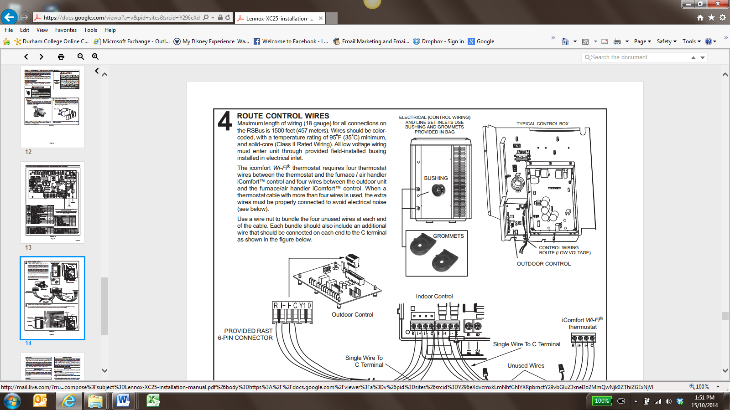
Page 14 (text in top left corner)
Image as of October 2014

Task 5:
Possible URL source for answers: http://www.techcommunicators.com/emanuals/wrm/chap01/01-04_online.htm
- They can be searched quickly using either the table of contents, index, or internal cross-references. These features use the ability to link from one place to another in a manual.

Task Title: Refrigeration and Air Conditioning Installation
Performance Descriptors |  | Needs Work | Completes task with support from practitioner | Completes task independently
A1.2 | - Scans text to locate information
 | - Locates multiple pieces of information in simple texts
 | - Reads more complex texts to locate a single piece of information
 | - Makes low level inferences
A2.3 | - performs complex searches using multiple search criteria
 | - manages unfamiliar elements (e.g. vocabulary, context, topic) to complete tasks
 | - integrates several pieces of information from documents
 | - uses layout to locate information
 | - identifies the purpose and relevance of documents
 | - makes inferences and draws conclusions from information displays
 | - identifies sources, evaluates and integrates information
B2.1 | - writes simple texts to request, remind or inform
 | - conveys simple ideas and factual information
 | - demonstrates a limited understanding of sequence
 | - uses sentence structure, upper and lower case and basic punctuation
C4.1 | - recognizes values in number and word format
 | - identifies and compares quantities of items
 | - understands numerical order
D2 | - selects and follows appropriate steps to complete tasks
 | - locates and recognizes functions and commands
 | - makes low-level inferences to interpret icons and text
 | - begins to identify sources and evaluate information
 | - performs simple searches using keywords (e.g. internet, software help menu)
D3 | - manages unfamiliar elements (e.g. vocabulary, context, topic) to complete tasks
 | - makes inferences to interpret icons and text
 | - selects appropriate software when required by the task
 | - identifies sources, evaluates and integrates information

This task: was successfully completed___ needs to be tried again___

Learner Comments

____________________________ _________________________

Instructor (print) Learner Signature

