Task-based Activity Cover Sheet
Task Title: Select a computer desk
Learner Name:

Date Started: Date Completed:

Successful Completion: Yes___ No___
Goal Path: Employment ✓ Apprenticeship___ Secondary School Post Secondary Independence ✓
Task Description:
The learner will look at a flyer and choose a desk that will be big enough to hold a computer and a printer.
Competency:  C: Understand and Use Numbers | Task Group(s):  C3: Use Measures
Level Indicators:
C3.1: Measure and make simple comparisons and calculations

Performance Descriptors: see chart on last page or click here
Links to skill building activities: see the last page or click here
Materials Required:
- Pen/pencil
- Scrap paper or calculator
- Attached flyer
ESKARGO:
Addition & Subtraction
- Rounds whole numbers
- Writes and solves simple addition and subtraction sentences (e.g., 5 + 6 = 11)
- Adds and subtracts multi-digit whole numbers with and without regrouping
- Identifies and performs required 1-step operations
Decimals
- Demonstrates an understanding that a standard unit to measure is used to describe the measure of an object
- Develops rules for calculating the perimeter and area of rectangles, generalizes rules, and develops formulas
- Estimates and calculates the perimeter and area of rectangles and squares
- Distinguishes between estimated and precise measurements and knows when each kind is required
- Selects the most appropriate standard unit to measure
- Chooses appropriate units of measurement (e.g., centimetres, metres, kilometres)
- Uses common standard units (e.g., metres, inches) and non-standard units (e.g., paces, cupfuls, scoops)
- Identifies and performs required operation
- Interprets and represents measures using whole numbers, decimals, and simple, common fractions (e.g., ½, ¼)
- Interprets and represents measures using symbols and abbreviations (e.g., inches as “, centimetres as cm, pounds as lbs, kilograms as kilos or kg)
- Follows apparent steps to reach solutions
- Rounds to the nearest whole unit (e.g., kilos)
- Uses strategies to check accuracy (e.g., estimating, using a calculator, repeating a calculation, using the reverse operation)

Attitudes:
Practitioner,
We encourage you to talk with the learner about attitudes required to complete this task set. The context of the task has to be considered when identifying attitudes. With your learner, please check one of the following:
□ Attitude is not important □ Attitude is somewhat important □ Attitude is very important

Task Title: Select a computer desk
Purchasing or office managers may order office furniture for the workplace. Individuals may order office furniture for home use. Before buying, purchasers must determine what size will meet workplace or home needs. Look at the flyer.

Learner Information and Tasks:
A mobile desk will be purchased from Staples. It must be large enough to hold both a laptop and a printer. The laptop is 15” wide, and the printer is 20” wide.

Task 1: Calculate the minimum width that the desk must be add in 1” for clearance?

Task 2: Circle the desk in the flyer that meets the width requirement.

Task 3: The space where the desk will be set up is 48” wide, so the manager decides they will not need the printer on the desk. Which desk(s) can now be purchased?

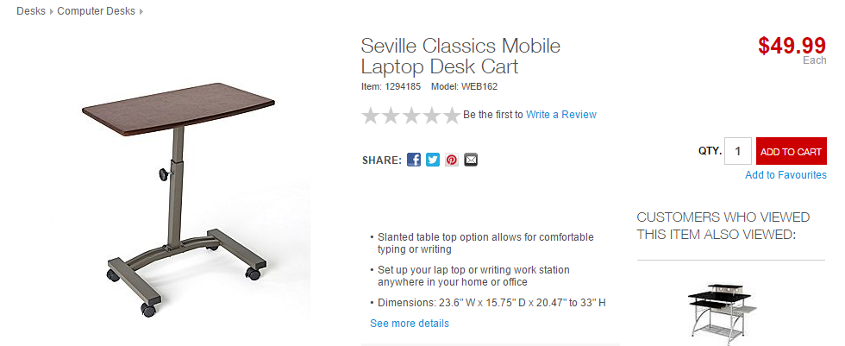
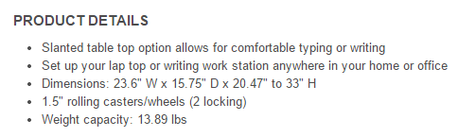

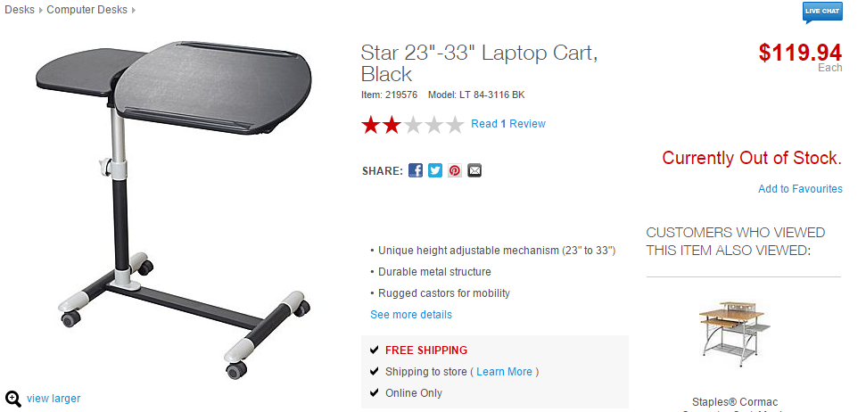
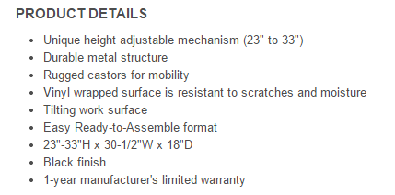

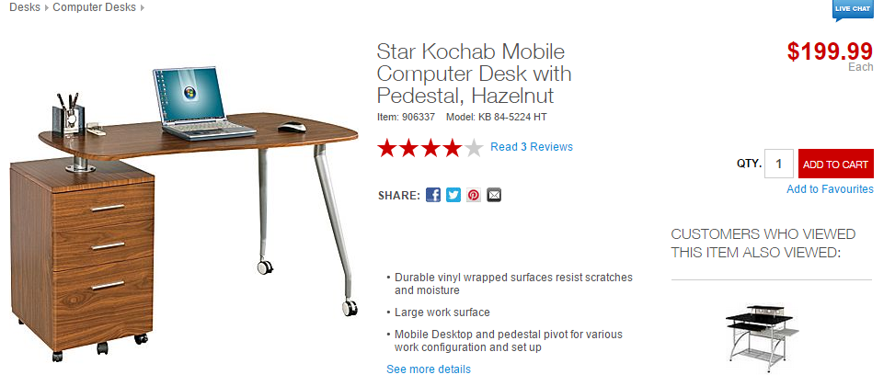
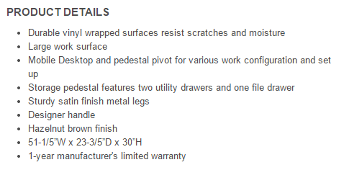

Task Title: Select a computer desk
Answer Key

Task 1: Calculate the minimum width that the desk must be?
15 + 20 + 1 = 36”

Task 2: Circle the desk in the flyer that meets the width requirement.
The Star Mochab Mobile Computer desk should be circled

Task 3: The space where the desk will be set up is 48” wide, so the manager decides they will not need the printer on the desk. Which desk(s) can now be purchased?

The Star Mochab cannot be purchased because it is too wide.

The two other desks (The Seville and The Star) can now be purchased because they only need 15” without the printer.

Task Title: Select a computer desk
Performance Descriptors |  | Needs Work | Completes task with support from practitioner | Completes task independently
C3.1 | - adds and subtracts whole number measurements
 | - recognizes values in number and word format
 | - identifies and performs required operation
 | - interprets and represents measures using whole numbers, decimals and simple, common fractions (e.g. ½, ¼)
 | - interprets and represents measures using symbols and abbreviations (e.g. inches as “, centimeters as cm, pounds as lbs, kilograms as kilos or kg)
 | - follows apparent steps to reach solutions
 | - uses strategies to check accuracy (e.g. estimating, using a calculator, repeating a calculation, using the reverse operation)

This task: was successfully completed___ needs to be tried again___

Learner Comments

____________________________ _________________________

Instructor (print) Learner Signature
Skill Building Activities
Links for online resources:
How to add, subtract, multiply and divide…:
http://www.mathsisfun.com/numbers/index.html
Scroll down to the “How to add, subtract, multiply and divide…” Each math operation is defined and examples with visuals are used. There are also interactive games and worksheets provided for extra practice.
How to estimate answers…:
http://www.mathsisfun.com/numbers/estimation.html
“Estimation is a skill for life.” This link is an introduction to estimation and will help the learner to understand how estimation can be applied to everyday life. There are estimation games and practice activities to help learners practice their estimation skills.
Metric Length:
https://www.mathsisfun.com/measure/metric-length.html
“We can measure how long things are, or how tall, or how far apart they are.” This link is an introduction to the most common metric measurements: millimeters, centimetres, metres and kilometres. Each unit of measurement is defined and examples are included. Look for the activity “Discover Lengths” in which learners are asked to measure common household items.
Calculating Area:
http://www.tv411.org/math/geometry/calculating-area
Practice in calculating area. This link brings the learner to a series of activities that will help the learner to “understand square units and how they are used to measure area and use the formulas A = l × w and A = s × s to figure out the areas of rectangles and squares.” By clicking on “Begin Lesson,” the learner is taken to a series of 10 questions that works through word problems directly related to calculating area.
Metric Area:
https://www.mathsisfun.com/measure/metric-area.html

This link defines the most common metric measurements of area: square millimeter, square centimetre, square metre, hectare and square kilometre. Look for the “Garden Area Activity” when scrolling to the bottom of the page; this activity asks learners to measure and calculate the area of their own garden!
LearningHUB Courses Available:
Math, Independent Study - 100 Whole Numbers Assignment; 101 Addition, Subtraction Assignment 1 & 2; 201 Multiplication, Division Assignment; 302 Decimals Assignment; 303 Data Analysis Assignment; 401 Measurement Assignment (Assigned by Practitioner after assessment)
Live Classes (SABA) – Multiplication, Division, Decimals A, Decimals B, Math Stories
*To access LearningHUB courses, learners must register for the LearningHUB e-Channel program by completing the registration form on their website and completing the course selection (page 2 of the registration form): https://www.learninghub.ca/get_registered.aspx
*To Access LearningHUB Course Catalogue:
http://www.learninghub.ca/Files/PDF-files/HUBcoursecatalogue,%20December%2023,%202014%20revision.pdf

