OALCF Task Cover Sheet
Task Title: Series and Parallel Circuits
Learner Name:

Date Started: Date Completed:

Successful Completion: Yes___ No___
Goal Path: Employment Apprenticeship Secondary School Post Secondary Independence___
Task Description:
Electricians interpret diagrams of series and parallel circuits to make calculations.
Competency:  A: Find and Use Information  B: Communicate Ideas and Information  C: Understand and Use Numbers  D: Use Digital Technology | Task Group(s):  A1: Read continuous text  A2: Interpret documents  B2: Write continuous text  C3: Use measures  C4: Manage data
Level Indicators:
A1.2: Read texts to locate and connect ideas and information
A2.2: Interpret simple documents to locate and connect information
B2.2: Write texts to explain and describe information and ideas
C3.2: Use measures to make one-step calculations
C3.3: Use measures to make multi-step calculations: use specialized measuring tools
D.1: Perform simple digital tasks according to a set procedure
D.2: Perform well-defined, multi-step digital tasks
Performance Descriptors: see chart on the last page
Materials Required:
- Pencil
- Calculator
- Circuits drawing
- Internet access

Task Title: Series and Parallel Circuits
Electricians interpret diagrams of series and parallel circuits to make calculations. Read the “Definitions” and “Formulas” below.
Learner Information and Tasks:
Definitions
Series circuits are continuous as a circle. The electricity moves along a continuous path.
Parallel circuits contain more than one path. Branches of the circuit run parallel to each other.
See the Circuits diagram for pictures of Series and Parallel circuits.
Supply Voltage is the amount of power provided for the circuit (e.g. 24 volts). The Total Voltage in a circuit is the sum of the voltages at each resistor in a circuit and is the same value as the Supply Voltage.
Formulas
I = E/R where I = current (amps), E = power (volts) and R = resistance (ohms)
Ω = ohms; you will see this symbol on the series and parallel circuits on the Circuits document.
To calculate total resistance in a series circuit, add all the resistance values:
Total R = R₁ + R₂ + R₃ + ... + R_{n}
In a parallel circuit, the current depends on the resistance of the branch. To calculate total current in a parallel circuit, you first have to calculate the current for each branch:
I₁ = E/R + I₂ = E/R + I₃ = E/R ... I_{n} = E/R
The total current is the sum of all the branch amounts.

Look at the “Circuits” document.

Task 1: Use the Series circuit to complete these tasks.
- Calculate the total resistance (ohms) of the circuit.

- Calculate the current (amps) of the circuit.

- Calculate the voltage (volts) at each resistor. If I = E/R, then E = I x R.

Task 2: Use the Parallel circuit on the Circuits diagram to complete these tasks.
- Calculate the current (amps) for each branch.

- Calculate the total current (amps) in the circuit.

- Calculate the total resistance (ohms) in the circuit.

Task 3: Search the Internet to find an advantage of using a series circuit. Write your findings below.

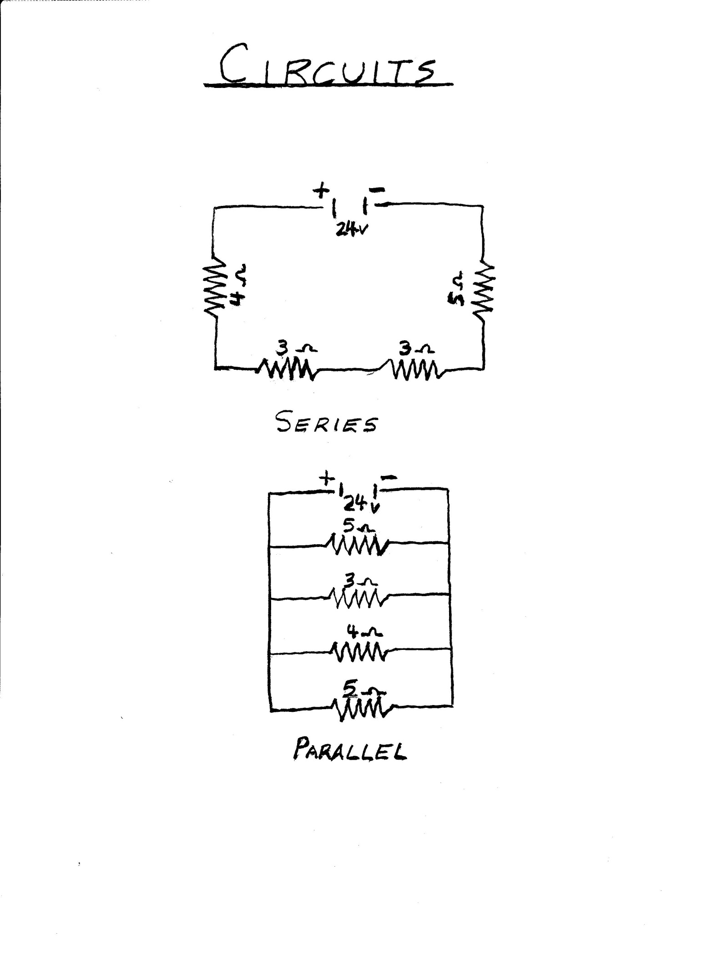
Task Title: Series and Parallel Circuits
Answer Key
Task 1: a) Total R = R₁ + R₂ + R₃ + ... + R_{n}
Total R = 5 + 3 + 3 + 4
Total R = 15 ohms
b) I = E/R
I = 24/15
I = 1.6 amps
c) E = I x R (for each resistor)
If the learner did not get 1.6 amps for b), make sure to see if they used their answer for b) within these formulas.
E₁ = 1.6 x 5 E₂ = 1.6 x 3 E₃ = 1.6 x 3 E₄ = 1.6 x 4
E₁ = 8 volts
E₂ = 4.8 volts
E₃ = 4.8 volts
E₄ = 6.4 volts
- Total E = E₁ + E₂ + E₃ + E₄
Total E = 8 + 4.8 + 4.8 + 6.4
Total E = 24 volts
- The supply voltage and the “voltage drop” are the same amount.
Task 2: a) I₁ = E/R + I₂ = E/R + I₃ = E/R + ... I_{n} = E/R
I₁ = 24 / 5 + I₂ = 24 / 3 + I₃ = 24 / 4 + I₄ = 24 / 5
I₁ = 4.8 amps + I₂ = 8 amps + I₃ = 6 amps + I₄ = 4.8 amps
b) Total I = I₁ + I₂ + I₃ + I₄
Total I = 4.8 + 8 + 6 + 4.8
Total I = 23.6 amps
c) R = E/I
R = 24 / 23.6
R = 1.02 ohms Answer is rounded up to 2 decimals
Task 3: Answers will vary but may include:
- One switch can control all the resistors
- Uses less wire than a parallel circuit
- Easy to add more power sources to increase voltage to resistors
- The current across all resistors is the same

Task Title: Series and Parallel Circuits
Performance Descriptors |  | Needs Work | Completes task with support from practitioner | Completes task independently
A1.2 | - scans text to locate information
 | - locates multiple pieces of information in simple texts
 | - makes low-level inferences
 | - makes connections between sentences and between paragraphs in a single text
 | - reads more complex texts to locate a single piece of information
 | - follows the main events of descriptive, narrative and informational texts
 | - obtains information from detailed reading
 | - begins to identify sources and evaluate information
A2.2 | - performs limited searches using one or two search criteria
 | - locates information in simple graphs and maps
 | - uses layout to locate information
 | - makes connections between parts of documents
 | - makes low-level inferences
B2.2 | - writes texts to explain and describe
 | - conveys intended meaning on familiar topics for a limited range of purposes and audiences
 | - uses limited range of vocabulary and punctuation appropriate to the task
 | - begins to select words and tone appropriate to the task
 | - begins to organize writing to communicate effectively
C3.2 | - calculates using numbers expressed as whole numbers, fractions, decimals, percentages, and integers
 | - understands and uses ratio and proportion
 | - interprets and applies rates (e.g. km/hr) and ratios (e.g. map scales)
 | - understands and uses formulas for finding the perimeter, area, and volume of simple, common shapes
 | - chooses and performs required operation(s); may make inferences to identify required operation(s)
 | - selects appropriate steps to solutions
C3.3 | - calculates using numbers expressed as whole numbers, fractions, decimals, percentages, and integers
 | - manages unfamiliar elements (e.g. context, content) to complete tasks
 | - interprets and represents measurements taken with specialized tools (e.g. calipers, multimeters)
 | - chooses and performs required operations; makes inferences to identify required operations
 | - interprets, represents, and converts measures using whole numbers, decimals, percentages, ratios, and fractions
 | - selects appropriate steps to solutions from among options
 | - uses strategies to check accuracy (e.g. estimating, using a calculator, repeating a calculation, using the reverse operation)
D.1 | - follows simple prompts
 | - follows apparent steps to complete tasks
 | - locates specific functions and information
 | - selects and follows appropriate steps to complete tasks
D.2 | - locates and recognizes functions and commands
 | - makes low-level inferences to interpret icons and text
 | - begins to identify sources and evaluate information
 | - performs simple searches using keywords (e.g. internet, software help menu)

This task: was successfully completed___ needs to be tried again___

Learner Comments

____________________________ _________________________

Instructor (print) Learner Signature

