Task Title: Starting a Bank Account

OALCF Cover Sheet – Practitioner Copy

Learner Name:
Date Started (m/d/yyyy):
Date Completed (m/d/yyyy):
Successful Completion: Yes No

Goal Path: | Employment | Apprenticeship
Secondary School | Post Secondary | Independence √
Task Description: Learners will complete a form based on finances and
their future plans.
Competency: B: Communicate Ideas and Information
E: Manage Learning
Task Groups: B1: Interact with Others
B3: Complete and create documents
E.2: N/A
Level Indicators:
- B1.2: Initiate and maintain interactions with one or more persons to discuss, explain or exchange information and opinions
- B3.3a: Decide what, where, and how to enter information in somewhat complex documents
- E.2: Set realistic short- and long-term goals, use a limited number of learning strategies and monitor own learning
Performance Descriptors: See chart on the last page

Materials Required:
- Decide whether interactions will be in a small group or one on one with the instructor
- Pencil or pen

Notes for instructors/facilitators:
Review individually
- Discussions with the learner will be important for the circles section…maybe it could be done in a pair with another learner
- Learner can start with the checklist independently, unless literacy levels are lower

Learner Information and Tasks
When opening an account at Libro you will be asked to fill in a Prosperity Planner. Look at the “My Prosperity Planner.”
Task 1: Fill out the Prosperity Planner

Task 2: Discuss the Prosperity Planner with your Instructor

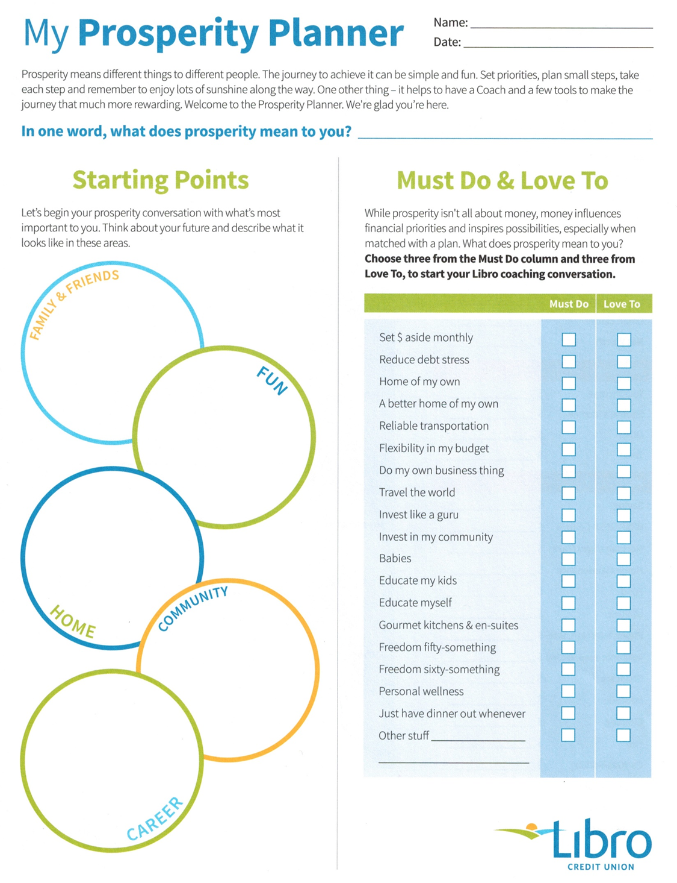

Performance Descriptors
Levels | Performance Descriptors | Needs Work | Completes task with support from practitioner | Completes task independently
B1.2 | shows an awareness of factors that affect interactions, such as differences in opinions and ideas, and social, linguistic, and cultural differences
 | demonstrates some ability to use tone appropriately
 | uses strategies to maintain communication, such as encouraging responses from others and asking questions
 | speaks or signs clearly in a focused and organized way
 | rephrases to confirm or increase understanding
 | uses and interprets non-verbal cues (e.g. body language, facial expressions, gestures
B3.3a | uses layout to determine where to make entries
 | makes inferences to decide what, where, and how to enter information
E.2 | sets realistic short-and long-term goals
 | identifies steps required to achieve goals
 | identifies barriers to achieving goals
E.2 | begins to adjust goals, activities, and timelines to address obstacles to achieving goals
 | sequences activities in multi-step tasks
 | begins to identify how skills and strategies can transfer to different contexts
 | identifies multiple sources of information to complete tasks

This task:
Was successfully completed Needs to be tried again

Learner Comments:

Instructor (print): Learner Signature

