OALCF Task Cover Sheet
Task Title: These Boots Are Made for Working
Learner Name:

Date Started: Date Completed:

Successful Completion: Yes___ No___
Goal Path: Employment___ Apprenticeship ✔ Secondary School___ Post-Secondary___ Independence___
Task Description:
In this activity, the learner will compare three different work boots and calculate how much each pair will cost with sales tax, and after a $75.00 credit.

Competency:  A: Find and Use Information  C: Understand and Use Numbers | Task Group(s):  A1: Read continuous text  A2: Interpret documents  C1: Manage money  C4: Manage data
Level Indicators:
A1.1: Read brief texts to locate specific details
A2.1: Interpret very simple documents to locate specific details
C1.2: Make low-level inferences to calculate costs and expenses that may include rates such as taxes and discounts
C4.1 Make simple comparisons and calculations

Performance Descriptors: see chart on last page
Skill Building Activities: Please find skill building activities at the end of this task set or click here.
Materials Required:
- Print out of the task which includes three sample advertisements of work boots
- Pen or pencil or computer

Practitioner Notes
This task has a skill building activity to teach the learner how to determine the total price of an item that includes sales tax. The activity can be recreated using examples of numerous products the learner may want to purchase.
Task Title: These Boots Are Made for Working
A new apprentice may be required to purchase a pair of work boots before starting a job. Look at the three advertisements for work boots.

Learner Information and Tasks

Task 1: Which work boots are waterproof?
_____________________________________________________________________________
Task 2: Which work boots have a removable insole?
_____________________________________________________________________________
Task 3: Which work boot has a TPU bumper toe guard?
_____________________________________________________________________________
Task 4: Which work boot is better for carpenters and plasterers?
_____________________________________________________________________________
Task 5: Which work boot is made for someone who spends a long time on his or her feet?
_____________________________________________________________________________
Task 6: Which work boot offers the most savings?
_____________________________________________________________________________
Task 7: How much do you save if you buy work boot #3?
_____________________________________________________________________________
Task 8: How much do each of the work boots cost with sales tax? Sales tax is 13%.
____________________________________________________________________________
____________________________________________________________________________
____________________________________________________________________________

Task 9: The Company gave you a $75.00 coupon off the purchase price of a new pair of work boots. You decide to purchase work boot #2. How much would you pay with sales tax?

____________________________________________________________________________

Task Title: These Boots Are Made for Working

Work Boot #1

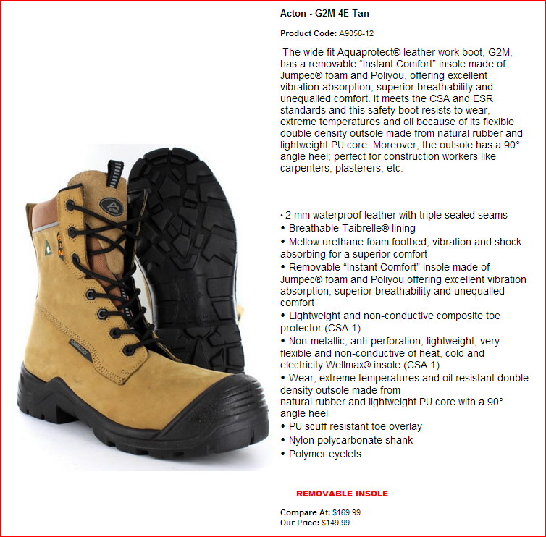

Task Title: These Boots Are Made for Working

Work Boot #2

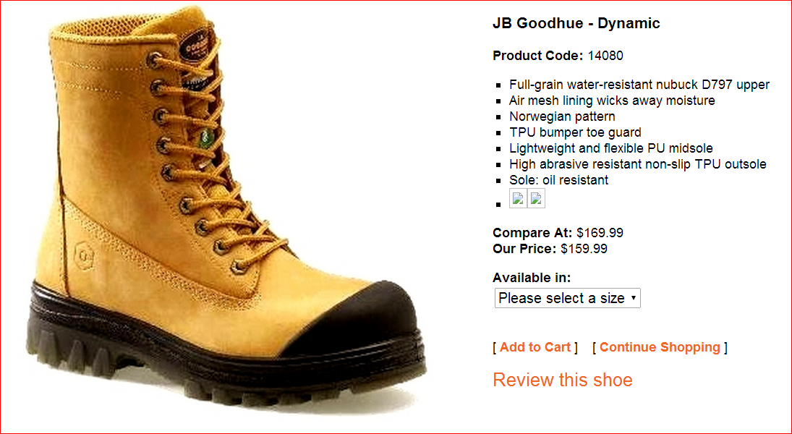

Task Title: These Boots Are Made for Working

Work Boot #3

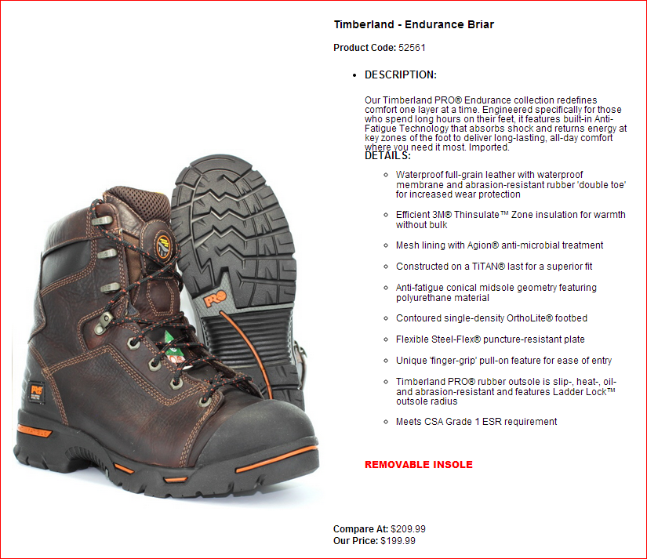

Task Title: These Boots Are Made for Working

Answer Key:
Task 1: Work boots # 1 and # 3
Task 2: Work boots # 1 and # 3
Task 3: Work boot # 2
Task 4: Work boots # 1
Task 5: Work boot # 3
Task 6: Work boot # 1
Task 7: $10.00
Task 8: Work boot # 1 costs $169.48 or $169.49 *
Work boot # 2 costs $180.78 or $180.79 *
Work boot # 3 costs $225.98 or $225.99 *
Task 9: Work boot # 2 would cost $96.03 or $96.04 **

* The answer to Task 8 has the option of two prices per work boot; either answer is correct. These answers take into consideration the learner’s understanding of rounding up and rounding down.
** The answer to Task 9 is calculated by first subtracting $75.00 from the purchase price of the work boot and then adding the 13% sales tax. It is incorrect to subtract $75.00 from the answer in Task 8.

Task Title: These Boots Are Made for Working

Performance Descriptors |  | Needs Work | Completes task with support from practitioner | Completes task independently
A1.1 | - decodes words and makes meaning of sentences in a single text
 | - reads short texts to locate a single piece of information
 | - identifies the main idea in brief texts
A2.1 | - scans to locate specific details
 | - interprets brief text and common symbols
 | - locates specific details in simple documents, such as labels and signs
C1.2 | - calculates using numbers expressed as whole number, fractions, decimals, percentages, and integers
 | - calculates percentages
 | - selects appropriate steps to reach solutions
 | - represents costs and rates using monetary symbols, decimals, and percentages
C4.1 | - adds, subtracts, multiplies, and divides whole numbers and decimals
 | - identifies and performs required operation

This task: was successfully completed___ needs to be tried again___

Learner Comments

____________________________ _________________________

Instructor (print) Learner Signature

Skill Building Activity: These Boots Are Made for Working

Many apprentices need to buy personal safety equipment for their job. To determine the total price of each piece of personal safety equipment, you need to include sales tax. In Ontario, a 13% sales tax is charged on goods and services.

How to convert a percentage to a decimal
Before doing the math required to add sales tax to the price of an item, you need to convert the percentage to a decimal. To do so, simply remove the percentage (%) symbol after the number, and replace it with a decimal (.) before the number. For example:

13% = 0.13

25% = 0.25

75% = 0.75

How to calculate the total price of an item including sales tax
To calculate the total price including Ontario’s 13% sales tax, put a 1 in front of the decimal (changing it from .13 to 1.13) and multiply the price of the item by the decimal number.

Price of the item x 1.13 = the total price of the item including sales tax

For example, the price of a pair of work boots is $164.00. To calculate the total price, use the following formula:
164 x 1.13 = 185.32

You will pay a total of $185.32 including sales tax.

Now try to calculate the sales tax for yourself

- Convert the following percentage to a decimal:

65% = _________________________ 10% = _________________________

45% = _________________________ 90% = _________________________

- Use the formula to calculate the price with sales tax for the following personal safety equipment.

- Chemical Splash Goggles $10.00 __________________________________________

- Orange Mesh Safety Vest $5.59 __________________________________________

- Hard Hat $6.89 __________________________________________

- Safety Gloves $12.50 __________________________________________

Skill Building Activity: These Boots Are Made for Working

Answer Key:

- 65% = .65 10% = .10 or .1
45% = .45 90% = .90 or .9

- a. Chemical Splash Goggles $10.00 = $11.30
b. Orange Mesh Safety Vest $5.59 = $6.31 or $6.32 *
c. Hard Hat $6.89 = $7.78 or $7.79 *
d. Safety Gloves $12.50 = $14.12 or $14.13 *

* The two prices provided take into consideration the learners understanding of rounding up and rounding down. Therefore, either answer is correct.

