OALCF Task Cover Sheet
Task Title: Understand nutritional labels to plan a healthy lunch
Learner Name:

Date Started: Date Completed:

Successful Completion: Yes___ No___
Goal Path: Employment___ Apprenticeship___ Secondary School___ Post Secondary___ Independence✓
Task Description: It’s important to read and understand nutritional labels in order to plan and prepare healthy meals. In this task, the learner will read a selection of nutritional labels and nutritional information to plan a healthy lunch.
Competency:  - Find and Use Information  - Communicate Ideas and Information  - Use Digital Technology (optional) | Task Group(s):  A1: Read continuous text  A2: Interpret documents  B3: Complete and create documents  n/a
Level Indicators:
A1.2: Read texts to locate and connect ideas and information
A2.3: Interpret somewhat complex documents to connect, evaluate and integrate information
B3.2a: Use layout to determine where to make entries in simple documents
D.2: Perform well-defined, multi-step digital tasks (optional)
Performance Descriptors: see chart on last page
Materials Required:
- A variety of food with nutritional labels or just labels
- A variety of other fresh/non-processed food with no labels
- Access to a computer with internet
- Nutritional Fact Sheets
- Food and Nutrition Tracker
- Paper/pen

Instructor’s Preparation: Prior to doing this activity you may want to devote some class time to reviewing Canada’s Food Guide and understanding nutritional labels. One good resource is http://www.has.uwo.ca/hospitality/nutrition/pdf/foodguide.pdf which can be printed or reviewed on screen with the whole class.
For the activity, set up an area in the classroom with a wide variety of food items with nutritional labels as well as fresh items with no labels. If space is an issue you can just have the food labels and get pictures of the food from grocery store flyers or magazines. You can have the learners bring in the food and/or labels or provide them yourself. Examples can include fresh fruit and vegetables, cookies, granola bars, nuts, crackers and cheese. Distribute the Nutritional Fact Sheets and Food and Nutrition Tracker.
Special Note: If Task 3 is too difficult based on the computer skills of your learner you can delete tasks 3, 4 and 5 and provide the nutritional information of the fresh items to your students.
Task title: Understand nutritional labels to plan a healthy lunch
It’s important to read and understand nutritional labels in order to plan and prepare healthy meals.
Task 1: Read the Nutritional Fact Sheets to understand nutritional labels. Which nutrients should you get less of?
Task 2: View the food with nutritional labels (or just the labels) and write the calories, fat, fibre, sugar and salt content of each item on your Food and Nutrition Tracker sheet.
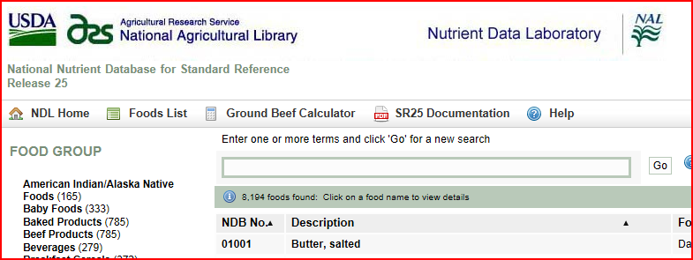
Task 3: Open the internet connection on your computer and enter the website http://ndb.nal.usda.gov/ndb/foods/list into the browser to find the Nutrient Data Laboratory. Using the search box on the screen or the food categories on the left side of the screen, locate one of the fresh items from the classroom table that doesn’t have a label.

Task 4: Once you have found the fresh item, scroll through the screen and write the calories (energy), fat, fibre, sugar and salt content of the item onto your Food and Nutrition Tracker sheet.

Task 5: Repeat tasks 3 and 4 for all the fresh items on the classroom table. Exit the Nutrient Data Laboratory website when done.

Task 6: Review the nutritional values of the foods you have written. Refer to the Nutrition Fact Sheets for information about understanding daily value %. Highlight or circle four items on your Food and Nutrition Tracker that you would pick for your healthy lunch.
Nutritional Fact Sheets
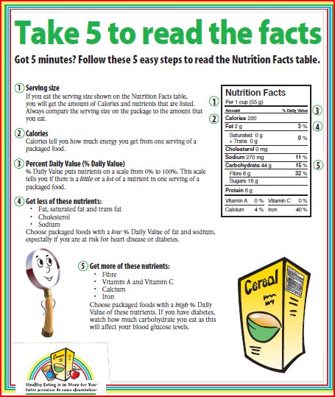

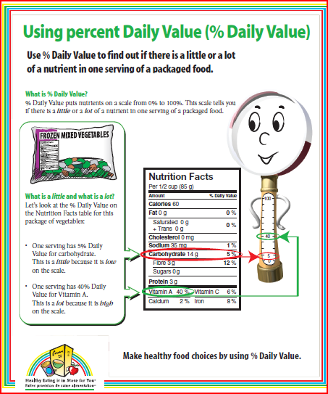

Food and Nutrition Tracker
Food | Calories (energy) | Fat | Fibre | Sugar | Salt

Task title: Understand nutritional labels to plan a healthy lunch
Performance Descriptors |  | Needs Work | Completes task with support from practitioner | Completes task independently
A1.2 | - scans text to locate information
 | - locates multiple pieces of information in simple texts
 | - follows the main events of descriptive, narrative and informational texts
A2.3 | - performs complex searches using multiple search criteria
 | - manages unfamiliar elements (e.g. vocabulary, context, topic) to complete tasks
 | - integrates several pieces of information from documents
 | - compares or contrasts information between two or more documents
 | - uses layout to locate information
 | - identifies the purpose and relevance of documents
 | - makes inferences and draws conclusions from information displays
 | - identifies sources, evaluates and integrates information
B3.2a | - uses layout to determine where to make entries
 | - begins to make some inferences to decide what information is needed, where and how to enter the information
D.2 | - selects and follows appropriate steps to complete tasks
 | - makes low-level inferences to interpret icons and text
This task: was successfully completed___ needs to be tried again___

Learner Comments
____________________________ _________________________

Instructor (print) Learner Signature

