OALCF Task Cover Sheet
Task Title: Vehicle Maintenance Schedule
Learner Name:

Date Started: Date Completed:

Successful Completion: Yes___ No___
Goal Path: Employment___ Apprenticeship ✓ Secondary School Post Secondary Independence___
Task Description:
Understand how to use the internet to search a database to locate and use information related to vehicle maintenance
Competency:  A: Find and Use Information  B: Communicate Ideas and Information  D: Use Digital Technology | Task Group(s):  A1: Read continuous text  A2: Interpret Documents  B2: Write continuous text  B3: Complete and create documents  D2: Use Digital Technology
Level Indicators:
A1.1: Read brief texts to locate specific details
A2.2: Interpret simple documents to locate and connect information
B2.2: Write texts to explain and describe information and ideas
D2: Perform well-defined, multi-step digital tasks

Performance Descriptors: see chart on last page
Materials Required:
- Computer with internet access
- Pencil and paper

Task Title: Vehicle Maintenance Schedule
Automotive service technicians talk about vehicle maintenance procedures and schedules with customers.
Learner Information and Tasks:
Task 1: Go to the “Goodwrench Service Maintenance Schedule” (http://www.gm.ca/gm/english/services/goodwrench/schedule) and locate the drop list boxes to select 2011 (year) Chevrolet (make) Cruze (model). Click on the “Show Services” button. Read the “Required Maintenance” information.

Task 2: The customer has 13 000 km on her 2011 Chevrolet Cruze and has never had it in for maintenance; list five of the services recommended for a car at this mileage.

Task 3: List five of the services recommended for a 2011 Chevrolet Cruze on a yearly basis.

Task 4: When the CHANGE ENGINE OIL SOON message displays, when should the customer bring the vehicle in for service?
Task Title: Vehicle Maintenance Schedule
Answer Key
Task 1: - Open the internet.
- Use a search engine, such as Google, to search “Goodwrench Service Maintenance Schedule”
- 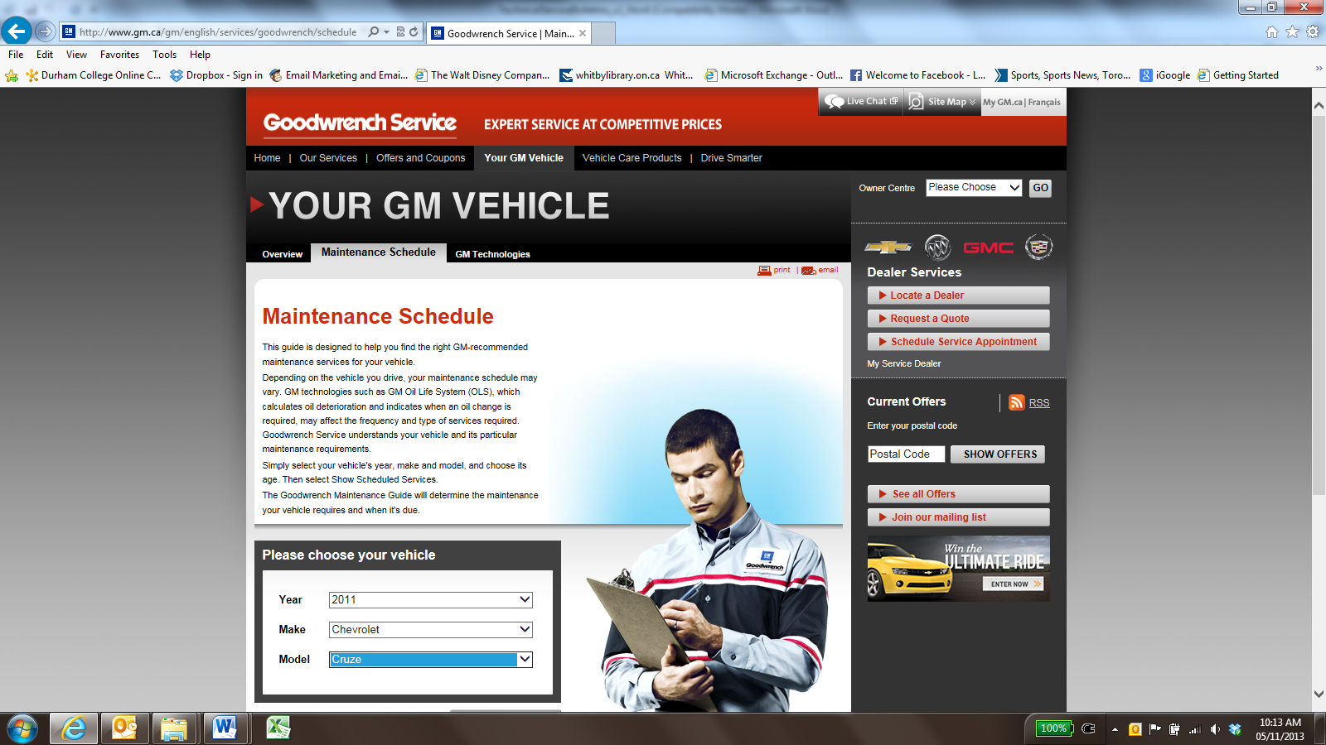
- Image as of November 2013
- Use the drop down lists under “Please choose your vehicle”
  - select “2011” for year
  - select “Chevrolet” for make
  - select “Cruze” for model
- Click on the “Show services” button located under the ‘Model’ drop box and to the left of the picture of the automotive service technician
Task 2: Answers will vary, but should include five of the following:
•Lubricate body hinges and latches, key lock cylinders, folding seat hardware, and sunroof.
•Brake system inspection.
•Change engine oil and filter. Reset oil system.
•Engine air cleaner filter inspection.
•Engine coolant level check.
•Engine cooling inspection. Visual inspection of pipes, fittings, and clamps if needed.
•Exhaust system and nearby heat shields inspection for loose and damaged components.
•Fluid visual leak check.
•Fuel system inspection.
•Restraint system component check.
•Steering and suspension inspection.
•Tire inflation pressure check.
•Tire wear inspection.
•Windshield washer fluid check.
•Windshield wiper blade inspection for wear, cracking or contamination.
•Tire rotation.
•Sunroof track and seal inspection, if equipped.
Task 3: Answers will vary, but should include five of the following:
- Accelerator pedal check for damage, high effort or binding.
- Automatic transmission shift lock control function.
- Ignition transmission lock check.
- Park brake and p (park) mechanism check.
- Starter switch check.
- Underbody flushing service (recommended every Spring to remove dust, dirt and chemicals used for snow & ice removal).
- Hood/decklid/liftgate/liftglass support gas strut service.
- If the vehicle has a tire sealant and compressor kit, check the sealant expiration date printed on the instruction label of the kit.

Task 4: When the CHANGE ENGINE OIL SOON message displays, service is required for the vehicle as soon as possible, within the next 1 000 km/600 miles.

Task Title: Vehicle Maintenance Schedule
Performance Descriptors |  | Needs Work | Completes task with support from practitioner | Completes task independently
A1.1 | - reads short texts to locate a single piece of information
 | - decodes words and makes meaning of sentences in a single text
 | - follows the sequence of events in straightforward chronological texts
 | - follow simple, straightforward instructional texts
 | - identifies the main idea in brief texts
A2.2 | - performs limited searches using one or two search criteria
 | - extracts information from tables and forms
 | - uses layout to locate information
 | - makes connections between parts of documents
 | - makes low-level inferences
B2.2 | - writes texts to explain and describe
 | - conveys intended meaning on familiar topics for a limited range of purposes and audiences
 | - uses limited range of vocabulary and punctuation appropriate to the task
 | - begins to select words and tone appropriate to the task
 | - begins to organize writing to communicate effectively
B2.3 | - writes texts to present information, summarize, express opinions, present arguments, convey ideas or persuade
 | - manages unfamiliar elements (e.g. vocabulary, context, topic) to complete tasks
 | - selects and uses vocabulary, tone and structure appropriate to the task
 | - organizes and sequences writing to communicate effectively
D2 | - selects and follows appropriate steps to complete tasks
 | - locates and recognizes functions and commands
 | - makes low-level inferences to interpret icons and text
 | - begins to identify sources and evaluate information
 | - performs simple searches using keywords (e.g. internet, software help menu)

This task: was successfully completed___ needs to be tried again___

Learner Comments

____________________________ _________________________

Instructor (print) Learner Signature

