Task-based Activity Cover Sheet
Task Title: Your Banking Options – Ways to Bank
Learner Name:

Date Started: Date Completed:

Successful Completion: Yes □ No □
Goal Path: Employment □ Apprenticeship □ Secondary School □ Post-Secondary □ Independence X
Task Description:
Learners understand the options of Ways to Bank with Libro.
Competency:  A: Find and Use Information  C: Understand and Use Numbers | Task Group(s):  A1: Read continuous text  C2: Manage time
Level Indicators:
A1.1: Read brief texts to locate specific details
A1.2: Read texts to locate and connect ideas and information
C2.1: Measure time and make simple comparisons and calculations

Performance Descriptors: see chart on last page
Materials Required:
- Pencil or pen or computer

Task Title: Your Banking Options – Ways to Bank
Credit Unions and Banks have brochures that help customers understand what services they provide. Look at the handout “Ways to Bank”.
Learner Information and Tasks:
Task 1: How many Automated Teller Machines does someone have access to across Canada as a customer of Libro?

Task 2: What 3 things can you do with Online banking?

Task 3: How can you deposit a cheque using the mobile phone app Deposit Anywhere?

Task 4: How many hours during a weekday can you call the Telephone Banking Contact Centre?

Task Title: Your Banking Options – Ways to Bank
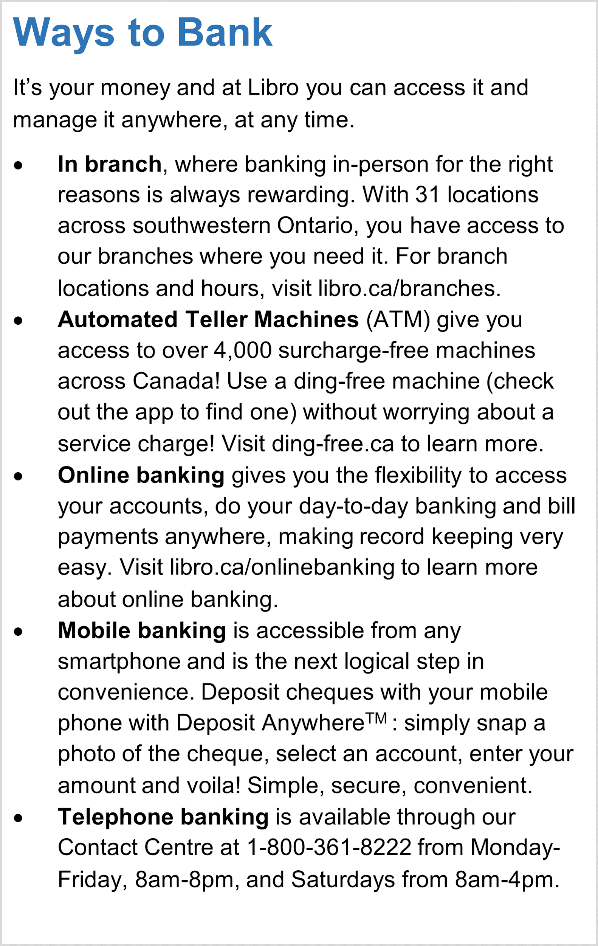

Task Title: Your Banking Options – Ways to Bank
Answer Key
Task 1: How many Automated Teller Machines does someone have access to across Canada as a customer of Libro?
A: over 4000
Task 2: What 3 things can you do with Online banking?
A: 1 – flexibility to access your accounts
2 – do your day to day banking
3 – bill payments anywhere
Task 3: How can you deposit a cheque using the mobile phone app Deposit Anywhere?
A: simply snap a photo of the cheque, select an account, enter your amount and voila!
Task 4: How many hours during a weekday can you call the Telephone Banking Contact Centre?
A: M – F 8 am – 8 pm therefore 12 hours

Task Title: Your Banking Options – Ways to Bank

Performance Descriptors |  | Needs Work | Completes task with support from practitioner | Completes task independently
A1.1 | reads short texts to locate a single piece of information
A1.2 | scans text to locate information
 | locates multiple pieces of information in simple texts
C2.1 | adds, subtracts, multiplies, and divides whole numbers and decimals
 | understands chronological order
 | identifies and performs required operation

This task: was successfully completed □ needs to be tried again □

Learner Comments

____________________________ _________________________

Instructor (print) Learner Signature

